
School of Electrical Engineering and Computer Science

Senior Design Group 6 Project EEL 4915

Mini-Substation Monitoring System
August 10, 2009

Group Members:
John Blackburn
Devin King
Steve Johnson
Anish Raj Pant
Table of Contents
1. Executive Summary 1
2. Project Description 2
2.1 Power Monitoring 4
2.2 Why conduct remote substation monitoring? 5
2.3Wireless connectivity 5
2.4 Graphical User Interface 5
2.5 Fault Recognition 5
3. Specifications 6
3.1 Power Metering 6
3.2 Station Alarm 6
3.3 Power Supply 6
3.4 Microcontroller 7
3.5 Wireless Communications 7
3.5.1 Wireless Connectivity 7
3.6 Computer Requirements 8
3.6.1 Software and User Interface 8
4. Research 10
4.1 Methods 10
4.1.1 Research 10
4.1.2 Design Methods 11
4.1.3 Project Management 11
4.1.4 Interfacing and Testing 11
4.2 AC to DC Power Supply 12
4.2.1 Transformers 13
4.2.2 Rectification and Smoothing 14
4.2.3 Voltage Regulating 15
4.3 Microcontrollers 16
4.3.1 PIC Microcontrollers 17
4.3.1.1 PIC18F85J90 18
4.3.1.2 PIC16F77 18
4.3.2 ATMEL Microcontrollers 19
4.4 Energy Measurement IC's 20
4.4.1 ADE7753 20
4.5 Current Sensors 20
4.5.1 Current Shunt 21
4.5.2 Current Transformer 24
4.5.2.1 Rogowski Coil 25
4.6 Wireless Communication 26
4.6.1 Wi-Fi 26
4.6.2 ZigBee 27
4.6.3 Aurel 28
4.6.4 Radiocrafts 29
4.6.5 XBee 29
4.6.6 GSM / GPRS 30
4.6.7 Bluetooth 31
4.7 Relay/ Breaker 33
4.7.1 Electromechanical Relay 33
4.7.2 Reed Relay 35
4.7.2 Rail Mounted Relay (4PDT DIN) 36
4.7.3 RW-SS-112D Relay 38
4.7.4 Solid State Relay 41
4.7.5 Field Effect Transistor Relay 42
4.7.6 Bosch Relay 46
4.8 Liquid Crystal Display (LCD) 47
4.8.1 CFA632YFBKS LCD (16*2) 48
4.8.1.1 CFA632YFBKS LCD specifications: 50
4.8.2 CFA634NFAKS LCD (24*4) 52
4.8.2.1 CFA634NFAKS LCD specifications: 54
4.8.3 CFAX12864CP1WGHTS LCD 55
4.8.3.1 CFAX12864CP1WGHTS LCD specifications 57
4.8.4 Interfacing LCD with Hitachi 44780 controller 61
4.9 Programming 62
4.9.1 Assembly 62
4.9.2 C/C++ Programming 63
4.10 SCADA 63
4.11 Software and User Interface 64
4.11.1 Citect 64
4.11.2 Prodigy 67
4.11.3 Siemens Energy 69
4.11.4 Control Microsystems – ClearScada 71
4.12 Modbus 75
5. Design 79
5.1 Station Alarm System 79
5.1.1 SPDT relay 79
5.1.2 Circuit Design and Schematic 79
5.2 Power Supply 81
5.2.1 Transformer 81
5.2.2 Rectifier 82
5.2.3 Smoothing and Regulating 83
5.3 Energy Metering Design 85
5.3.1 ADE7753 and PIC16F77 Pin Configuration 86
5.3.2 Current and Voltage Sensor Input 87
5.3.3 Serial Interface 88
5.4 PIC16F77 Microcontroller 89
5.4.1 Oscillator 90
5.5 Connecting Relay to a Microcontroller 91
5.6 Wireless communications 91
5.7 User Interface Design 100
5.7.1 Software 100
5.7.2 Modbus Communication 105
6. Test Procedure 111
6.1 Wireless Communication 111
7. Project Milestones 120
7.1 Senior Design 1 120
7.2 Senior Design 2 120
7.3 Project Cost of Material 121
8. Final Product 122
Appendix 1
Permissions Granted 1
Works Cited 10

1. Executive Summary
As the world becomes increasing more dependent on electricity, the need for reliable power distribution has practically evolved into a necessity of life. For many Americans even a short-lived power outage feels like a major disaster. After all, how can we possibly expect to survive without air conditioners, televisions, computers, microwaves, refrigerators, stoves, and ovens? While that may seems like a disaster to many, imagine the impact that power outages have in other situations. How can retail locations conduct business without lights and without electricity to power their cash registers and computers? What does the daily commute turn into without traffic lights? How about factories, banks, and grocery stores? It seems as if the world comes to a stand-still without electricity.
Most power interruptions are not a fault of the power generation facility itself, as interruptions from the source are a rare occurrence. Secondly, the transmission of the electricity from the generation plant to the power substations is typically conducted on very large, sturdy, metal structures that are usually far away from vehicular traffic and civilization and therefore that part of the system is generally not the cause of power interruptions. Where the problems lie tends to be at some point between the substation facility and the consumer. That leg of the system is typically in more populated areas and closer to roadways. This subjects the lines and poles to situations where they are often struck by motor vehicles or subjected to physical damage in a number of ways. This is the reason that the ability to monitor power at the substation is crucial to the consistent and reliable delivery of electricity from the generation plant to the consumer.
To aid in successfully delivering continuous power to the consumer, we have developed a substation monitoring device. This device consists of monitoring chips that can accurately measure current consumption and voltage across the output of the power substation and includes a protection relay to prevent damage or suspend further damage to the system. Information gathered by these devices are then automatically and wirelessly relayed to a computer containing user friendly interface software that displays the information graphically, computes trend information, and can even send email and text message alerts to warn of occurring fault conditions or a developing problem. The software can also be used to activate the protection relay manually from a remote location. All of these functions come in a small weather proof enclosure that can easily be retrofitted to any existing substation.
As substation monitors become more widely implemented, power outages and system down-time will be reduced, maintenance and repair costs will be kept to a minimum, and fault conditions can be more quickly recognized and located so that the system can be brought back on line in the shortest amount of time possible.

2. Project Description
Our Mini-Substation Monitoring System is a self-contained unit providing substation monitoring and wireless communications that is designed to be easily installed or integrated into power substations. The core of the device is comprised of a microcontroller, a current sensor, a load sensor, and a voltage sensor mounted on a printed circuit board. In addition, a relay is also incorporated into the device to serve as a breaker should a fault condition occur. The fault conditions will be predetermined by the consumer and designed to meet the requirements of the application. The system also consists of a small, exterior mounted liquid crystal display (LCD) so real-time conditions of the substation can be observed. The exterior of the housing will also contain a light emitting diode (LED) incorporated with an audio alarm. Both would be automatically activated at an indication of trouble with the system. The single LED could also be upgraded to a cluster of LED’s which would be visible from a much greater distance, however for purposes of the prototype demonstration, the system will only utilize a single LED. Information collected from the current and voltage sensors is sent via an integrated wireless device to a transceiver connected to a nearby laptop computer. The laptop computer contains a graphical user interface that displays information collected from the substation monitor’s sensors. The software also is capable of developing trend data for easy identification of high and low usage times and condition trends. Once a fault condition is relayed to the user interface, the computer automatically sends the information via email and cell phone text messages to alert the user of current conditions occurring at the substation.
Sub-Systems
- Microcontroller
- Current Sensor
- Voltage Sensor
- Energy Metering IC
- LCD Display
- LED’s
- Relay
- Audible Alarm
- Wireless RF modules
- Graphical User Interface
- Host laptop computer
The Mini-Substation Monitoring System will have various inputs and outputs, which can be seen below in Figure 1: Mini-Substation Monitoring System Input/Outputs. Along the top there are three inputs to the system, a power source, relay inputs, user inputs. Shown along the bottom are the system outputs, which include text message notification, E-mail notification, fault status, full metered values (current, voltage, power, etc.).

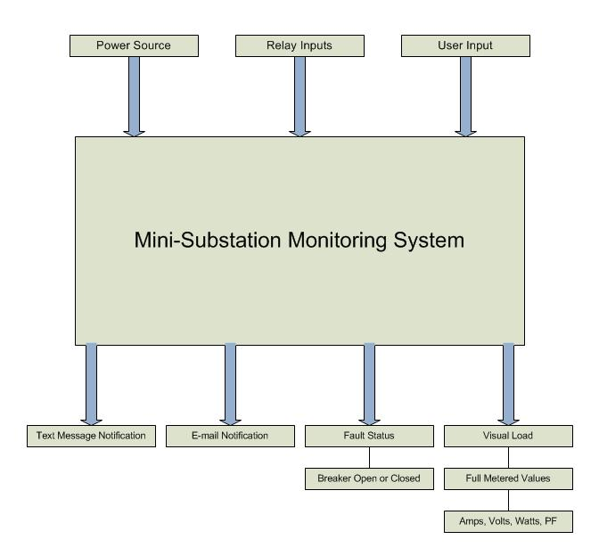
Figure 1: Mini-Substation Monitoring System Input/Outputs
There is more to this monitoring system then the inputs and outputs. The system contains a lot of components inside that build up to the big picture. The actual sub-station will contain components such as relays, integrated circuit chips, microcontrollers and many more as seen in Figure 2: Power Monitoring Sub-System Block Diagram (Detailed). Then on the Laptop computer side there are a couple of things that are of great importance, which consist of the software, user interface, wireless communication with the station. These diagrams are only a basic interpretation of the system; much more detail will be discussed and shown in the upcoming sections of this paper.
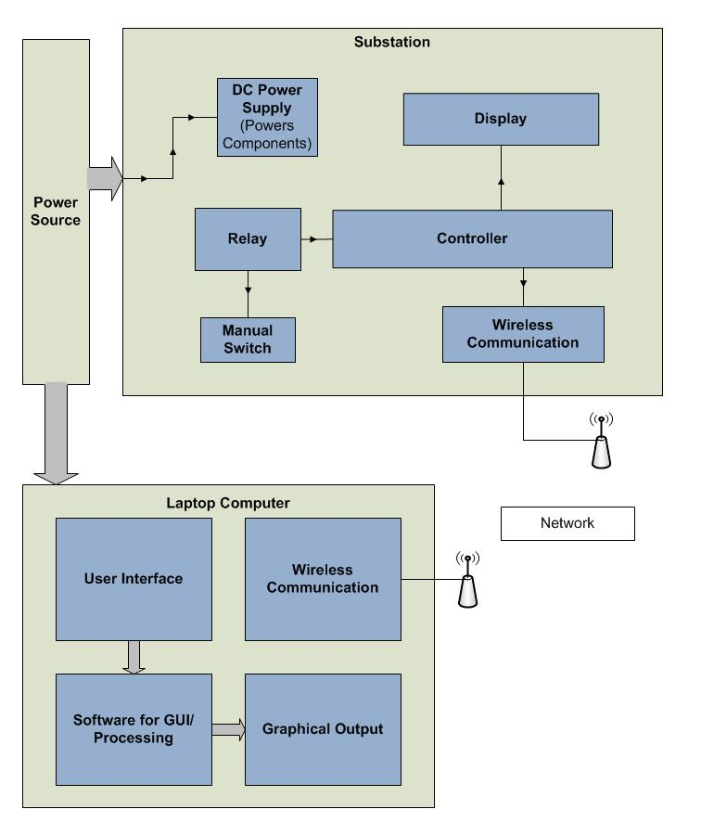
Figure 2: Power Monitoring Sub-System Block Diagram (Detailed)

2.1 Power Monitoring
Our system draws on data from electronic sensors to accurately assess the condition and capacity of a transformer substation unit. Factors important to this achievement include monitoring changes in output current and voltage to evaluate transformer loading, providing information on current and impedance during operation to determine how the system protection circuitry is performing, as well as analyzing fault conditions. Monitoring all of these conditions allow power system personnel to develop trend data and improve reliability and performance. Automated early warning devices alert the user to developing fault conditions that could lead to equipment failures and power outages. This allows providers to remotely monitor substations saving on maintenance cost, manpower, and service down time.

2.2 Why conduct remote substation monitoring?
In the electric utility industry the distribution system reliability and operational efficiency is of the utmost importance. The increasing reliance on electrically based technology means that it is more important than ever that power system interruptions are kept to a minimum. Substation monitoring is crucial to reaching this goal. By implementing effective substation monitoring devices, the overall efficiency of power distribution can be maximized. For example, load monitoring allows the substation to deliver a maximal amount of power without out exceeding its limitations. Another advantage of power monitoring is to keep maintenance and repair costs to a minimum.

2.3Wireless connectivity
Data drawn from the sensors are then sent wirelessly to laptop computer manned by power supply station personnel. This allows personnel to drive within range of the wireless device and receive information regarding the current status of the substation without having to physically plug into the unit and without even having to get out of the car. A slightly higher cost unit could connect directly to the internet and send information directly to the graphical user interface as well as send email alerts and text message alerts. Our monitor provides the aforementioned alerting capabilities without the direct internet access. For our unit to access the internet, the user’s mobile computer or a nearby ground based computer must be within range.

2.4 Graphical User Interface
System information received wirelessly by the monitoring personnel’s computer is fed directly into a user friendly graphical user interface. This software displays current, voltage, load conditions, calculates power factor, indicates fault conditions, and is capable of creating graphical trending information. Another feature of the software it the ability to remotely trip the latching relay on demand of the user should such a necessity arise.

2.5 Fault Recognition
Should a fault condition occur the system is capable of detecting the condition and sending out the appropriate alerts such as activating an audible alarm and illuminating indication lights on the panel, as well as sending alert emails, and text messages. The conditions which cause a fault could be a breaker trip, maximum load violation, maximum voltage violation, or any other relevant condition preset by the user.

3. Specifications

3.1 Power Metering
The power metering component of the monitoring system is one of the most important segments of the project. The whole idea revolves around the method of using sensors to calculate the current, voltage and power being used at all times. The sensors and calculations must be very accurate to prove affective. In order to do this, the following specifications have been presented.
- Single Phase Metering IC
- Power Consumption of 25mW
- IRMS Accuracy of 0.5% over 200:1
- VRMS Accuracy of 0.5% over 20:1
- VAR Energy Accuracy of 0.5% over 1000:1
- Active Energy Accuracy of 0.1% over 1000:1
- Serial Communication

3.2 Station Alarm
The alarm is an important part of the substation monitoring system. It needs to be efficient and alarming enough to alert servicing personnel. The response time will be immediate. Once the relay trips, the alarm will immediately activate alerting any nearby personnel.
- The circuit will be powered by 9 VDC coming from the power supply
- 9 VDC Buzzer
- 3200 HZ audio supplied by buzzer
- Buzzer Intensity level of 100dB
- Red LED to visually alert servicing personnel
- 5mm LED; Maximum Current = 25 mA; Maximum Forward voltage drop of 2 VDC
- Resistance of 280 Ohms to limit the current through the LED
- Switch to disable alarm

3.3 Power Supply
The power supply will need to convert a 120 VAC signal to several DC voltages. The DC voltages are needed to power the different components and chips in the monitoring system. The DC ripple that will be in the signal after the smoothing from the capacitor needs to be minimized using voltage regulators. This will prevent inconsistent voltages to supply the system.
- Fuse for the 120 VAC
- Transformer: converts 120 VAC to 12 VAC at 700 mA
- Full Wave bridge rectifier
- Variable Voltage Regulators
- 9 VDC voltage line
- 5 VDC voltage line
- 3.3 VDC voltage line
- Switch to disable DC power supply

3.4 Microcontroller
The microcontroller needs to be able to handle the functions of several components in the design. The features that the microcontroller will be handling include the LCD display, Xbee wireless communications and power calculations. It is important that the specifications of the microcontroller are carefully chosen since there are many devices that are dependent on it communicating properly and efficiently.
- Operating voltage range of 2 - 5.5 VDC
- CPU Speed ≥ 5
- Flash memory > 10 KB
- I/O pins designated to the LCD
- I/O pins designated from the Power Metering IC
- I/O pins designated to the Xbee
- I/O pin designated for Relay sensor input
- Programmed using C programming language

3.5 Wireless Communications
The device responsible for wirelessly communicating with the user computer needs to be capable of accurately transmitting data collected from the monitor’s sensors. The device must also be capable of receiving information transmitted from the user’s computer in order to remotely activate the integrated relay.
- Bi-directional communications
- 3.3 or 5.5 DC operational voltage
- Small form factor < 3”x3”x3” for panel
- Small form factor < 2”x2”x2” for computer interface
- Serial communications
- Data transfer rate minimum of 50kbps
- Effective range of >100 feet

3.5.1 Wireless Connectivity
To implement the wireless connectivity between the substation monitor and the graphical user interface, a few options were considered: Wi-Fi, ZigBee, GSM/GPRS and Bluetooth. Each option has its pros and cons and in this section, next we will discuss and compare these options.

3.6 Computer Requirements

3.6.1 Software and User Interface
Software requirements for our mini substation senior design project are specific to our project. Our project requires software that can be configured to analyze data and create a user interface that is easy to use for out end user. This would include a very eye pleasing graphics environment that would be easy to use and maintain. The graphics will need to be user friendly that way we can customize them to work with our specific devices. Communications from the SCADA software to the devices are a key to completing the task of monitoring data, statuses, and faults.
Our project requires that our software be capable of communicating with many different devices. We would like our software to have wireless capabilities. Also included in our communications with our mini substation panel would be with either RS-232 serial or TCP/IP. In today’s SCADA software, Ethernet and TCP/IP are very common connections but in the past serial RS-232 along with a whole of array of industrial radios were the typical types of connections used.
Data monitoring and fault monitoring are also a factor that we would like to have. We need to be able to create information points that can be watched over and customized. We are going to be monitoring voltage, current, power, and the status of our relay breaker. Alarm conditions are never something that is wanted but a part of every type of system. We need our system to be able to notify us when alarm conditions are met. The alarm conditions must be customizable so that we can create our own limits and values for the alarm conditions to occur. If the values are too low the alarm condition will be set off too early, which would not be efficient. If the alarms are set too late many bad things can happen within a system. We need our software to help us monitor these alarm conditions and respond quickly to actions that are needed to be taken. It would great to be able to respond within a 100 milliseconds of the condition. Customizing each point with its own alarm will give us a versatile system that can be tracked for as many problems as we can come up with.
Our software also must include scripting and coding that is in the industry today to make our project marketable and easy to use by today’s engineers. This will allow us to develop communications and these specific alarm conditions needed for our project. After the alarms are developed and configured we are going to develop a system in order to email and/or text message a person or group of people so the alarm condition can be acknowledged in a timely manner. In the end the monitoring software will be and easy to use interface for the end user and will the monitoring and alarm capabilities that are necessary in any SCADA type system.
The computer we use must have some of the following requirements for each of the applications that are going to running on it. In the industrial market there is a lot of SCADA software available and most of them work off of a point system for their objects and data that is to be monitored and measured. The more points and objects that are monitored and displayed the more computing power the computer is going to need. Most of the software out there is very graphic oriented which takes up a great deal of the computers resources for processing. The following table (Table 1) describes some of the computer properties that may be needed to run different applications of SCADA software.(1)
Application |  | PC Requirement
Client running a Web interface for casual use |  | 2GHz processor, 256MB RAM, 50MB free disk space. Windows XP or Windows Vista (Business or Ultimate, 32 bit or 64 bit)
Client running Actual Application locally for operational use |  | 2GHz processor, 512MB RAM, 200MB free disk space, high performance graphics card. Windows XP, Windows Vista, or Windows Vista (Business or Ultimate, 32 bit or 64 bit).
Small stand-alone client-server with up to 1000 objects |  | 2GHz processor, 512MB RAM, 500MB free disk space. Windows XP, Windows Vista, or Windows Vista (Business or Ultimate, 32 bit or 64 bit).
Small stand-alone client-server with up to 10,000 objects and 1-2 remote clients |  | 2GHz processor, 512MB RAM, 500MB free disk space. Windows XP, Windows Vista, or Windows Vista (Business or Ultimate, 32 bit or 64 bit).
Server with 10,000 objects, 5,000 historic points stored for 2 years on-line, 3 or more clients |  | 2 x 2GHz processor, 2GB RAM, 100 GB free disk space, separate disk for historic data. Windows Server 2003 R2, Windows Server 2003 SP1, Windows Server 2003, Windows 2000 Server SP4, or Windows Server 2008.
Table 1: Description of common computer requirements for SCADA software
Printed with permission of BCI Technologies

4. Research

4.1 Methods

4.1.1 Research
Our Project on the mini-substation monitoring system required a substantial amount of research. The task of researching many different topics in order to gather enough data and information for any project takes a considerable amount of time even for one person. In order to use all of our time wisely we divided the work load between each of the members in our group. This allows each member to gather material on different sections of the project at one time, cutting down the research time. The majority of the research was carried out through searching the internet for the best possible solutions, brainstorming and discussing ideas with each other, emailing professionals, and discussing on forums. In order to divide the research we just chose some of components of our project that sounded interesting to each of us.
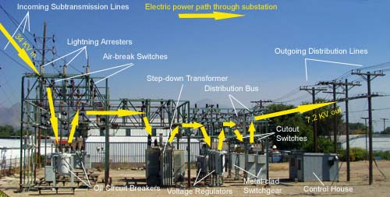
Figure 3: Substation layout pointing out the electric power energy flow
This figure was reprinted with their freedom of information act.
The Mini-Substation Monitoring System required a different variety of components. In Figure 3 above it shows the power energy flow of how the energy flows into and out of a substation. A substation is a place where the electricity flows into and the voltage is either stepped up or stepped down in order to feed power to a house or business or pass it along the rest of the grid. This project has called for a wide range of information to capture the entire scope. Many topics that were included were, software, relays, microcontrollers, chips for the microcontrollers, alarm set up, substation designs, wireless chip transceivers and receivers, panel building, and SCADA components. The group had the general layout and idea of how we wanted to do this project but we all needed to iron out our ideas and make them one. This included talking, emailing, and searching on design specifications, schematics, layouts, diagrams, figures, and information to help us capture the idea of our project as a whole. We believe that research gathers the information needed in order to complete a good design on one of the first designs. Although, many great designs are not great the first time they are put together, good research can bring a good design and prototype or make troubleshooting a little bit easier when you know the components have been studied and cataloged.

4.1.2 Design Methods
One idea of a good design in electrical engineering is one that can work together as a system. A Supervisory Control and Data Acquisition system is a monitoring, alarm, and historic system that works with many components at the same time. Our project has different sections that are self-contained but work together as a whole. The overall idea of this project came from a collection of people including our group members and the help of BCI Technologies. Their overall plan for the Mini-Substation Monitoring System is to have it as a COTS device. The term COTS is equivalent to commercially off the shelf. If the project can be successfully completed then each component can become a stock item and be made into a commercially off the shelf design to be further manufactured. Our design includes a microcontroller and circuitry, relay system, lights, wireless chips, software and user interface. While each of these works together as a team system, each component is separate that we can troubleshoot or test if we need to. Although our entire group is electrical engineering majors we still have our own areas of interest and specialty. This helped us decide what piece of the project was to be completed by which member of the group. Our schematics and layout designs were done on paper and in simulated software.

4.1.3 Project Management
Project management is the study of organizing, planning, and managing certain resources to bring together the completion of a specific objective, goal, or certain project. Project management is a very important aspect not only for work or group projects but in many aspects of life. It is important to be organized and have a plan of objectives in order to complete the task at hand. In order to keep our groups production level at an efficient level we divided the work load between each of the members. To get around the normal schedule conflicts that any team or group would have we used online chats and messaging to discuss what needs to be done and our progress. Our communication between each of our members in our group was done through Windows Live Mesh, emails, other messaging outlets, such as Facebook and AIM, and calling meetings. This would be done in the work place and just about anywhere in order to keep each of the team members on the same page as to what is done and what is needed to be done in order to successfully complete the project at hand.

4.1.4 Interfacing and Testing
To implement our ideas we first set up meetings to plan out how we were going to design, interface, and test our design that we would set out to build. After an agreeable design then we set out for the parts and components needed to build the devices for the mini substation monitoring system. We planned to use a microcontroller with sensors as inputs to capture our load values of voltage, current, and power. After this we sent them wirelessly to our station computer, if values are out of ranges that we set then the breaker or relay will trip causing an alarm, thus saving the system from overloading.
To test our mini substation monitoring system, we are going to use a test load or a variable AC transformer or Variac. A Variac is usually designed for low voltage applications, which is how our system is designed to simulate a power substation. This allows us to turn the voltage up and down to simulate loads. If the load becomes greater than the specified values set up in the alarm, then the relay or breaker will trip therefore testing that our circuit will work as an alarm and safety net breaker for protection of the circuit and its components.
The mini substation monitoring systems will be interfaced with a type of SCADA software. We will be using Control Microsystems, ClearScada as our platform to build our graphics, user interface, and devices in the computer. This user interface will be used to communicate to the mini substation panel wirelessly, showing the values of voltage, current, power, and status of our relay breaker. In our design we would like to be able to remotely open and close the breaker also. We will be communicating wirelessly with a TCP/IP connection or a serial connection inside the panel. This means that the panel itself will be on its own network and have an IP address. If the values of our voltage, current, and power of our load become out of range of our parameters then a status alarm will be set on the screen, also sending out a text message and/or email notifying the situation and status of the relay breaker.

4.2 AC to DC Power Supply
The power supply is one of the most essential pieces of this project. It distributes power to all of the components of the substation monitoring system, such as the microcontroller, energy metering chip and the alarm system. All of these components require a DC power source, which opens up a few options. The simplest option would be to use a battery to power the circuitry; however, the substation monitoring system is something that needs to have constant power without the risk of a battery dying. This opens up the idea of converting an AC source into a DC source. There are many different variations of converting an AC signal into a DC signal depending on the application. In most DC power supplies that use an AC input use a similar process to the one shown in Figure 4: Block Diagram of a Power Supply System. Starting from the left is the transformer, then rectification, smoothing and regulation. All of these steps lead to a clean DC regulated output voltage.
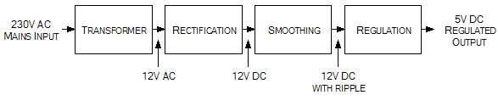
Figure 4: Block Diagram of a Power Supply System
Reprinted with permission from eleinmec.com
Each section in the block diagram contains certain components that do the job stated. Figure 5 below shows the basic components of each section which may vary from design to design.
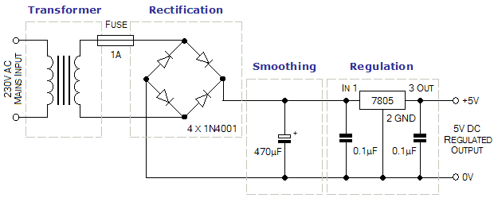
Figure 5: Simple 5V DC Regulated Power Supply System
Reprinted with permission from eleinmec.com

4.2.1 Transformers
Transformers consist of two coils or “windings” and an iron core. There are two common ways that the transformer windings are oriented, the most common being the windings wrapped around separate sides of a magnetically-coupled core as seen in Figure 6. Through mutual induction the alternating current going through the primary coil created a varying magnetic field in the transformer core. This varying magnetic field in the core then creates an alternating current in the secondary winding. Depending on the number of turns the voltage can either be stepped up or stepped down. The transformer in Figure 6 is a step-down transformer which causes the secondary voltage to be smaller than the input voltage without a huge power loss. (2)
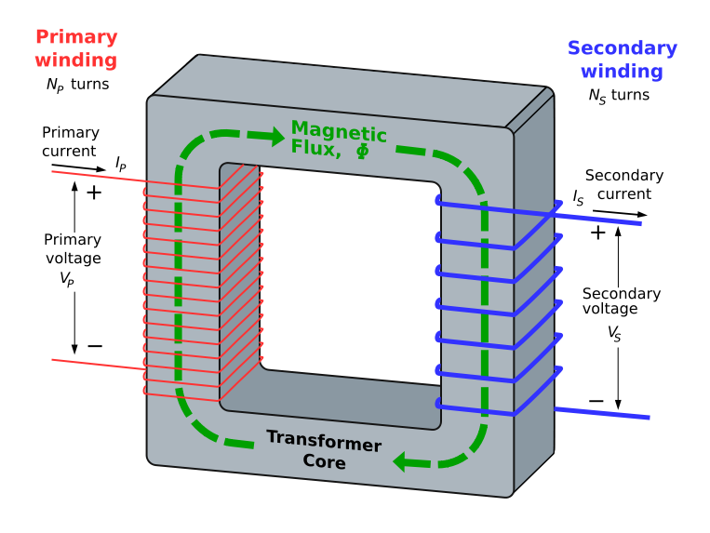
Figure 6: Ideal Step-Down Transformer
Reprinted with permission from Wikipedia (Authors: BillC, Omegatron)

4.2.2 Rectification and Smoothing
A rectifier is a device that converts an alternating current waveform into a direct current waveform. Whether being a full wave or half wave rectifier it uses diodes to manipulate the waveform so that the whole signal has the same polarity. When only one diode is used to rectify AC, a process known as blocking the negative or positive portion of the waveform, there is not that much difference between the term diode and the term rectifier. Almost all rectifiers possess a number of diodes in a specific arrangement for more efficiently converting AC supply to DC supply. Figure 7 below shows a Grantz Bridge Rectifier, which consists of four diodes arranged in a way to guide all the current to the positive terminal not allowing any to flow to the negative terminal.(3)
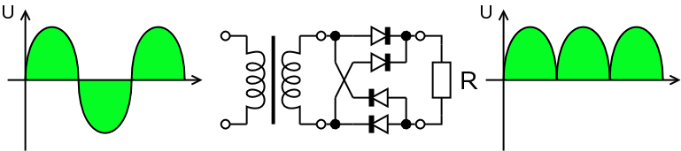
Figure 7: Gratz Bridge Rectifier (Full Wave)
Reprinted with permission from Wikipedia
The rectifier distributes a DC output, but this output does not maintain a constant voltage. Therefore, after the rectification of the signal it then needs to be smoothed out to create a more stable voltage source. The use of capacitors here is essential due to its ability to hold charge. As the voltage increases the capacitor charges up so that when the voltage begins to decrease the capacitor will generally remain the same voltage. However, while the voltage decreases the capacitor will slowly discharge creating a ripple in the DC signal. This smoothing circuit is also sometimes referred to as a filter and is always required in a AC to DC converter. (3)

4.2.3 Voltage Regulating
When a DC source has a ripple voltage that is not wanted the use of a voltage regulator is needed. This regulator is designed to constantly sustain a stable voltage level. There are all sorts of voltage regulators which are designed to handle different current amounts and different voltage amounts. Each regulator has a minimum input voltage which is required for it to be capable of maintaining the constant voltage level. All present voltage regulators function by comparing the output voltage to an inner set reference voltage. In Figure 8 below the pin-out diagram is shown of a basic voltage regulator.(4)
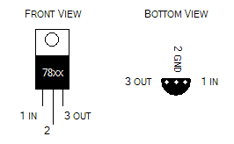
Figure 8: Pin-out diagram of the 78xx series of regulator ICs
Permission requested from eleinmec.com
The most basic voltage regulating circuit consists of a capacitor between the input and ground, a capacitor between the output and ground, and then pin 2 connected directly to ground. A visual layout of this can be seen in Figure 9: Wiring up a regulator IC
Permission requested from eleinmec.com. Variations of this circuit can be implemented depending on the voltage regulator and its application. The same regulator can be used for other types of regulators with different characteristics such as variable voltage output or high current adjustability.
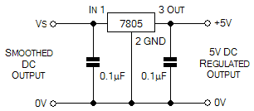
Figure 9: Wiring up a regulator IC
Permission requested from eleinmec.com

4.3 Microcontrollers
Microcontrollers are a very significant component in ones everyday life and are more commonly used than the average person would think. They are found in all modern automobiles to control a variety of different components of a vehicle such as the engine, anti-lock brakes and cruise control. Also, just about any home appliance that has a LCD screen with some sort of keyboard, or uses a remote like a television or VCR. These are just a few of the thousands of electronic devices that are used in everyday living that are controlled by these mini computers.(5)
Microcontrollers are computers, but on a smaller scale then known by the general public. All computers have certain things in common whether it's a desktop computer or a mainframe computer. The central processing unit (CPU) is the main component of any computer which is used to execute programs. Alongside of a CPU is the RAM, or random access memory, which is used to store various variables. The last main feature is the input and output devices which allows communication with a user. Inside the microcontroller are other features that make them very useful for various tasks. Some of these features are timers, a crystal oscillator, serial and analog I/O’s and many more.(5)
Besides being a very complex but simple device there are some other characteristics that separate microcontrollers from other computers. They can be called an embedded controller for the fact that they are inside devices with the ability to control certain features of a product. This can be seen by looking at all the products mentioned above. In no way is the microcontroller advertised being part of the product or even mentioned, but is needed for them to work. Unlike personal computers, microcontrollers are devoted to certain tasks and only able to run one program without being reprogrammed each time. It is possible that it is controlling several things depending on how many I/O pins it has or how much ROM it has, but is limited to that which the designer is aware of. The main reasons that microcontrollers are such a powerful tool are that they are low-power devices, small and low cost. While a desktop computer may use 50 watts of power, a microcontroller being powered by a battery or low voltage may only be using 50mW. On top of the low power consumption they can fit onto small circuit boards and even as small of a place as in a cell phone. And lastly they are very cheap. Basic purpose microcontrollers only run a couple of dollars and when purchased in high quantities the price can be reduced noticeably. These characteristics may be simple, but they are the reason microcontrollers are such an important factor in the electronic world today.(5)

4.3.1 PIC Microcontrollers
PIC microcontrollers are one of the most dominant families of microcontrollers which are produced by Microchip Technology. What is now referred to as PIC's comes from the initial name of "Peripheral Interface Controller". These controllers are based Harvard architecture which separate signal pathways and storage for data and instructions. The popularity of this product comes from several characteristics such as low cost, development tools, broad availability and re-programming with flash memory capabilities. There are three main product families of PIC microcontrollers which include 8-bit, 16-bit and 32-bit microcontrollers. Within these families there are different series produced. Table 2 shows all of the different families along with the series of PIC microcontrollers. (6)
Family | Series
8-bit Microcontrollers | PIC10, PIC12, PIC14, PIC16, PIC17, PIC18
16-bit Microcontrollers | PIC24F, PIC24H
32-bit Microcontrollers | PIC32
16-bit Digital Signal Controllers | dsPIC30, dsPIC33F
Table 2: PIC Families and Series
There are certain features and characteristics that are needed in the microcontroller in order for the monitoring system to operate properly. There are a couple chips in particular that can be used in order to support all the features that will be presented such as the LCD screen and the wireless communication. Examples of PIC microcontrollers can be seen in Figure 10: PIC microcontrollers in DIP and QFN packages
Reprinted with permission from Wikipedia.
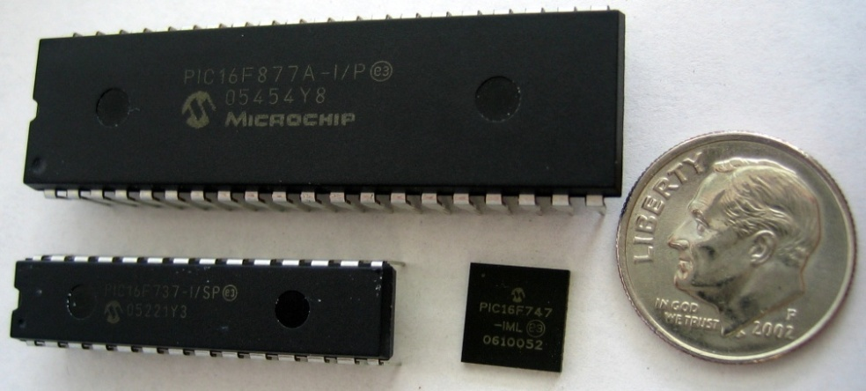
Figure 10: PIC microcontrollers in DIP and QFN packages
Reprinted with permission from Wikipedia (Author: MikeMurphy)

4.3.1.1 PIC18F85J90
This microcontroller has specific features that would assist our project. The feature that separates this controller from others is that it has an integrated driver module, which is able to drive 48 segments and 4 commons for an LCD display. Also included in this chip is an integrated LCD Voltage Boost Regulator. These particularly support the LCD component of this monitoring system. The full specifications of this integrated chip can be seen in Table 3: PIC18F85J90 Specifications.
Parameter Name | Value
Program Memory Type | Flash
Program Memory (KB) | 32
CPU Speed (MIPS) | 10
RAM Bytes | 2,048
Digital Communication Peripherals | 2-A/E/USART, 1-MSSP(SPI/I2C)
Capture/Compare/PWM Peripherals | 2 CCP
Timers | 1 x 8-bit, 3 x 16-bit
ADC | 12 ch, 10-bit
Comparators | 2
Segment LCD (pixels) | 192
Temperature Range (C) | -40 to 85
Operating Voltage Range (V) | 2 to 3.6
Pin Count | 80
Table 3: PIC18F85J90 Specifications
Having such a high pin count may make prototyping and testing difficult. The actual chip is a surface mount chip which is not supported by breadboards. The actual prototype may want to be build using a DIP adapter which will make it easier to make changes to the board without damaging the microcontroller.

4.3.1.2 PIC16F77
This microcontroller is a little more basic than the one described above. The pin count is only 40 so it has a significantly smaller feature set. This may also be an advantage since it is a much more basic microcontroller. It has a synchronous serial pot which can be configured as SPI or Serial Peripheral Interface bus, which will be useful in the transferring of data. The full specifications of this integrated chip can be seen in Table 4: PIC16F77 Specifications.

Parameter Name | Value
Program Memory Type | Flash
Program Memory (KB) | 14
CPU Speed (MIPS) | 5
RAM Bytes | 368
Digital Communication Peripherals | 1-A/E/USART, 1-SSP(SPI/I2C)
Capture/Compare/PWM Peripherals | 2 CCP
Timers | 2 x 8-bit, 1 x 16-bit
ADC | 8 ch, 8-bit
Temperature Range (C) | -40 to 125
Operating Voltage Range (V) | 2 to 5.5
Pin Count | 40
Table 4: PIC16F77 Specifications

4.3.2 ATMEL Microcontrollers
Atmel is another dominant company in producing microcontrollers. The AVR is the basic family of microcontrollers which is uses a modified Harvard architecture. This was also one of the first microcontrollers to use on-chip flash memory that would be used for program storage. This allowed them to be re-programmed instead of using programmable EPROM or EEPROM that can only be programmed once. There are four basic AVR families which include tinyAVR, megaAVR, XMEGA and Application specific AVR. Within these four families are a wide range of specifications that may be suitable for different applications such as LCD displays, UCB controllers or several applications in the automotive industry. An example of an Atmel AVR microcontroller can be seen in Figure 11. (7)
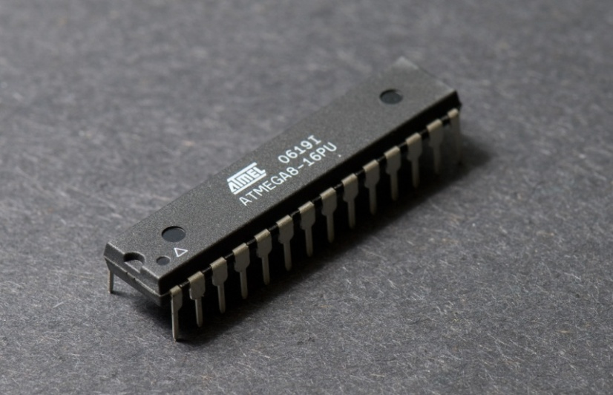
Figure 11: Atmel AVR ATmega8 PDIP
Reprinted with permission from Wikipedia (Author: Pengo)

4.4 Energy Measurement IC's
There are integrated circuits or IC's that are specifically designed for specific applications such as the one implemented in this project. There are different Energy Measurement IC's that can be used to monitor the power activity of the substation. The features of the IC's may vary from one to another, but the overall functionality of them remains the same. The two main families of energy measurement IC's are Microchip and Analog Devices which produce a wide range of chips.

4.4.1 ADE7753
This energy measurement IC is the one that will be incorporated into the monitoring system. There are several features of this chip that simplify the process of analyzing this sort of data. The IC contains two ADC’s that convert the analog signal to a digital signal for proper communication with a computer interface. Also included inside this IC is an onboard digital integrator which enables direct interface with the current sensors. One of the biggest key features is SPI compatible serial interface. This allows a great way of communication between the chip and computer. These components can all be seen in Figure 12 below, which is the functional block diagram for the ADE7753 energy measurement IC.
Figure 12: Functional Block Diagram of ADE7753
Reprinted with permission from Analog.com

4.5 Current Sensors
In order to do power calculation the current is one of the few things that need to be monitored. The ADE7753 Energy Metering IC will be implemented into the design to calculate various data. One of the inputs of the ADE7753 is a current metering from a current sensor. There are several different sensors that could be used to accomplish this task however some have more advantages then others. Accuracy is a key feature that is needed when dealing with energy measurements. Another key feature is low power consumption which is always looked for in practical cases. Figure 13 below shows a comparison between the different types of current sensors.
Figure 13: Current Sensor Comparison
Reprinted with permission from Analog.com

4.5.1 Current Shunt
Current shunts are resisters that have extremely small known resistances. The purpose of having a very small a resistance is so that it will not have a noticeable effect on the circuit being analyzed. Since the resistance value is known, the current can be found by finding the voltage drop across the shunt. The integrator is what will actually create the conversion into a current measurement.
Figure 14: Current Shunt
Reprinted with permission from Analog.com
The small resistance values used is in order to not disturb the circuit. When operating at the full rated current most current shunts are designed to have a voltage drop of 100mV, 75mV, or 50mV. This is also how shunts are rated, by using the maximum current that the shunt can withstand and the voltage drop at that particular current. Something that has to be accounted for is that all shunts have a de-rating factor that comes into play when a shunt is under continuous use which is most commonly 66%. The de-rating factor should be applied after the shunt has been under continuous use of two or more minutes. Along with the continuous use factor there are thermal limits that pertain to whether a shunt operates correctly or not. 80 degrees Celsius is when thermal drift begins to take place, at 120 degrees Celsius the thermal drift becomes more significant and depending on the shunt can cause and error of several percents. Once 140 degrees Celsius is reached then the manganin alloy will become permanently damaged causing the resistance value to drift up or down.(8)
There are two options when it comes to placing the current shunt into the circuit. It can either be placed on the low-side as seen in Figure 15 or the high-side as seen in Figure 16. The low-side is referred to as the return or grounded side of the load and the high-side is referred to as the supply side of the load. Both orientations have different advantages and disadvantages depending on the particular application.(8)
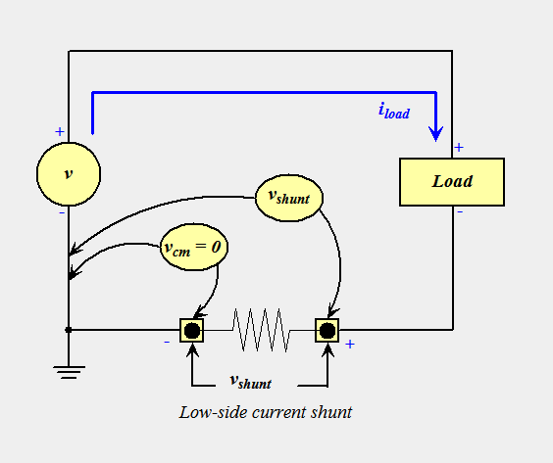
Figure 15: Low-side Current Shunt
Reprinted with permission from Wikipedia (Author: Rwl10257)
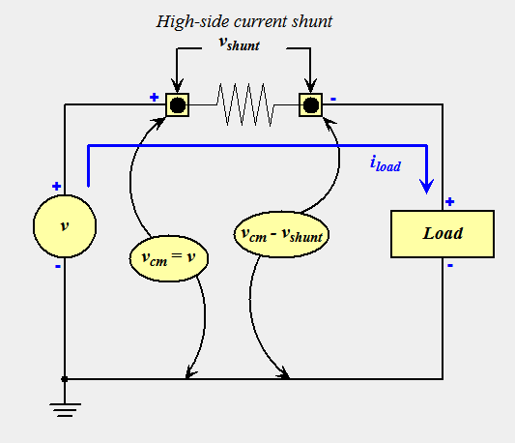
Figure 16: High-side Current Shunt
Reprinted with permission from Wikipedia (Author: Rwl10257)
The low-side current shunt placement is usually recommended in high voltage situations since it eliminates complications from the presence of common mode voltages. Although this is an advantage there are several drawbacks that are associated with the low-side insertion. Issues with control circuitry along with unwanted emissions may become present since the load is separated from the direct path to ground. A load's chassis may contain current leakage to ground which is not measure by the shunt and therefore leads to defective measurements.
The high-side current shunt placement resolves a large amount of the issues presented by the low-side placement. However, there are also several complications in using the high-side placement methods. There are two techniques that are commonly used that have two different reactions. Applying a voltage divider to every input of a differential amplifier, as seen in Figure 17, is the option with the lowest cost, but at the same time is the least desirable selection. The voltage dividers are used to reduce the amount of common mode voltage to within the amplifiers range. Then the difference capacity of the amplifiers is used to extract the shunt voltage regarding the specifications of the common mode amplifiers common mode rejection. Accuracy issues come into effect due to the resistors needing to be more or less perfectly matched. High precision resistors or trim potentiometers can be used to reach the desired tolerances. The low-level and high-level common mode voltages are divided by the same amount; this causes a need for a differential amplifier to supply significant gain. In turn, unwanted noise is produce in the current signal. By adding a divider the source resistance increases, which causes complications with the input resistance of the differential amplifier.(8)
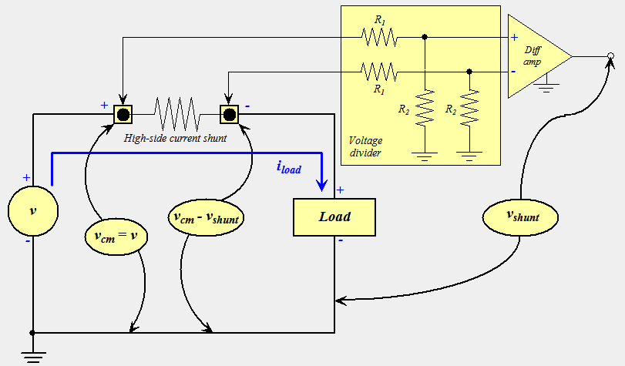
Figure 17: Divider Current Shunt
Reprinted with permission from Wikipedia (Author: Rwl10257)
The better alternative to both high-side and low-side shunt measurements is the isolated amplifier technique shown in Figure 18. The isolated amplifier will rise and fall in response to the magnitude of the applied common mode voltage due to an electrically floating end that allows it to do so. Due to this ability, the input and output ground references are free to be at independent potentials, leaving the breakdown voltage of the isolation barrier to define the common mode voltage magnitude to a tolerated value where voltages in the range of plus minus 1000 V is not unusual. Another downfall of this technique is that the price of these amplifiers with isolation are generally more expensive than others, however time and improvement have cause the prices to come down significantly enough to make them affordable.
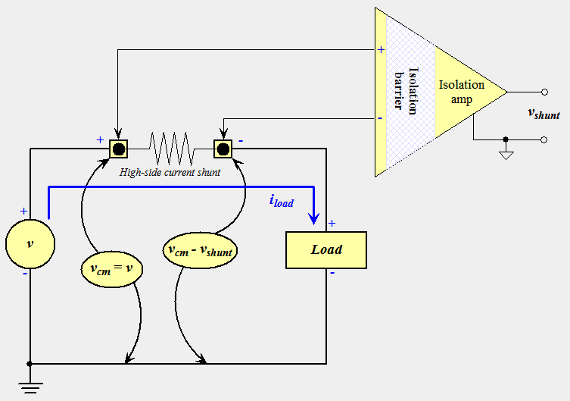
Figure 18: Isolation Current Shunt
Reprinted with permission from Wikipedia (Author: Rwl10257)

4.5.2 Current Transformer
A current transformer is a common way of measuring current. This is the most commonly used current sensor in today's current energy meters. It is extremely useful when dealing with large currents or high voltage in the primary circuit. The current transformer allows the current to be stepped down so it is possible to directly apply measurement devices. This also allows the measurement device to be placed at a distance from the primary circuit keeping it away from what may be high voltages. Current transformers, like any other transformer, contains a primary winding, secondary winding, and a magnetic core.
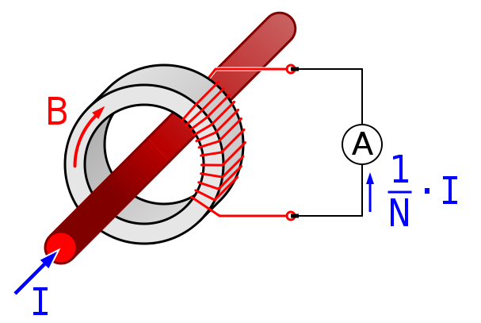
Figure 19: Current Transformer
Reprinted with permission from Wikipedia (Author: Biezl)

4.5.2.1 Rogowski Coil
A Rogowski Coil is a type of current transformer used to measure alternating current or current pulses. This is going to be the current sensing method used in the monitoring system for the advantages it brings. As seen in Figure 13, the Rogowski Coil has a good rating in every aspect that is looked at when deciding what type of sensor to use. It is made up of a wire wrapped up into a toroidal coil with the lead from one end running through the coil so that both leads are at the same end of the coil. The Rogowski coil is then wrapped around the straight wire that the current measurement is desired from. This can be seen There is a induced voltage in the coil that is the derivative of the current in the straight wire. This allows for the Rogowski coil to be connected to an integrator circuit to present an output signal that is proportional to current.(9)
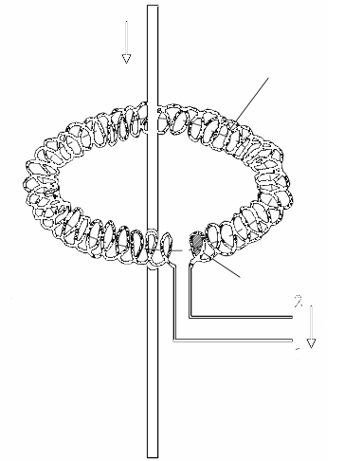
Figure 20: Rogowski Coil
Reprinted with permission from Wikipedia (Author: Fesalz)
The Rogowski coil has some advantages over other current transformer types. One advantage is that it can be produced open-ended allowing it to be flexible so that it can be wrapped around a live wire without disturbing it. This alone proves to be a huge advantage among others. Another big advantage is due to the fact that it does not have an iron core, but rather an air core causing it to have a low inductance and can act in response to fast changing currents. The air core also makes it highly linear even when subjected to large currents.(9)

4.6 Wireless Communication

4.6.1 Wi-Fi
Wi-Fi refers to products that are certified by the Wi-Fi Alliance based on the IEEE standard 802.11. It is similar to a wireless version of a traditional Ethernet network. 802.11 includes a variety of subsets, outlined below.
- 802.11 operates in the 2.4GHz range and was the original IEEE specification with a transfer rate of 1 to 2 Mbps.
- 802.11a is capable of data transmission at 5GHz and a data throughput of 54 Mbps. This standard also uses orthogonal frequency division multiplexing (OFDM).
- 802.11b transmits in the 2.4 GHz frequency band. It can only handle 11 Mbps and is among the slowest and cheapest of all the standard subsets. 802.11b uses a technology known as complementary code keying modulation (CCK). This type of modulation allows for higher data rates along with a decreased susceptibility to interference.
- 802.11g also operates in the 2.4 GHz range but has a data rate maximum of 54 Mbps. It is also compatible with 802.11b.
- 802.11n adds the improvement of multiple input multiple output (MIMO) which is the use of multiple antennas to transmit and receive data. 802.11n operates at the 5 GHz frequency with a throughput of 108 Mbps and a range of up to 300m indoors.
An advantage of Wi-Fi is it general capability to secure a strong connection. A typical home-based router has an effective range of approximately 120 ft indoors to 300 ft outdoors. This technology is generally used to implement Local Area Networks (LANs). Wi-Fi offers the use of Wi-Fi Protected Access (WPA) protection which, if configured correctly is a secure method of protecting data transmissions. This is compared to Wired Equivalent Privacy (WEP), which is used by other wireless devices and offers limited protection due to its vulnerability to hackers. A disadvantage is the high power consumption compared to ZigBee and Bluetooth and it’s significantly larger form factor. Below are examples of a Wi-Fi serial connected transceiver (left) and a Wi-Fi serial server.(10)
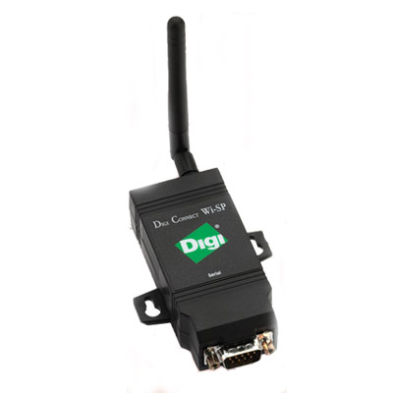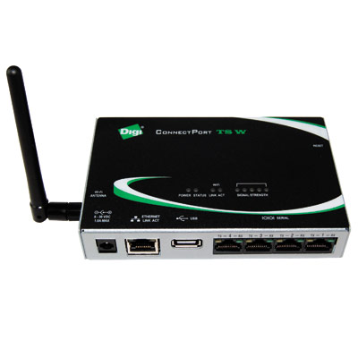
Figure 21: Wi-Fi serial connected transceiver, Wi-Fi serial server
Reprinted with permission from Digi.com

4.6.2 ZigBee
ZigBee is a lost cost, low power, open, global wireless, mesh networking standard. It was developed to satisfy the need for an alternative to Wi-Fi (802.11) for applications requiring a lower data rate. ZigBee follows the 802.15.4 standard, which is an IEEE standard completed in 2003. It offers simple connectivity and the capability to use battery power due to low power consumption. Because of the low power consumption and reliability, ZigBee works well in embedded systems, provided that a high data rate is not a requirement of the system. Mesh networking means that two radio could still communicate even if they were out of range of each other provided that a third radio is located between the two radios and within range of each other. This works because the ZigBee standard has built in message routing so the message is simply received and forwarded by intermediate nodes. The protocol is also self-healing so that if one node goes down, a new route will be determined and the data with continue on towards its destination. ZigBee also handles acknowledgements and retries in the case that data is received in error. A figure displaying an example of a mesh network topology is depicted below.
Figure 22: Mesh Networking Topology
Reprinted with permission from Digi.com
Most ZigBee modules operate in the ISM 2.4 GHz frequency band, which utilizes 5MHz channels although only about 2MHz of the bandwidth is actually utilized. The 802.15.4 standard mandates the use of Direct Sequence Spread Spectrum (DSSS). DSS is a modulation technique wherein the carrier signal occupies the entire bandwidth of the frequency. The method is implemented by multiplying the data signal by a noise signal and then multiplying it again by the same signal a second time at the receiving end to “de-spread” the signal. The advantages of this technique are that it resists jamming and aids with the determination of relative timing between the transmitter and the receiver. Although several RF modules exist to implement the ZigBee standard, we have narrowed our focus down to three for comparison: Aurel’s XTR-ZB1-xLI, Radiocrafts’ RC2300-ZNM, and Digi’s XBee.(10)

4.6.3 Aurel
The XTR-ZB1-xLI by Aurel uses a direct sequence spread spectrum (DSSS) which allows it to operate in heavily congested areas with an available 16 channels. Its module transceiver is equipped with an SMA antenna connector. With its planar inverted F antenna it can transmit in an open space with a range of 70 meters. The XTR-ZB1-xLI connects to a microcontroller through a serial interface and has a data rate of 250 Kbps RF. The size of this unit is relatively small at just 26 x 35 mm. The XTR-ZB1-xLI has an operating temperature range of -40 to +85 C. Below is an example of an Aurel XTR-ZB1-XLI RF module.(11)
- Mesh configuration
- Data Rate 250 Kbps
- Sensitivity -92dBm
- 16 available channels
- AES encryption
- Size of 26 x 35 mm
- Planar Inverted F Antenna (PIFA)
- Open-space range of 70 meters
- Cost of $24 each unit

4.6.4 Radiocrafts
The RC2300-ZNM developed by Radiocrafts is a compact surface mounted module measuring in at 12.7 x 25.4 x 2.5 mm. It offers 16 channels with a channel bandwidth of 25 kHz and a data rate of 250 Kbps. Serial communications are made through either a UART or SPI interface. The module offers EMC shielding as well as an integrated antenna with an indoor range of 10 – 30 meters and an outdoor line-of-sight range of 250 meters. The RC230-ZNM also has an operating temperature range of -40 to +85 C. The following picture shown is the Radiocrafts RC230-ZNM RF modules with accompanying data also shown below.(12)
- Mesh configuration
- Data rate of 19.2 kbps
- Sensitivity -95 dBm
- Supply voltage 2.8 - 5.5
- Current consumption RX 10.5 mA
- Current consumption TX 25 mA
- Size 12.7 X 25.4 X 3.5 mm
Figure 23: Radiocrafts RC10XX module
Reprinted with permission from Radiocrafts

4.6.5 XBee
The XBee device has a 50mW power output, an industrial temperature rating of -40C to +85C and is approved for use in the United States, Canada, Europe, and Australia. Included are 128-bit AES encryption and a data rate of 250 kbps. There are three options available as far as the antenna is concerned for the XBee RF module. The first option is a chip integrated antenna. This option provides about 470 feet of line-of-sight transmission distance on the standard XBee and approximately 1690 feet on the XBee-Pro. The PCB chip antenna does not have any problems transmitting through a plastic enclosure. The second antenna option is the Whip antenna which is a small antenna built into the module. This increases the line of sight range to 845 feet on the standard XBee and 4382 on the XBee-Pro. As with the integrated chip antenna it can be fully enclosed in a plastic box, but does not provide the same range if a metal enclosure is used. With a metal enclosure, the manufacturer suggests using the U.FL antenna connector with a dipole antenna. This provides approximately the same range as the whip antenna without the attenuation problems associated the metal enclosure. The pictures below show three different example of the XBee with the various antenna configurations. http://www.digi.com/products/wireless/zigbee-mesh/
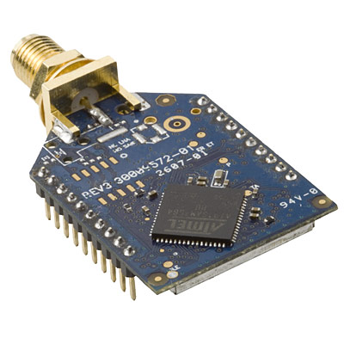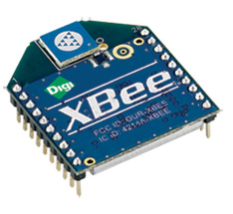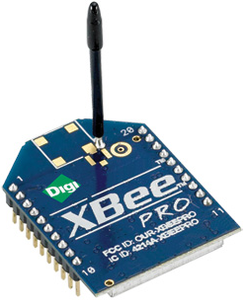
Figure 24: XBee module – U.FL antenna connector, PCB antenna, and whip antenna
Reprinted with permission from digi.com

4.6.6 GSM / GPRS
A General Packet Radio Service (GPRS) modem is a Global System for Mobile Communications (GSM) modem that uses packet switching compared to GSM’s circuit-switched technology, which allows for a higher data throughput. A GPRS modem such as the MultiTech Systems MultiModem GPRS (shown below) provides wireless data communication while providing a variety of interface options such as Ethernet, USB, and RS232. The MultiModem incorporates MNP 2 error correction and an SMA antenna connector. A photograph of the MultiTech MultiModem is show below with some features of the unit.(13)
Features:
- Quad-band architecture operating at 850/900/1800/1900 MHz
- Packet-switched data rate up to 85.6Kbps
- Circuit-switched data rate up to 14.4 Kbps
- Embedded TCP/IP stack
- SMA antenna connector and SIM socket
- MNP2 error correction, V.42bis compression
- Form factor size 4.3”L x 2.4”W X 0.94”H
- Operation voltage of 5V to 32V DC
- Cost of $169.00
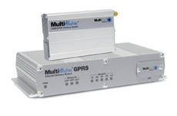
Figure 25: MultiTech MultiModem
Reprinted with permission from MultiTech Systems
The main advantage of a GPRS / GSM modem is its extended range of up to several kilometers compared to the other wireless options. Therefore wireless communications can be made directly to the user interface without the need to come within a certain range in order to obtain the measured data from the monitor. Therefore this unit could be implemented in an alternate version of the Substation Monitor however there would be a significant cost increase to the consumer as well as service subscription cost for the wireless access.

4.6.7 Bluetooth
Bluetooth is a wireless protocol communication technology based on low power, short-range wireless communications operating under the IEEE 802.15.1 standard. This technology is inexpensive and the form-factor is relatively small. The technology consists of a baseband, a RF transceiver, and a protocol stack. Bluetooth works in fixed and mobile devices with omnidirectional signal output, operating in the 2.4 GHz short-range radio frequency bandwidth. Bluetooth is capable of transmission rates up to 3Mbits/s. It is generally used in the implementation of Personal Area Networks (PANs). Synchronization is not an issue with Bluetooth as it can connect several devices. The following chart lists the power classes and their respective ranges.(11)
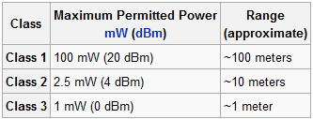
Table 5: Bluetooth Power Classes and Range
Below is an example of a Bluetooth 18 pin transceiver.
Figure 26: Bluetooth 18 Pin Transceiver
Reprinted with permission from Multi-Tech
The following is a table which summarizes some of the key differences between Wi-Fi, ZigBee, GSM/GPRS, and Bluetooth.
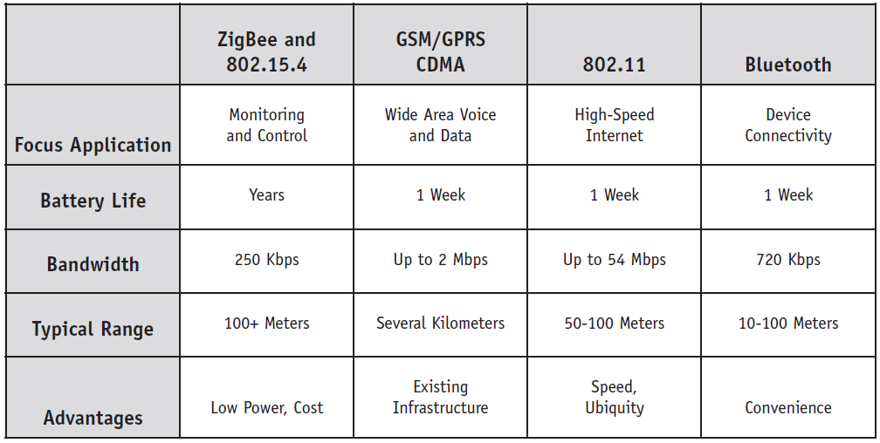
Figure 27: Wireless Comparison Table
Reprinted with permission from Digi.com
In conclusion, ZigBee offers a much better battery life while maintaining adequate range. However, 802.11 and Bluetooth offer a greater throughput.

4.7 Relay/ Breaker
A relay is made of a wire coil and usually has two sets of contacts. The coil has two pins connected to it while the contacts could have a lot more pins associated with it. A magnetic field is created when current is passing through the coil through the two pins. The magnetic field attracts the metal contacts and switches them from one contact to another. The contact pin is common to both sides. When the coil is off, the side that connects to the contact is called normally closed (NC). The side that connects to the contact when it is on is called normally open (NO). If a component has to be off but only should be on when the relay is switched, that component should be connected to normally open side of the relay. In the original form, the switch is operated by an electromagnet to open or close one or many sets of contacts. A relay can be considered as an electrical amplifier as it is able to control an output circuit of higher power than the input circuit. A simple relay in a car shown in Figure 28 below is an adaptation of an electromagnet. It consists of a coil of wire surrounding a soft iron core, which provides a low reluctance path for magnetic flux, a moveable iron armature, and a set of contacts. (14)
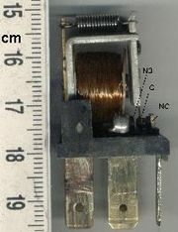
Figure 28 Automotive Style Miniature Relay
Reprinted with permission from Wikipedia (Author: Sonett72)
Different Types of relays found in market today: Latching relay, Reed relay, Mercury – Wetted relay, Polarized relay, Machine tool relay, Contactor relay, Solid – State relay, Solid state Contactor relay, Buchholz relay, Forced – guided contacts relay, Overload protection relay.

4.7.1 Electromechanical Relay
One of the Relay we came across is the electromechanical relay when its coil is energized; a magnetic field is induced which in turns move the armature which opens and closes the contacts as seen Figure 29: Electromechanical Relay. They can be used for a wide range of applications from low voltage and current to high voltage and current. One problem with that relay is its lack of switching speed and their short lifetime. The contacts are also larger therefore would require larger space. The advantage of those large contacts is their ability to withstand unexpected surge currents, yet its speed may be too slow for our applications.
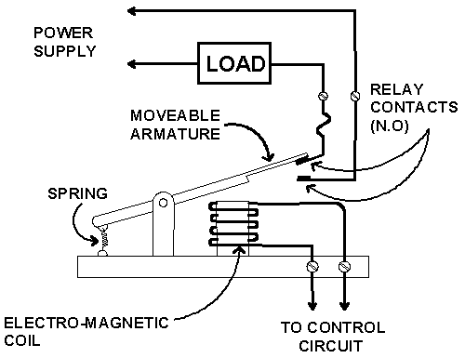
Figure 29: Electromechanical Relay
One of the electromechanical relay that we have researched is named GHI from global components, its dimensions of 11*11.5 makes it ideal for PCB mounting
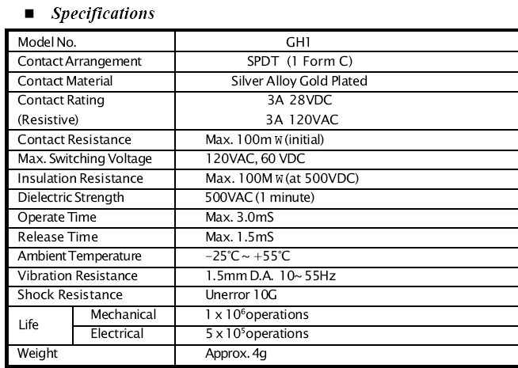
Table 6: GHI Electro-Mechanical Relay
Reprinted with permission from Global Components

4.7.2 Reed Relay
The next relay we have researched is the reed relay. The contacts on the relay are much smaller than the electromechanical relay. The relay is made of coils wrapped around reed switches composing of two overlapped blades sealed within a glass capsule which is filled of an inert gas. When the coil is energized, the switches come together in a way where their contacts complete a path through the relay as seen in Figure 30.
A reed relay is much smaller than the electromechanical type, an example is seen in Figure 31 because of its size it can switch much faster approximately ten times faster and it lasts longer. Because of its size the disadvantage is damage from arcing. When the switch is closed there is a chance that an arc can jump and burn the contacts rendering the relay inoperable. Their thermal electromagnetic force may cause noise which will in turn cause errors in measurements.
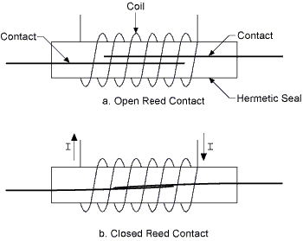
Figure 30 Reed Relay Contacts
Emailed for permission to eleinmec.com
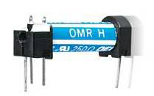
Figure 31 Reed Relay
Emailed for permission to eleinmec.com

4.7.2 Rail Mounted Relay (4PDT DIN)
Another type of relay that we researched was the 4PDT DIN Rail Mounted relay seen in Figure 32, this relay is used for applications of vending machine, cooking appliances, office machine, domestic appliances, control equipment and so on. This relay comes in different versions from 1 pole with 15 amps switching current to 4 poles with 10 amps switching current. It comes with printed circuit board terminal, solder lug terminal and flanged case which are designed for panel mounting use. Another advantage of this relay is its low coil power consumption with high response time, its high reliability and a better life expectancy with better vibration and shock resistance. Also upon the customer request, this relay can also be equipped with a touch button and a LED light. The characteristics of this relay are very similar to the RW-SS-112D and it is shown in the Table 7 below. This relay weights more than 3 times of the RW-SS-112D relay and also cost about four times more. The Mount relay was meant for bigger applications.(15)
Model | Maximum current | Maximum voltage | Max Apparent power | Min Switching load
1 P | 15 A | 250V AC  110 VDC | 1700 VA  360 W | 10 mA  DC 10V
2P, 3P, 4P | 10 A | 240V AC  110 VDC | 1100 VA  240 W | 10 mA  DC 10V
Model | Contact Resistance | Temperature range | Humidity range | Contact material
1P-4P | 100 mΩ | -25 to 55ºC | 45- 85 % RH | Ag Alloy
Model | Coil temp rise | Life expectancy | Dielectric strength | weight
 | 60ºC | Mechanical: 10⁷ ops at no load condition  Electrical: 10⁵ ops at rated resistive load | Between coil & contact: 1500 VAC at 50/60 Hz for 1 mn  Between contacts: 1000VAC at 50/60 HZ per mn | 35 g for 1-2P  50g for 3P  60g for 4P
Table 7: Relay Specifications (15)
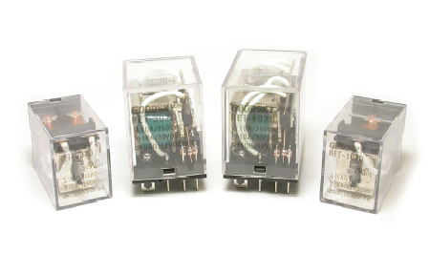
Figure 32: Rail mounted relay
Reprinted with permission from Goodsky

4.7.3 RW-SS-112D Relay
We found different types of relay we could use to switch the appliance on and off. One last specific relay seen in figure 4.2.11o is RW-SS-112D manufactured by an Australian company named Goodsky. Depending on what type of circuit you want to switch on and off, you can use the RW-SS-112D or RW-SS-124D. These relays can switch a maximum of 5 A at 240 VAC, a maximum of 10A at 120 VAC and a maximum of 10A at 24 VDC. The specification table is seen in table 4.2.11p. (16)
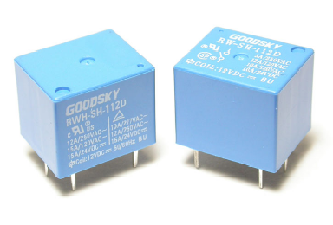
Figure 33: RW-SS-112D
Reprinted with permission from Goodsky

Model | Maximum current | Maximum voltage | Max Apparent power | Min Switching load
RW series | 10 A | 240V AC  110 VDC | 1500 VA  240 W | 10 mA  DC 5V
RWH series | 15 A | 240V AC  110 VDC | 1800 VA  360 W | 15 mA  DC 5V
Model | Contact Capacity | Temperature range | Humidity range | Contact material
RW series | 10 A at 120 VAC, 10 A at 24 VDC | -30 to 55ºC | 45- 85 % RH | Ag Alloy
RWH series | 12 A at 250 VAC, 15 A at 24 VDC | -30 to 55ºC | 45- 85 % RH | AgSn0₂
Model | Coil temp rise | Life expectancy | Dielectric strength | weight
RW series | 35ºC | Mechanical : 10⁷operations at no load condition  Electrical: 10⁵ ops at rated resistive load | Between coil & contact: 1000 VAC at 50/60 Hz for 1 mn  Between contacts: 500VAC at 50/60 HZ per mn | 11 g
RWH series | 35ºC | Mechanical : 10⁷operations at no load condition  Electrical: 10⁵ ops at rated resistive load | Between coil & contact: 1000 VAC at 50/60 Hz for 1 mn  Between contacts: 500VAC at 50/60 HZ per mn | 11 g
Table 8: Specifications of RW-SS-112D (16)
The RW-SS-112D relay is practical because of its size. Its measurement 19.5mm x 15.4mm x 15.4mm seen in Figure 34 makes it very attractive for our project. Also it has complete protective construction against dust and soldering flux, this component is very popular for applications like Domestic appliances, office machines, audio equipment, coffee-Pots, Control units and so forth. When used for electrical purpose, this relay can switch a device on and off a maximum of 30 operations per minute. However when used mechanically, it can operate a maximum of 300 operations per minute. The following figures show respectively how to wire a load to a relay contact. Below is a figure to wire a load to a relay contact using normally closed contact Figure 35. Below is a figure to wire a load to a relay’s contact using normally open contact Figure 36.(16)
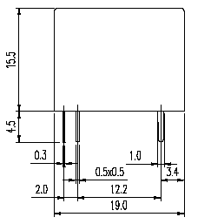
Figure 34: Relay Measurement
Reprinted with permission from Goodsky
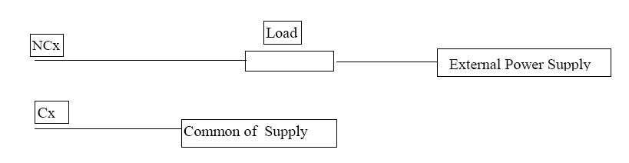
Figure 35: Relay Connection
Reprinted with permission from Goodsky
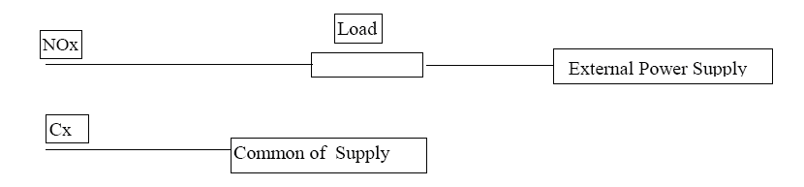
Figure 36: Relay connection
Reprinted with permission from Goodsky

4.7.4 Solid State Relay
The other relay is the SSR short for Solid State Relay, it is much faster than the reed relay, and it is made of photo-sensitive mosfet with a led to actuate the contacts is seen in Figure 37. The switching time is LED dependent, it has no mechanical parts and it has a longer lifetime than the reed relay. The SSR is mostly used for high voltage applications. Much like the reed and the electromechanical relays, it is prone to damage from surge currents and damages when used beyond their ratings. Given below in Table 9 is the specification for SSR relay.
Figure 37 Solid State Relay
Reprinted with permission from www.ni.com

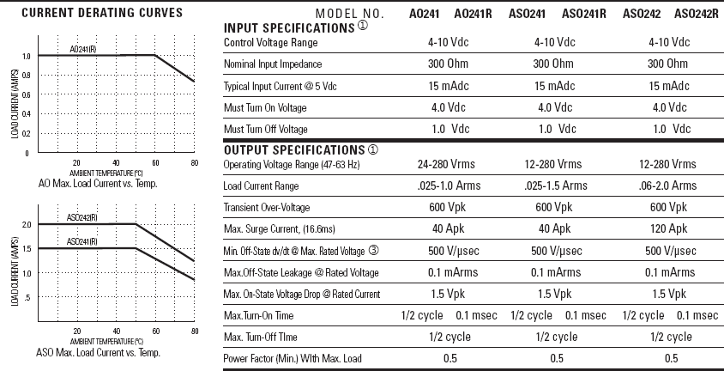
Table 9: Specification for SSR relay
Reprinted with permission from Digikey

4.7.5 Field Effect Transistor Relay
The next relay is the FET Relay short for field effect transistor; it uses several CMOS transistors to do its switching, no mechanical component. The difference between the SSR and the FET is the control circuit drives the gates of the transistors instead of using LED to do the switching as seen in Figure 38. So the time it took the LED between power on and power off is not an issue here therefore allows the FET to switch much faster than the SSR. They come also in very small sizes convenient for our project. A disadvantage is that it lacks a physical isolation barrier again that’s not an issue we will use for low voltage signals. One such relay that we found is the CMOS8RF ideal for RF applications like the Bluetooth we are designing also applicable for handsets and GPS systems.
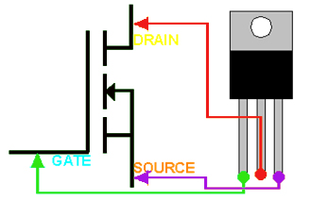
Figure 38 N Type FET
Re-printed with permission From BCAE
A solid state relay also called SSR for short name is a semiconductor device that can be utilized instead of a mechanical relay to switch power to a load in different applications. SSR are pure electronic, usually made of a low current control side with a high current load side. The low current control side would be the coil of an electromechanical relay and the high current load would be contact of a conventional relay. Solid state relay usually have electrical isolation to some thousands of volts between the control and load sides. Since there is isolation, the load side of the SSR is powered by the switched line. In order for that relay to operate, a line voltage and a load should be present. Figure 39 shows a typical triac based solid state relay diagram. The SSR has optical coupling to a photodiode array that ties driver circuitry which provides an interface to devices at the output. The diagram shown in Figure 8 has a built in series RC snubber network which main job is to protect the triac from line voltage surges. The snubber shields the triac from small to medium surges. A triac based solid state relay is a SCR which can work in both current directions: from cathode to anode and anode to cathode. An SCR is a quadruple layer diode made with three terminals: the cathode, the anode and the gate. Unless a pulse of about 5-50 mA is fed to the gate, it is not conducted from anode to cathode. The moment the gate is fed with pulses, it turns on and drives from anode to cathode until the current going through it decreases to a certain level. After it turned on by a gate pulse, it will turn off until current stops going through it. Small triacs ship into packages and may handle about 500 mA to 1.5 A. SCR types of triac come TO-220 packages and can handle about 4 to 8 A. They also have very large SCR which can handle hundred or maybe thousands of amps. They can work from a range of 100 V to 1500V. Semiconductor relays are not very complex as we can see from the diagram and they are not made from rare components. However they are still very expensive and although its simplicity could drive the idea of building your own circuit, it is not considered the safest way to switch circuit. Table 10 below shows the general and mechanical specifications for SSR.
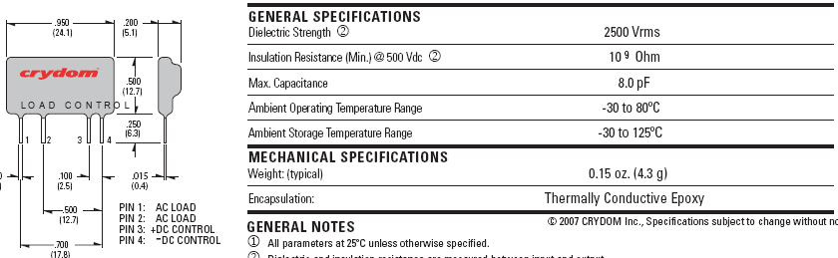
Table 10: General & Mechanical Specifications for SSR
Reprinted with permission from BCAE
Advantages of using the SSR are following: The advantages of using SSR are that there is no inductor on control side. There is no arching in contacts. There are no mechanical moving parts. It has a long operating life. There is high resistance to shock and vibration. There is high switching speed, and no arching or sparking. There are no inductors on the control side. There are no contact materials to wear out infrequent use of the device. It has high reliability. There is no acoustical noise.
.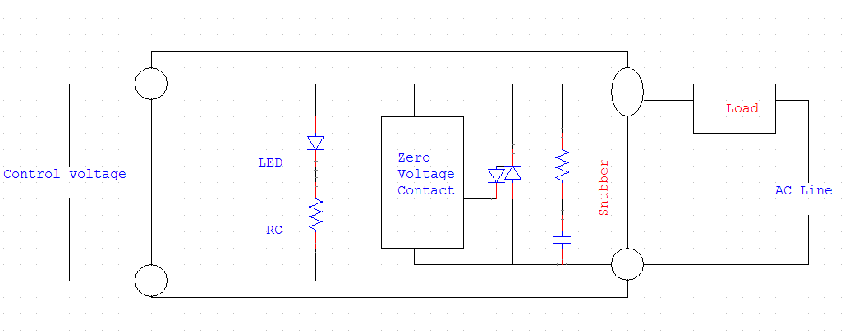
Figure 39 Triac Based SSR
Disadvantages of using the SSR are following: It is more expensive than normal relays. When on off-state, output has some leakage. Has only one pole, normally open (NO). Output can be damaged easily by overvoltages. It also has a larger output capacitance than normal relay (20 pF). Failure mode is output short circuit. SSR relay heats up significantly when big current passes through it. The triac inside the semiconductor relay can act like a rectifier and turns in a pulsating DC to the load if it’s not driven properly. It is more susceptible to voltage transients. It is larger on-resistance than normal relays. They mostly work with AC current only.
When working with triacs it’s very important to be particularly meticulous. We make circuit board in order for the traces to maintain enough current capacity for load. PCB traces must have enough separation between them to endure big voltages. Correct size fuse must be installed in the circuit in order for the triac to have any protection. The components must be able to withstand the voltages they control in the circuit. If we are facing a 230V operation, at least a 400V triac must be used. Also the capacitor that connects the semiconductor relay main’s circuit must be a capacitor that is rated for this kind of applications. Coil type that can handle the total load current without overheating or saturating must be used all the time. Triacs are really a very compelling way to control AC power loads with high duty cycle. Whenever using a triac, we don’t have to worry about the contact sticking, bounce and wear and tear associated with normal electromechanical relays. Figure 40 below use a triac as a basic static switch. That circuit allows random fast turn on for the AC loads. As soon as the switch closed, a significant control current will activate the triac to conduct. From that point, the triac will drive the current to the subsequent zero crossing of mains voltage. The way this thing designed, even a small switch can control large currents. Only the small control current needed to trigger the triac will actually be handled by the switch. The circuit is designed to work very easily with resistive loads. In case somebody swapped this switch with any remotely control trigger, the circuit will therefore be made into a semiconductor relay. (17)
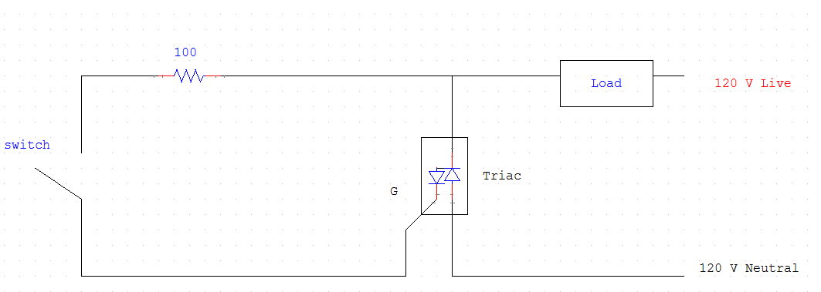
Figure 40 Triac use as a basic static switch
The resistor is there in the designed circuit to avoid gate current peaks. This resistor should not be bigger than the ratio of the peak supply voltage and the peak gate current rating of the actual triac. The value of that resistor must be bigger than result obtained by the formula R = ((sqrt(2) * V_{rms}) / (I_{gtm})) - (R_{load} + R_{switch}). V_{rms} would be the input voltage of the circuit which ranges typically from 120V to 230 V. I_{gtm} is the peak of the gate current permitted for a triac. R_{load} is the resistance of the load related to the circuit and R_{switch} is the resistance of the actual switching device. We should know also that if the resistor is made too high, the triac will possibly not trigger at the beginning of each cycle. Every application must have its proper triac. One main characteristic is that it should be able to withstand the peak voltage present in the mains voltage. For instance if we have a 230 V AC, the peak voltage should be expected to be around 325 V. Therefore we should leave some extra capacity by selecting a triac of about
400 V. However, in case we might have some inductive loads, we should go even higher by selecting a 600 V model triac. Remember triac has to be able to sustain the maximum continuous current flowing through the circuit. If we want to make our circuit as safe as possible and very reliable, we need to use a triac that has double the current capacity in the circuit designed. Some triacs that would work fine for our project are the TIC246M that can handle up to 5A loads and another one is the TIC263 that can handle up to 10 A loads. Also in selection of our triac, we understand we should select one that has a trigger current specification that suits our control circuit. If the control circuit does not offer enough circuit to activate the triac well, then the circuit will not function at all or it will not be reliable. Even though the semiconductor relay was very tempting to use, one disadvantage of this relay is the fact that they can be easily damaged by over current or overvoltage and that if using these types of relays, we must have extra protection against spikes and inductive kicks. Also these types of relays are more expensive than the electromechanical relays and less safe.

4.7.6 Bosch Relay
Relays are very useful, in some cases a transistor will do but there are several shortfalls to that. First relays can switch both AC and DC, high voltages, currents less than 5A, switch many contacts at once. The transistor is much faster at switching, uses less power, but can only switch DC signal. The fastest relay is the reed relay but it cannot handle high currents. Most relays can be PCB mounted even soldering directly to the pins providing care is taken. There are several types of relays, for our project we must consider the best one; for example the size and pin arrangement, the coil voltage is important for us an ideal one would be 5V or 12 V supply, the coil resistance which we can find using supply voltage/ coil current, and last is the relay switch ratings. Bosch relay can do just that. Below is the specification for Bosch Relay Table 11: Bosh Relay Specification
Printed with permission from BCAE. It is mostly used in the automotive industry, the 12 VDC and the 24 VDC made their ways in several applications like automatic sliding doors, electric lawn mowers, garage door drives, conveyor belts, robot controls and so on. We came over a relay named the Bosch Relay which enlightens us quite a bit. For the switch to work there must be potential between pin 85 and 86 (Figure 41).
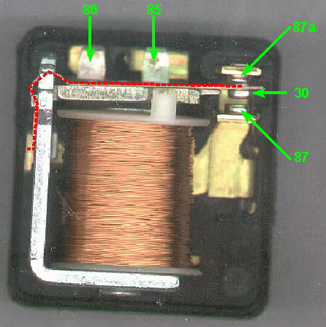
Figure 41 Bosch relay
Re-printed with permission From BCAE
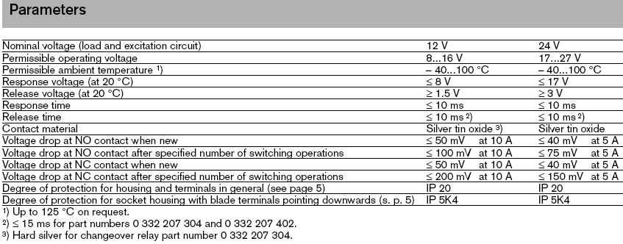
Table 11: Bosh Relay Specification
Printed with permission from BCAE

4.8 Liquid Crystal Display (LCD)
We use items containing an LCD every day like in our laptop computers, digital clocks and watches, microwave ovens, and many other electronic devices. LCD’s are common because they offer some real advantages over other display technologies. The LCD for the most part is portable and takes less space. They rely on a technology that is not harmful to the user. The LCD uses Liquid that has an interesting property when current goes through it. The liquid that is in the LCD are in the solid and liquid state at the same time. The current that goes in makes them take a direction and lit up red, blue or green. These basic three colors are the basis of any picture; they combine in defined manner to create a good picture. The only bad thing about a LCD is the viewing range. If the user is placed at a certain location across the LCD the screen will not be visible, this has been improved in other type of LCD, and they are called OLED (Organize Light Emitting Diode), since they are expensive we won’t cover them in our project.
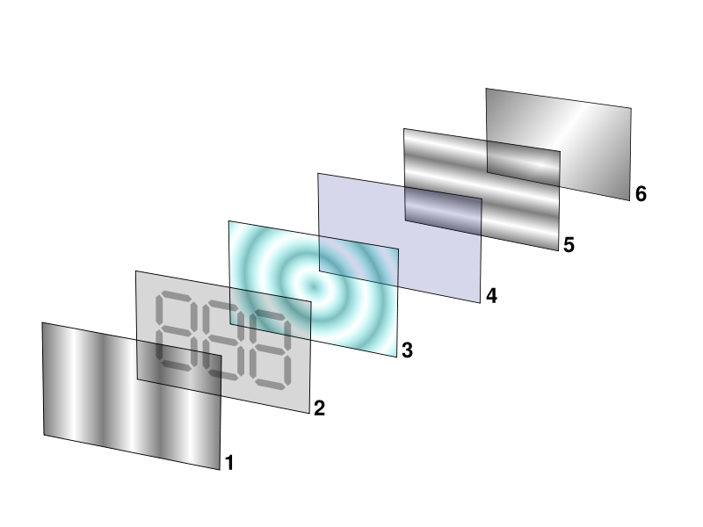
Figure 42: Reflective Twisted nematic liquid crystal display
Reprinted with permission from Wikipedia
The Figure 42 lets us see the internal working of an LCD. Layer 1 is polarizing filter film with a vertical axis to polarize light as it enters. Layer 2 is a glass substrate with ITO electrodes. The shapes of these electrodes will determine the shapes that will appear when the LCD is turned ON. Vertical ridges etched on the surface are smooth. Layer 3 is twisted nematic liquid crystal. Layer 4 is a glass substrate with common electrode film with horizontal ridges to line up with the horizontal filter. Layer 5 is a polarizing filter film with a horizontal axis to block/pass light. Layer 6 is a reflective surface to send light back to viewer. (18)

4.8.1 CFA632YFBKS LCD (16*2)
One of the LCD that we have been researching is the CFA632YFBKS LCD. We can see that in Figure 43 and Figure 44. It is a 16*2 RoHS Compliant, Yellow/Green LED Backlight, and FSTN Positive LCD. The LCD material is FSTN (Film compensated Super Twisted Nematic) instead of STN. FSTN gives better contrast, faster response and makes an all-around more readable display. The display has the ability to store a customized boot screen of the design in its EEPROM. All features of the display are controlled: characters displayed. The good feature of this LCD is it is uses User-definable characters, it has backlight setting, contrast setting, cursor position, cursor style, "wrap" setting, "scroll" setting, and even the scrolling marquee. The PCB silkscreen has an abbreviated jumper setting table, so all the jumper settings are always in easy reference. The Character generator ROM is an enhanced version with many more useful characters: numeric superscripts, icons, mathematical symbols, some fractions, and a great variety of arrows, many currency symbols, and more. The processor’s reset circuit has been improved to handle a wider range of slow-turn-on power supply conditions. This LCD also provides us with a simple RS-232 hookup. The overall dimension of this LCD is shown in Table 12. This particular LCD has large font display. The general Specification of the LCD is given in the Table 13 below. It has an adjustable LED backlighting, which consumes low power. It has gapless horizontal bar graphs. This particular LCD costs about $35-$40.(19)
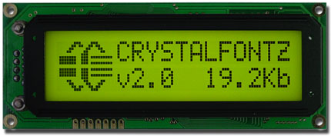
Figure 43: Front of CFA632YFBKS,
Reprinted with permission from Crystalfontz
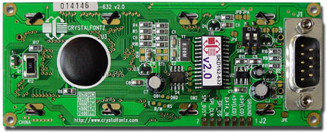
Figure 44: Back of CFA632YFBKS,
Reprinted with permission from Crystalfontz
Table 12: Mechanical Characteristics,
Reprinted with permission from Crystalfontz
Table 13: Genreal Specification,
Reprinted with permission from Crystalfontz

4.8.1.1 CFA632YFBKS LCD specifications:
When handling this unit care should be taken as electrostatic discharge may damage the unit. The module is really fragile and cannot take more than it supposed to. Some of the precautions when handling this LCD module are avoid applying excessive shocks to the module or making any alterations or modifications to it, not to make extra holes on the printed circuit board, modify its shape or change the components of LCD module, and soldering only to the I/O terminals. The LCD works with 5 volts. The LCD can work in a maximum of 50 degree Celsius and 0 degree Celsius. The RS232 power and signal Connections to a personal computer is shown in the Table 14 below. The Jumper location and function for RS-232 which is going to help us connect our LCD to a PC is Shown in Figure 46, which is shown below. The interface description of the LCD is shown in Figure 45.
Table 14: RS-232 Power and signal connection,
Reprinted with permission from Crystalfontz
Figure 45: Interface description for CFA632YFBKS,
Reprinted with permission from Crystalfontz
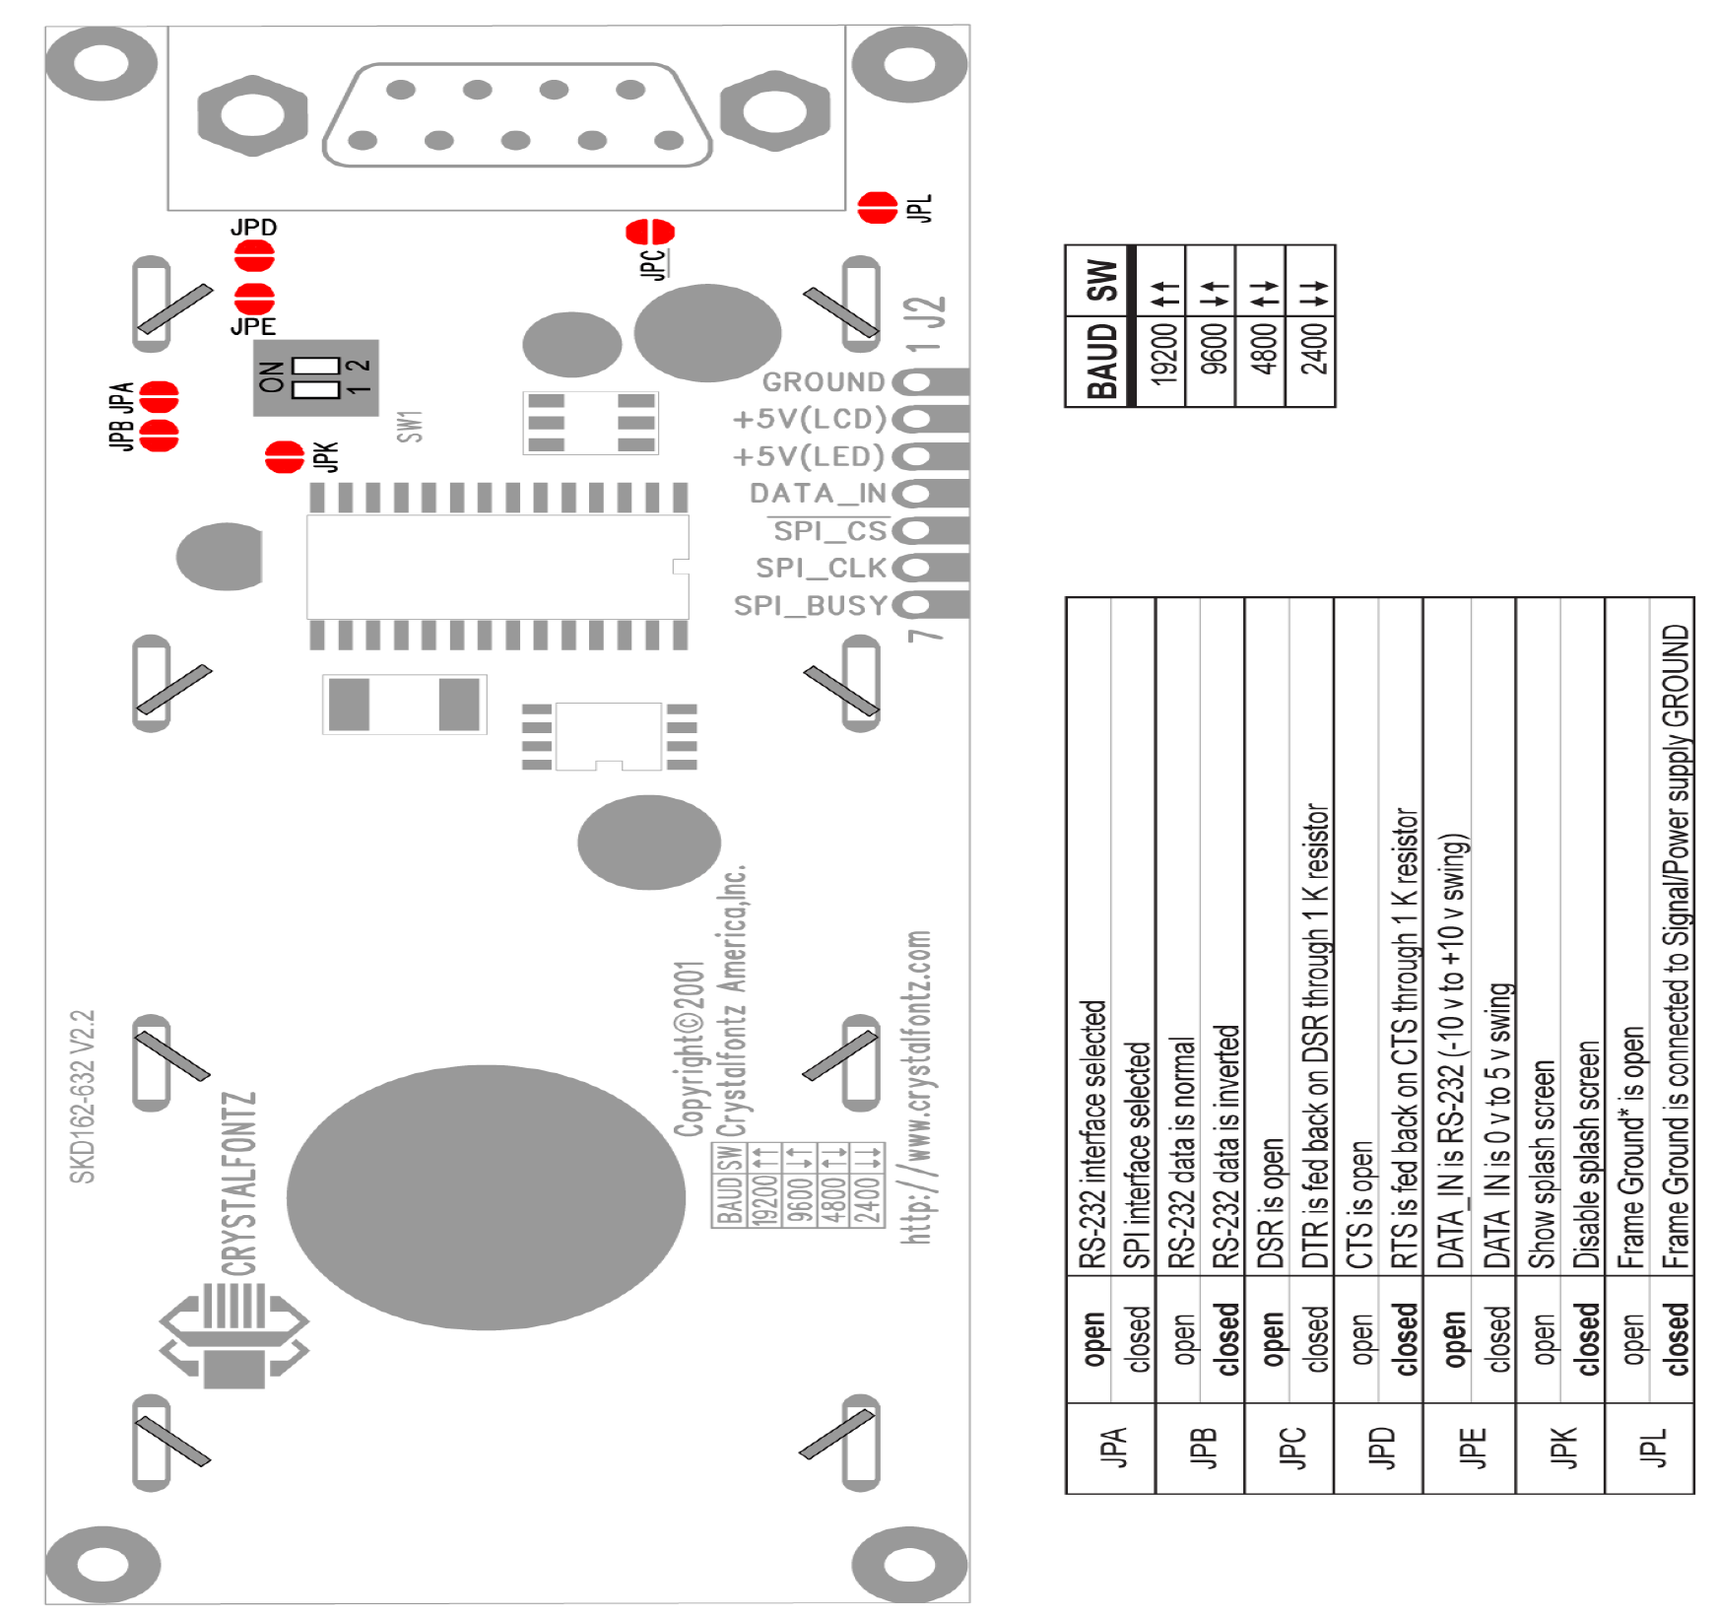
Figure 46: Jumper location and function for RS-232,
Reprinted with permission from Crystalfontz

4.8.2 CFA634NFAKS LCD (24*4)
The other LCD screen that we researched was the CFA634NFAKS which is also provided by Crystal Fontz LCD’s shown in Figure 47 and Figure 48. It is a CFA-634 Serial LCD. This LCD is made with FSTN (Film compensated Super Twisted Nematic) instead of STN. FSTN gives better contrast, faster response and makes an all-around more readable display. The display has the ability to store a customized boot screen of the design in its EEPROM. All features of the display are controlled: characters displayed. The good feature of this LCD is it is uses User-definable characters, it has backlight setting, contrast setting, cursor position, cursor style, "wrap" setting, "scroll" setting, and even the scrolling marquee. The PCB silkscreen has an abbreviated jumper setting table, so all the jumper settings are always in easy reference. The Character generator ROM is an enhanced version with many more useful characters: numeric superscripts, icons, mathematical symbols, some fractions, and a great variety of arrows, many currency symbols, and more. The processor’s reset circuit has been improved to handle a wider range of slow-turn-on power supply conditions. This LCD also provides us with a simple RS-232 hookup. The overall dimension of this LCD is shown in Table 15. This particular LCD has large font display. The general Specification of the LCD is given in the Table 16Table 13 below. It has gapless horizontal bar graphs. This particular LCD costs about $40-$45.(20)
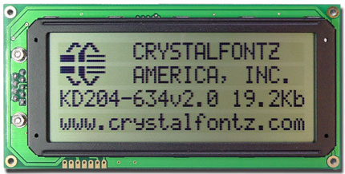
Figure 47: Front of CFA632YFBKS,
Reprinted with permission from Crystalfontz
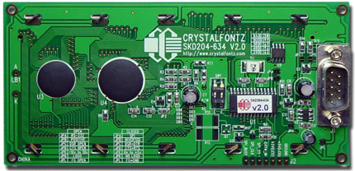
Figure 48: BACK of CFA632YFBKS,
Reprinted with permission from Crystalfontz
Table 15: Mechanical Characterisitcs,
Reprinted with permission from Crystalfontz
Table 16: Genreal Specification,
Reprinted with permission from Crystalfontz

4.8.2.1 CFA634NFAKS LCD specifications:
When handling this unit care should be taken as electrostatic discharge may damage the unit. The module is really fragile and cannot take more than it supposed to. Some of the precautions when handling this LCD module are avoid applying excessive shocks to the module or making any alterations or modifications to it, not to make extra holes on the printed circuit board, modify its shape or change the components of LCD module, and soldering only to the I/O terminals. The LCD works with 5 volts. The LCD can work in a maximum of 50 degree Celsius and 0 degree Celsius. The RS232 power and signal Connections to a personal computer is same as to CFA632YFBKS shown in the Table 14 above. The Jumper location and function for RS-232 for CFA634NFAKS is same to as CFA632YFBKS which is going to help us connect our LCD to a PC is shown in Figure 46 which is shown above. The interface description of the LCD is shown in Figure 45 above.

4.8.3 CFAX12864CP1WGHTS LCD
In our project LCD will have a big impact, due to the fact that the LCD will be displaying important data that will be transformed into useful data to the user point of view. Since graphics will be needed the GLCD (Graphics LCD) from Crystal front is our choice for the project. The part number is CFAX12864CP1WGHTS; the picture of the part that we will be using is above Figure 49. This module also contains a touch screen. This LCD component has three different parts, the actual LCD, the Driver, the Touch screen device, and the Backlight connectors. The LCD runs on 5volts however for the background light AC is needed, therefore another device will used so that backlight can be provided. The device that will used is called a current inverter it, with that device if a potentiometer is placed in order to control the current the contrast of the background can be adjusted dynamically. The touch screen part has a four wire zip connector. Each of these connector are place at the bottom, top, left side, right side of screen so that they can pick up the exact location where a user is touching.
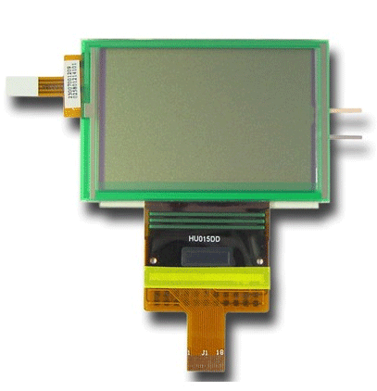
Figure 49: Crystalfontz LCD panel
Reprinted with permission from Crystalfontz
Table 17: Contour Drawing and Block Diagram
Reprinted with permission from Crystalfontz
Pin No. | Symbol | I/O | Description
1 | VCC | - | Power supply pin for logic
2 | GND | - | Ground pin, connected to 0V
3 | CS1B | I | Chip select input pins, Data/instruction i/o is enabled only when CS1Bis”L”and CS2”H”. When chip select is non-active, DB0 TO DB7 may be high impedance.
4 | CS2 | I | Chip select input pins. Data/instruction i/o is enabled only when CS1Bis”L”and CS2”H”.  When chip select is non-active,DB0 TO DB7 may be high impedance.
5 | RES | I | Reset input pin. When RESETB is “L”, initialization is executed.
6 | RS | I | Register select input pin. -RS = “H”:DB0 to DB7 are display data  -RS = “L” :DB0 to DB7 are control data
7 | R/W | I | When connected to 80-family MPU:  Write enable clock input pin. The data ON DB0~DB7 are latched at the  rising edge of the /WR signal.  When connected to 68-family MPU: RW = ”H”: read, RW = “L”: write
8 | E | I | When connected to 80-family MPU:  Read enable clock input pin. When /RD is “L”, DB0~DB7 are in an  output status  When connected to 68-family MPU:  RW = ”H”: When E is “H”, DB0~DB7 are in an output status  RW = “L”: The data on DB0~DB7 are latched at the falling edge of the E signal
9-16 | DB0~DB7 | I/O | 8-bit bi-directional data bus that is connected to the standard 8-bit  Microprocessor data bus.  When the serial interface selected(PS=”L”)  DB0~DB5: high impedance  DB6: serial input clock (SCLK)  DB7: serial input data (SID)  When chip select is not active, DB0~DB7 may be high impedance.
17 | MI | I | Microprocessor interface selects pin.  MI=”H”: 6800-series MPU interface  MI=”L”: 8080-series MPU interface
18 | PS | I | Parallel/Serial data input select pin.  Interface Data Read/Write Serial clock  PS=”H”: Parallel DB0~DB7 E_RD,RW_WR -  PS=”L”: Serial SID(DB7) Write only SCLK(DB6)  In serial mode, it is impossible to read data from the on-chip RAM. And, DB0 to DB5 are high impedance and E_RD and RW_WR must be fixed to either “H” or “L”.
Table 18: Interface description for CFAX12864CP1WGHTS LCD

4.8.3.1 CFAX12864CP1WGHTS LCD specifications
When using a LCD screen several precautions are to be remembered. The module is really fragile and cannot take more than it supposed to. Some of the precautions when handling this LCD module are avoid applying excessive shocks to the module or making any alterations or modifications to it, not to make extra holes on the printed circuit board, modify its shape or change the components of LCD module, and soldering only to the I/O terminals. The LCD works with 5 volts and 3.3 volts, and the electrical characteristics is shown in the Table 21below. The LCD can work in a maximum of 70 degree Celsius and -20 degree Celsius as seen on Table 20 below. The general specification for the LCD screen we will be using has been listed in the Table 19 below. The Optical Characteristics of the LCD that we will be using is in the Table 22 below
Table 19: General Specification for CFAX12864CP1WGHTS
Reprinted with permission from Crystalfontz

Table 20: Absolute Maximum Rating
Reprinted with permission from Crystalfontz
Table 21: Electrical Characteristics For LCD
Reprinted with permission from Crystalfontz.
Table 22: Optical Characteristics of LCD
Reprinted with permission from Crystalfontz
Table 23: Backlight Information for LCD
Reprinted with permission from Crystalfontz
Touch Panel Style: | Analog Resistance
Dimension Specifications:
 | Dimension Outline | 63.5mm ±0.3mm x 41.5mm ±0.3mm
 | Viewable Area | 56.70mm x 35.00mm
 | Active area | 54.40mm x 32.40mm
 | PET thickness | Max. 200 μm
 | Glass Thickness | 1.1mm
Dot Spacer Specifications:
 | Diameter: | 0.05mm ±0.01 mm
 | Height: | 5 um ~ 10 um
 | Pitch: | 3 mm
 | Pattern: | Rhombus
 | Operative Force: | <=40g
Surface Hardness PET: | >=3H
Transparency | Non-Glare Panel | >=70%, Wave Length at 450 ~ 700mm
Table 24: Touch Screen information

4.8.4 Interfacing LCD with Hitachi 44780 controller
One of the the most common type of LCD controller is HITACHI 44780 which provides a simple interface between the controller & an LCD. These LCD's are very simple to interface with the controller as well as are cost effective. The LCD requires 3 control lines (RS, R/W & EN) & 8 (or 4) data lines. The number on data lines depends on the mode of operation. If operated in 8-bit mode then 8 data lines + 3 control lines i.e. total 11 lines are required. And if operated in 4-bit mode then 4 data lines + 3 control lines i.e. 7 lines are required. How do we decide which mode to use? It’s simple if we have sufficient data lines you can go for 8 bit mode & if there is a time constrain i.e. display should be faster then we have to use 8-bit mode because basically 4-bit mode takes twice as more time as compared to 8-bit mode. Figure 50 gives us a basic over view of how the LCD is going to be connected to the microcontroller.(21)
Pin | Symbol | Function
1 | Vss | Ground
2 | Vdd | Supply Voltage
3 | Vo | Contrast Setting
4 | RS | Register Select
5 | R/W | Read/Write Select
6 | En | Chip Enable Signal
7-14 | DB0-DB7 | Data Lines
15 | A/Vee | Ground For the Backlight
16 | K | Vcc for backlight
Table 25: A 2*16 line LCD display pin numbers, symbol and function
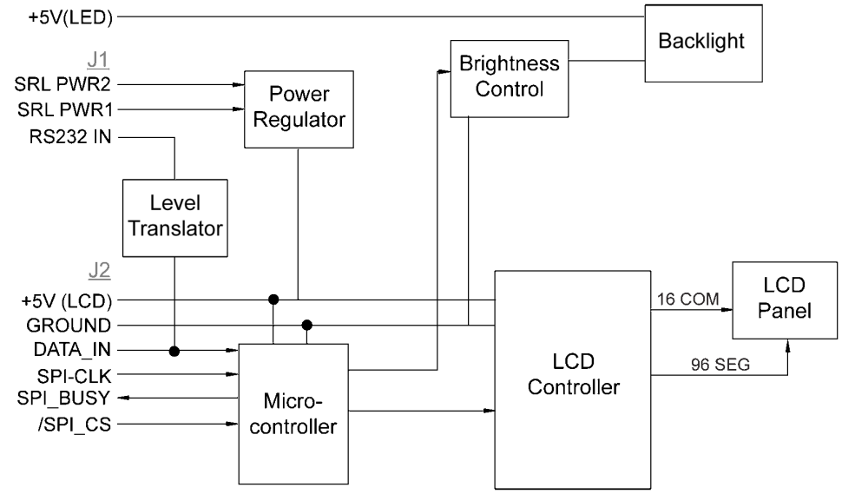
Figure 50: 8051 microcontroller connected to 2*16 LCD
When RS is low (0), the data is to be treated as a command. When RS is high (1), the data being sent is considered as text data which should be displayed on the screen. When R/W is low (0), the information on the data bus is being written to the LCD. When RW is high (1), the program is effectively reading from the LCD. Most of the times there is no need to read from the LCD so this line can directly be connected to Gnd thus saving one controller line.
The ENABLE pin is used to latch the data present on the data pins. A HIGH - LOW signal is required to latch the data. The LCD interprets and executes our command at the instant the EN line is brought low. If you never bring EN low, your instruction will never be executed. Display Data Ram (DDRAM) stores the display data. So when we have to display a character on LCD we basically write it into DDRAM. Table 26 gives us the description of the instructions we are going to be using and these instructions are discussed below.
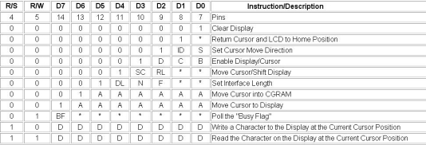
Table 26: Instruction Description

4.9 Programming

4.9.1 Assembly
Assembly language is a low-level language for programming computers. It implements a symbolic representation of the numeric machine codes and other constants needed to program a particular CPU architecture. An assembly language is thus specific to certain physical or virtual computer architecture (as opposed to most high-level languages, which are usually portable). Assembly is a language that is lower than C, which means that it is closer to the machine language. In other words, assembly is a low-level language created in order to program computers. The machine language is binary, in order to make the machine language understandable to human, assembly represents the binary by symbol, thus making assembly a symbolic representation of the binary codes and other constants required for a particular CPU architecture. The symbolic representation is often defined by the hardware manufacturer. For instance Intel and Motorola have different semantics and rule in the way to write assembly code for their hardware. The way they go about it is to represent the instructions by abbreviations called mnemonics that help the programmer remember them. In conclusion assembly language is specific to certain physical computer architecture. Assembly is therefore different from higher level language such as C and C++. for this project we could use assembly to program the microcontrollers, however, there are several microcontroller program software that will let us write code in C and then compile that code into hex or binary so that we can load it into the microcontroller. The only advantage that assembly has on C is speed. In assembly codes are really compact and not self explanatory as C or any high level programming language. As stated in our previous paragraph we will choose C as the programming language for our project. Assembly may be used in extreme case of performance needs.

4.9.2 C/C++ Programming
C is a programming language developed in 1972 by Dennis Ritchie at Bell Telephones laboratories for use with the UNIX operating system. Although C was designed for writing architecturally independent system software, it is also widely used for developing application software. C is still the first or second most popular language in terms of number of developer positions or publicly available code. Advantage of C offers comparing to its predecessor is language construct that map efficiently to machine instructions. C programmer could program with English sentences and make the code more understandable than old previous machine language. C was written to be portable to any other system even though it was tight up with low level mechanism. With all those advantages the language became available on very wide range of platforms. From embedded microcontrollers to supercomputers. C programming language will be used in this project for the microcontrollers, instead of using assembly to program our chips.

4.10 SCADA
In today’s world there are lots of issues in how to manage, control and monitor energy usage and consumption. In order to stay ahead of the game many companies today have to keep up with the competition, keep customer satisfaction, and keep the customer coming back. The market is always changing with new technology and requirements. These companies must be flexible in how they react and must act quickly. In today’s market of energy and power there are solutions out there to do this. Many companies already use software to help accurately control and monitor their systems or they are in the process of converting older system to new up to date monitoring software.
A monitoring system that is used for controlling and gathering data usually in an industrial setting has come to be known as SCADA. SCADA is used in many industries. Broken down, this is Supervisory Control and Data Acquisition. The term SCADA describes the entire system as a whole. A SCADA system is made up of many components that communicate together in order to monitor and control particular pieces of equipment or a type of station. The system might contain components such as: a graphical user interface (GUI) which would run on the main supervisory computer and allow a user to control the system remotely, this is also called HMI (human machine interface), a network of sensors or relays for inputs and outputs of the information that is being monitored, and communications and software to monitor, keep track, and trend data that is being monitored. Each of these types of software does require some sort of license agreement. These licenses keep a count of how many objects or points you are going to monitor and cost accordingly.
There are many types of SCADA systems in today’s technological world. Such examples could be in the power industry, water and waste water industry, communication, manufacturing, distribution, auto making and automation. Our project focuses mainly on the power industry in which a SCADA system may be designed to control a substation or a power plant. Inside these plants the SCADA system would provide an easy to use interface between human and machine. While these systems collect data, monitor progress using sophisticated charts and wizards, and notify the proper people when alarm conditions can occur, they also many control and safety features to prevent human errors and mistakes. In order to keep things safe and secure, certain parameters are set to allow access or deny access of certain functions, controls, and validations of the systems operations. As you can see there is a wide variety of uses for this type of software in today’s society.(22)

4.11 Software and User Interface

4.11.1 Citect
Citect is one of the leading companies in the industrial automation business. Their software has many benefits and uses including but not limited to, maximizing productivity, reducing costs in maintenance and production, integrating with custom business solutions, and improving end user product quality. This is done with their graphical representations of devices and processes, advanced event management, advanced analysis tools to analyze the trend and historical data, from the built in historian. It can be expanded to meet the industries changing needs through the easy to use user interface. This software also allows for process control and real time actions. Citect is very customizable, flexible and easy to scale to any size project as you can see in Figure 51
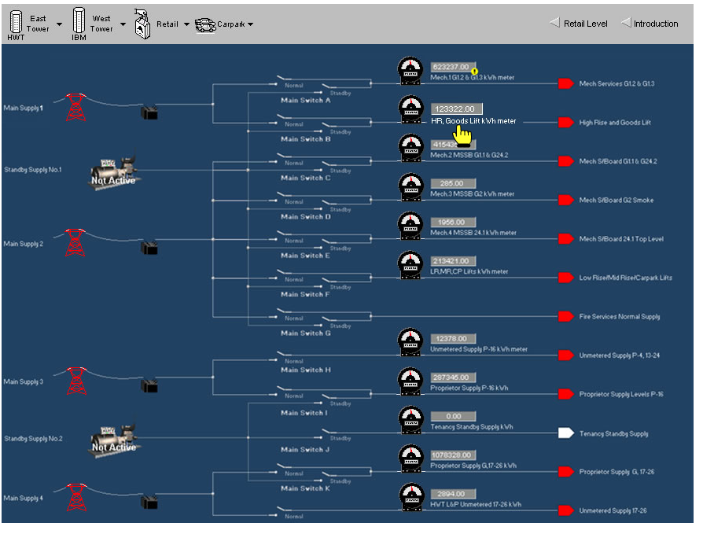
Figure 51: Screenshot of Citect graphics builer monitoring
main feeder lines running to a city business square
Reprinted with permission from citect.com
There are many ways to set, configure, and run Citect. One of the main ways Citect is connected to the communication world and the system that it is designed for is serial RS-232, wirelessly networked, by Ethernet and fiber optic. Many projects in today’s industrial market work with modbus and DNP3. Below in Figure 52 is an example of all three of these cases in a single communication network architecture. The figure shows that the interconnects for where the operations and servers are located is by Ethernet, then out to the communication ports by serial RS-232 to wireless. Once the information is passed wirelessly to the substations or plants they communicate by fiber optic. Fiber optic communication lines are becoming more popular in today’s industrial communication because it can pass lots of data at a very fast rate of speed.(23)
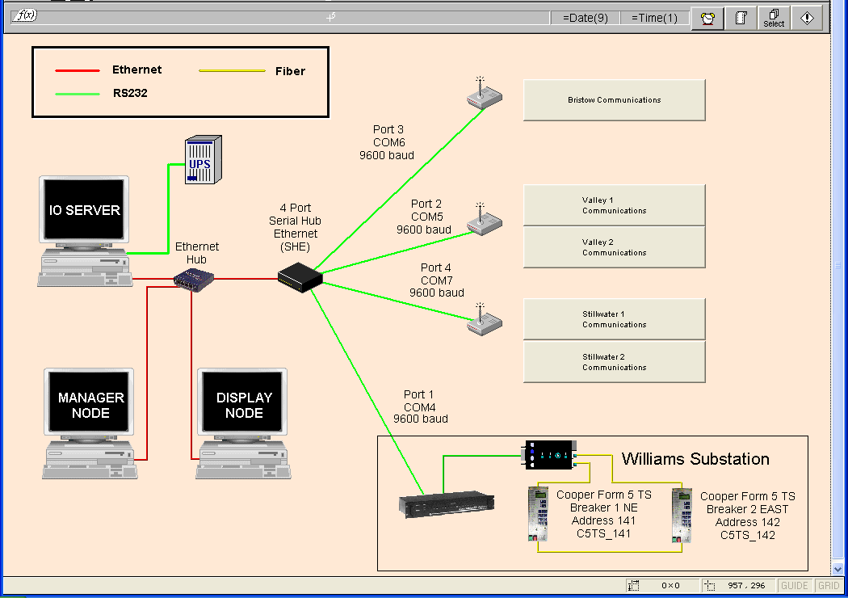
Figure 52: Collection of different communications in on diagram
Permission requested from www.citect.com
Another one of the ways Citect runs and can be configured is through on e of their own software languages. The language most used in Citect is Cicode which is their version the programming language for the software and Citect VBA, which is similar to visual basic. Both of these languages are a compilation of many software languages which could be good to use in our project and make programming easier. Using these programming languages, their graphical genies, super genies, names, tags, and pop up windows you can create a library of components that will link objects together and further enhance your user interface. They also include some templates and tutorials to help get started. Citect also has a variety of point licenses to purchase. The smallest being a 75 point license. This means you can monitor 75 different data points until you must upgrade your systems license. The 75 point license costs $1500 while the largest of an unlimited count point license costs a mere $14200. Both of these have upgrade prices in support if needed for specific project errors and troubleshooting. Each of the objects in Figure 53 below that are being monitored such as a value for pressure or temperarature of a unit or device would be considered data points.
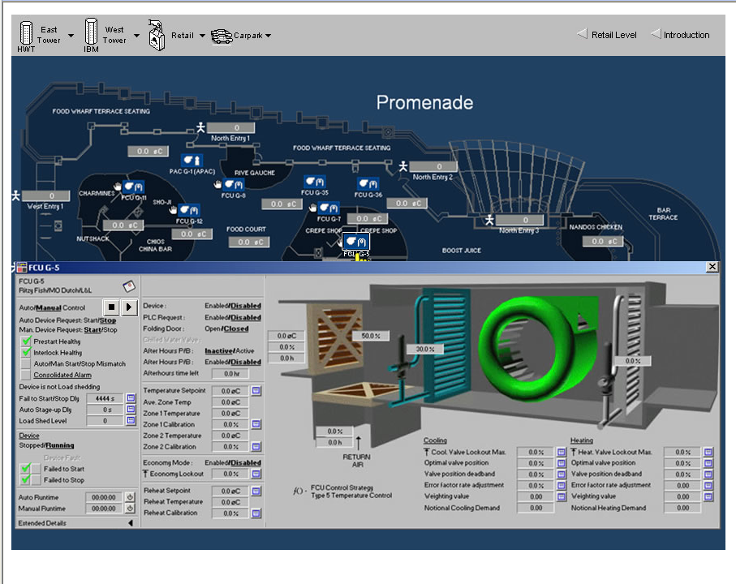
Figure 53: How citect can be used to control and monitor
Reprinted with permission requested from citect.com
Although there are many helpful articles and a wide range knowledgebase for any configuring and troubleshooting that may need to be done, there are also some done falls of Citect. It seems that Citect is a very specific language and data base oriented program. These downfalls could be that although Citect is scalable and very customizable, its main setup entails lots of data basing. In every case object you would like to set up, there is a different tag, name, location, trend, and alarm, to be configured separately for that single object. Each piece needs to be linked together manually with its alarm and trend point. If something was to change with a specific tag, then everything attached to that tag would have to be changed or a new tag and extras would have to be specified. This would mean set up and troubleshooting changes could be very involved and can be very lengthy. Also with each object point you create it takes away from your license agreement in this case you would need more points. There is also a much needed level of understanding with data bases and Cicode programming. The Citect SCADA software is a great application and is very detailed and thorough in its objective however a better alternative may suite us.(1)

4.11.2 Prodigy
Prodigy’s human and machine interface and SCADA for industrial automation is not as well known here in the United States but is still available. This is because they are located in the United Kingdom. Although Prodigy is used around the world, and in many United States companies, it seems their main focused market is in Europe. Their “complete industrial automation solutions” has a wide range of applications. Prodigy’s distributed control system and SCADA/human machine interface options are very versatile because they are developed for the plant floor, where the equipment is located, and to connect to the head supervisor and management level devices. Just the same as many SCADA systems, Prodigy can easily be scaled to any size necessary to complete the specific tasks of the industrial automation world. A screenshot of a process monitoring in their software is in Figure 54 below. A project may consist of just a few data point in a single piece of equipment and human machine interface or be thousands of data points connecting an entire distributed control system.
Figure 54: Screenshot of Prodigy Controls and process monitoring
Prodigy’s software is useful and can be very satisfying because it was designed around the needs of today’s customers and industrial automation industry. The design of the software is not as complicated as most and can be configured and customized to meet exact specifications of a wide range of projects. From the release date, Prodigy has been a very useful 32 bit application, not a 16 bit like some of the older technology that can have limited resources and slower performance. One interesting feature that Prodigy has mentioned over some competitors is that it can be run as a background Windows service, which would allow the system to run on startup without having an operator logged in.
Prodigy is not as well known as some of the other bigger competitors in the industrial market. While the product software may be just as good, the Prodigy software is a build to suite software. This means that it can be customized in just about any configuration for any application and your own needs. Like other SCADA software on the market you can get as many data points, tags, and facilities as needed for your entire system. This allows you to start your system with a smaller amount of tags and data points then add on additional tags as needed. See Figure 55 below for an example of Prodigy software running a water plant.
Figure 55: Prodigy software running a water plant
Permission requested
The software is also not a dongle based SCADA system so any upgrades or additional tags can be emailed or put on the web to be added to the configuration. Prodigy’s basic startup package and license start off at £499 or $733.13 (converted from British Pounds in March 2009 XE.com online conversion) with limited resources of the general display, real time trending, and database configurations. The highest package license goes for £7800 or $11449.49 (converted from British Pounds in March 2009 using XE.com online conversion) which includes just about all their features they offer. All of their packages have different add on options available. Prodigy’s human and machine interface SCADA software is not going to be a choice of ours for this application. Although it is nice that you can add on options that are project specific, other more current software already come with these features installed.(24)

4.11.3 Siemens Energy
Siemens Energy department is another leading company in the data monitoring industry. The figure to the right was used with permission of Siemens Energy. They are a well known supplier of different energy management and automation solutions. Some of these solutions are provided in power generation, transmission of power, distribution providers, system operators, single energy, multiple energy, and industrial power consumer industries. To ensure success of their product they have had more than 1800 installed control systems, according to the Siemens Energy website. They have many software options available. Some of these software solutions in the control and energy fields include Spectrum Power 3, Spectrum PowerCC Distribution Management, Spectrum PowerCC Generation Management, Spectrum PowerCC Energy Control, Spectrum Power TG SCADA, and the Spectrum Power Common Model Management System. All of these software solutions benefits, similar to other SCADA solutions, include cost reduction, production cost reduced, and productivity more efficient or optimized to the max.
Some features and benefits included in the Spectrum PowerCC Energy Control are the reliability of the software, the “easy to use” interface of the system, and the similar look and feel of a Microsoft program. Also included in their easy to use interface is a 32 layer WinCC graphics designer for drawing vector oriented designs as in Figure 56. One of the best aspects of the technical specifications of the Energy Control software is how easy their Microsoft look-a-like is to use. Along with their alarm processing for the changing conditions, data acquisition of real time components, and management of the peak loads, they have designed their interface to be controlled with manned and unmanned control centers.(25)
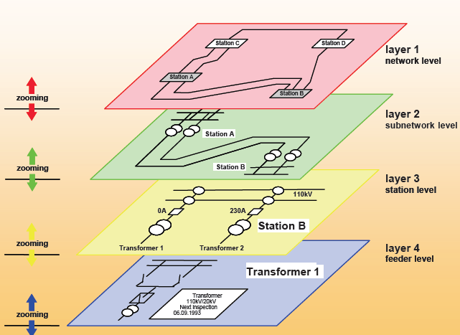
Figure 56: Illustration of Siemens 32 layer graphis designer with vector oriented graphics
Used with permission of Siemens Energy
As such a reliable monitoring system, it also has a utility built in for power flow control and optimization functions to optimize the system to keep it out of peak load conditions, which intern will help in energy purchasing and further reducing costs. Some key factors on this product are how easily it is to upgrade the system to keep up with the constantly changing data entries and maintenance. This PowerCC Energy Control uses standard communication protocols between RTU and system including IEC 60870-5-101, CDC II, and DNP 3.0 and modbus, which is what we would like to have. The layout of communication architecture used at Siemens can be seen in Figure 57 below.
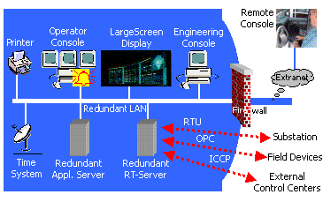
Figure 57: Layout of Communication Architecture used at Siemens
Used with the permission of Siemens Energy
This type of communication is a standard in today’s substation and energy equipment monitoring. The software also has many compatibles with active x controls, com and dcom, xml, sql, and opc types. To access the data stored you can export to excel or other spreadsheet application. The Siemens SCADA has a built in source database builder to define, relate, and manage different databases. There common language of ScriptCalc is modeled after the well known Microsoft Visual Basic. This product could be a good prospect for us and our monitoring project. The configuration process for the Siemens PowerCC Energy software seems to be on the average of setting up any sort of software. They do have an online forum that you have to sign up for so this may be something to do in the future to further our knowledge but I do not think this is the answer for our application.(26)

4.11.4 Control Microsystems – ClearScada
Control Microsystems ClearScada is on the premium level when it comes to SCADA and monitoring systems. ClearScada’s host platform has exceptional options and features for controlling and monitoring operations, utilities, and remote devices in many different industrial settings. It is known to have the best in class monitoring features combined with one of the easiest to use interfaces and one of the highest returns on the initial investment. ClearScada offers the most included features for the home environment, utility environment, and industrial environment in our current market today.
ClearScada has increased standards on integrating a SCADA system through their “Enhanced Integration” concepts. This concept of theirs keeps connectivity to the simplest form, increases functionality, increases efficiencies and has a very large scope of diagnostics. This also includes a high level of options and features are standard in their basic installed package. Some of these included features are host diagnostics and network configuration processes are available on line with some designed instrument templates in order to speed up development time and cost. One of the best and key features of ClearScada is the fast and easy flexibility, reliability, and scalability of the software. There are four areas of interest to follow when designing a SCADA system within the software. The four sections are as follows: the design stage, the build stage, the operate stage, and the maintain stage. An example of all four categories and some aspects of each can be found in Figure 58 below.
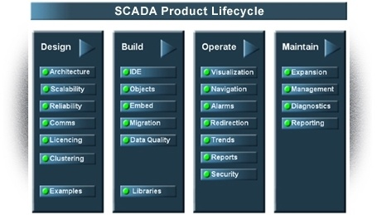
Figure 58: SCADA product Lifecycle
Permission requested to reprint from clearscada.com
In a few easy steps an entire system could be duplicated attaching device information, settings, configuration variables, and diagnostic information without having to enter the database to manually set these again. Their system is designed around a very object oriented environment. This is a much easier route in the design phase than the data basing path. It has a very graphical development platform that enriches the idea of the SCADA industry.
Our sponsor BCI Technologies is a distributer of the ClearScada software and would like us to use it in the project. The idea of the software is to read in points of measured values or information from the panel. This information is set up in a database and the values, colors, alarms, and trends are programmed into the tags and displayed on the screen. These information points are chosen in the design section of the Lifecycle chart. After being chosen each specification of the point are built in the build stage of the lifecycle. After all points are built up with all of their specifications for the system then you would be in the operate section of the lifecycle chart. During the operation stage is where engineers and technicians can have complete control if allowed access from the ViewX Client or the WebX Client. This is where the day to day monitoring and managing of your project begins, keeping the operation of your water station or power plant on line and on task. The next and final stage of the lifecycle chart is the maintenance field. During this stage is where you can expand your networking capabilities and maintain procedures of your entire project. In ClearScada, maintenance on the system can be done without any interruption to the system, loss of data, keeping the trends and historical changes logged in the system.
ClearScada’s easy to use environment has a wide range of uses like many other SCADA software out there today. In the communication department you can interface with many of the well known controllers. In Figure 59 you can see a screenshot of ClearScada courtesy of BCI Technologies of computer architecture and the graphics used to build it. Each one of the field tells something about the communication such as connected or disconnected.(22)
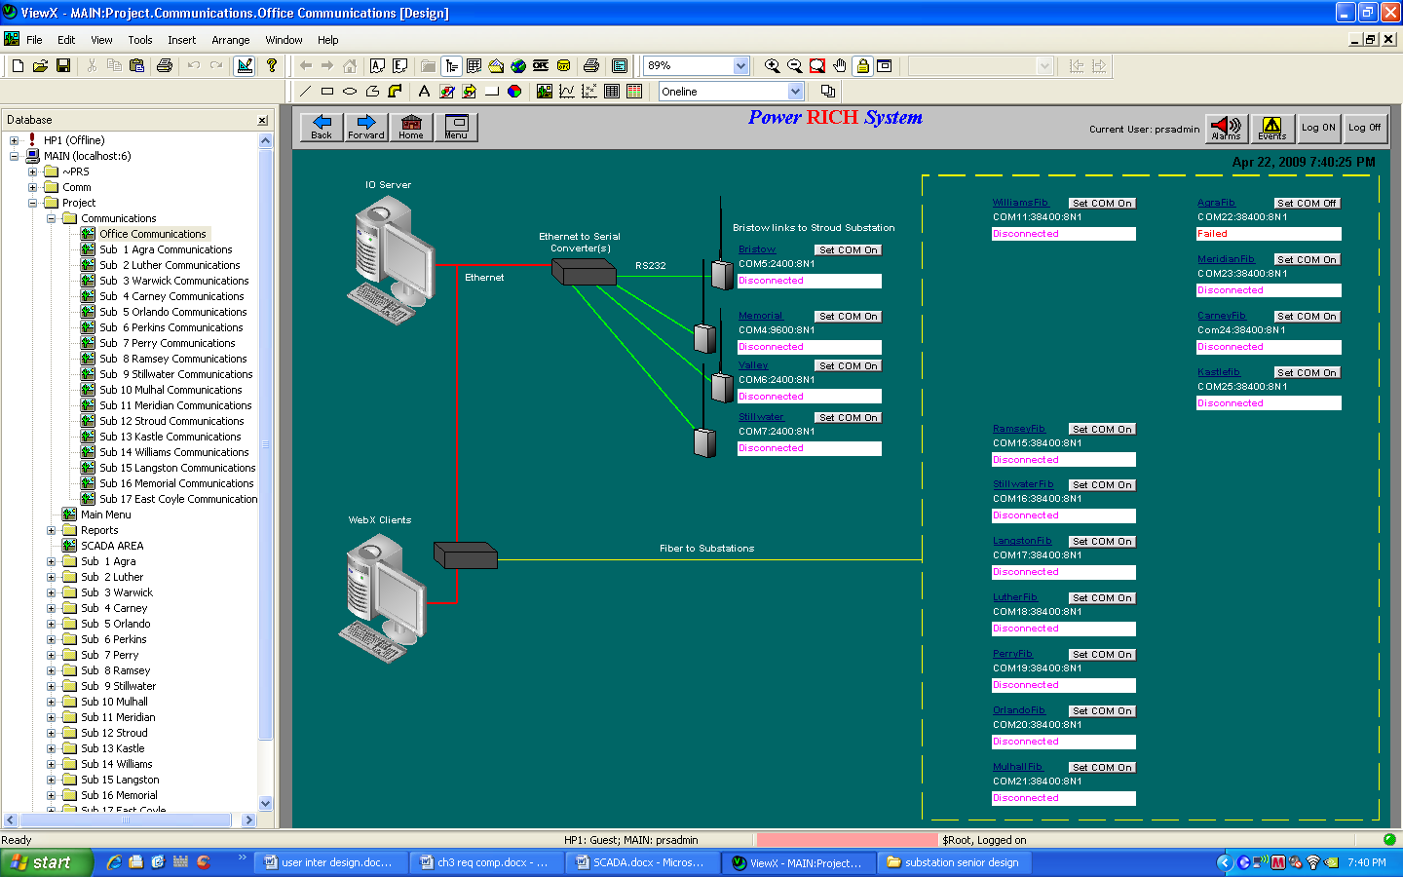
Figure 59: Screenshot of a Communication architecture in ClearScada
Printed with the permission of BCI Technologies
They also have an extensive support network to allow the best possible outcome for your system. These networks include an online update request if there is something specific for your project, online guides and tutorials, the ClearScada Knowledge Base ( a database of existing specifications and issues), recommended set ups and configurations, compatibility with Windows, current datasheets online, communication compliances, and driver development kits and updates. As well as an online forum and a remote desktop application where a technician can help diagnose any problems you may have. It is compatible with the newest 64 bit operating systems, OPC drivers, standby servers, dynamic data, and alarm set point time stamps. In the figure below (Figure 60) you can see how compatible ClearScada is with the newest Windows operating systems that are currently being used today. ClearScada is a leading software that is used in our current industrial market. ClearScada has one of the best ways of integrating engineering and data acquisition along with graphics and easy to use user interfaces. An example and a screenshot of how engineering meets custom easy to use software are both produced in Figure 61 below.(22)
Figure 60: Compatibility chart for ClearScada and Windows Operating Systems
Printed with permission of BCI Technologies
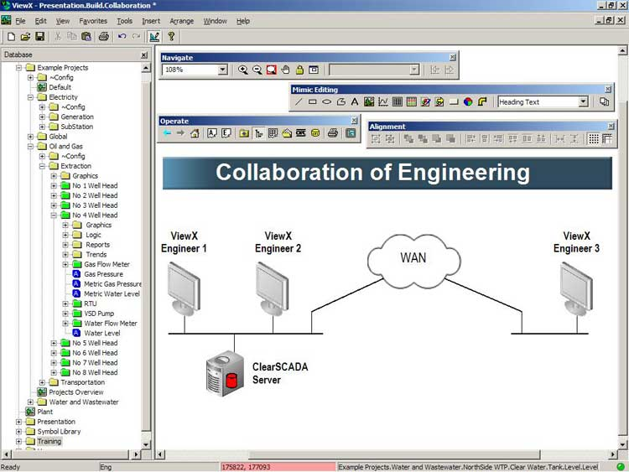
Figure 61: Example of ClearScada's engineering and graphics
Printed with the permission of ClearScada

4.12 Modbus
As mentioned in the previous chapter on the software interface using SCADA, our project is going to be programmed and configured to communicate and understand modbus protocol. Modbus is one of the most popular standard forms of communication in automation. Modbus was created in the late seventies and the design behind it was to create a communication network and interface for a multiple network setup using the master/slave or master/client type computer architecture.
Modbus is most commonly run on RS-232 serial but now has become popular on the RS-485 interface which can allow more distance and faster communication speeds. Many types of devices use a modbus interface to send data back to the host or master system because of its flexibility including microcontrollers, Remote Terminal Units (RTU), Programmable logic controllers (PLC) and many intelligent sensors. A common network setup can be seen in Figure 62 below.(27)
Figure 62: Common Network Communication setup for Modbus
Printed with the permission of Modbus-IDA
The mapping of Modbus communication protocol is on specific buses of application data. Modbus is set up to communicate through its own messages. A good factor of modbus is the messages are standard no matter what type of physical or virtual connection you may have. This means that whether the system is set up RS 485 or RS 232 or even TCP/IP on an Ethernet connection the messages will have the same type of structure giving the entire communication protocol a long lifespan in the industrial protocol structure.
The structure to the modbus messages come in the same standard form every time they are sent. Modbus messages are structured in a plain ASCII or RTU format on some simple systems but may be embedded packets that have the same format that is used in the physical interface. The main message structure is designed to communicate peer to peer, but because of the embedded packet format it can be used in point to point and networked communication. There are four fields associated with every modbus message that have the same sequence each time it is sent. The four basic elements in order of appearance are the device address, function code, data bits, and error check. An example and description of this can be seen in Table 1 below.

Field | Description
Device address | Address of the receiver
Function code | Code defining message type
Data | Data block with additional information
Error check | Numeric check value to test for communication errors
Table 27: Fields and Descriptions of modbus messages
Printed with the permission of Modbus-IDA
Modbus communications are based on a master and slave type environment. A sequence of steps is carried out each time data and information is sent over the connection. The data message and conversation is always begun with the master device on the modbus network. The master sends the initial message and decides how to handle it based on the contents of the message. Then the slave will respond appropriately. The first part of the message, the device address, calls out to that device for a response to the message. Each of the other slaves that do not match the address given in the beginning will ignore and not respond to the message. When a slave is responding it will repeat the requested address from the master, so the master knows and understands which message the slave is responding to.
All of the data sent by the master to the particular slave has to match in order to continue that message; otherwise the error check will find an error. This may cause the master to send the original message again. In figure it shows the cycle in which a message is sent through modbus from the master and slave. The modbus cycle happens many times a second but the response to a message can take a long time, so to get around the error, a timeout is set. The timeout has to be set in order to allow enough reasonable time to get a response but not tie up all resources in the communications waiting for a message response to occur. Below in Figure 63, the cycle of the modbus message is shown.
Figure 63: The Cycle of modbus message Path
Printed with the permission of Modbus-IDA
The data is the Modbus messages are based on sets of tables that contain different characteristics of the different type of registers. There are four different types of registers that are used in the data fields. The Discrete inputs, the Coils or outputs, the Input registers, and the holding registers. A detailed description can be found in Figure 64 along with object type and how they are configured.(28)
Figure 64: Table of properties for the data fields in Modbus
Printed with the permission of Modbus-IDA

5. Design

5.1 Station Alarm System
Having several different methods of alarming the monitoring personnel of a substation is very important. A visual alarm is very useful when there are loud noises present in the surrounding environment. An audio alarm is also very useful when no visual contact of the substation is available and can make a powerful on site notification system. These two methods are among the most effective alarm systems and combined with one another creates a very convenient way to alert someone that a relay has been energized.

5.1.1 SPDT relay
There are several ways in which one could go about designing a system that has audio and visual characteristics. The simplest way to have a circuit respond with a relay is to use a Single Pole Double Throw (SPDT) Relay. This type of relay consists of three terminals which are the common, normally closed, and normally open. In normal conditions the contact is applied between the common and normally closed terminals. Once the applied load draws a current significant enough to trigger the relay the contact will switch from the normally closed terminal in to the normally open terminal. This allows an external circuit to be activated when the relay is energized.(29)
This relay will be placed in series between the 120VAC outlet and the applied load. The designed circuit for the alarm will be connected in parallel to the normally open terminal. This will allow the alarm circuit to be activated when the contact switches to the normally open position.

5.1.2 Circuit Design and Schematic
The design for an alarm circuit can range from being very simple to very complex depending on what features are requested. Once the features are chosen the circuit design can begin. The first step is to decide how the circuit will be powered. The Mini-Substation includes a 120VAC power supply from the wall which will be converted to DC with a line that has a voltage of 9VDC. The 9 volt line will be connected to the normally open terminal of the relay while another wire is connect to the common then which is in series with and resister to ground. A single pole, single throw (SPST) switch is another important feature to add as a means of enabling or disabling the alarm circuit whether or not the relay has been energized.(30)
The substation contains one red LED which will be lit to identify the relay being energized. The option of including a green LED to indicate when the relay has not tripped is also available. The LED needs to be in series with a resister which will limit the current to prevent the LED from burning out. To decide what size resistor to use the optimal current needs to be known for the LED. Once the optimal current is found Kirchhoff's Voltage Law can be used to determine the resistance needed, which ends up being a simple equation. (31)
$$resistance in ohms \left(R\right)=\frac{power supply voltage \left(V_{s}\right)-LED voltage drop (V_{f})}{LED current rating (I_{f})}$$
In the equation above it is seen that the LED voltage drop and current rating need to be obtained. After deciding which LED to use, this information is then available. For a typical 5mm red LED the maximum DC forward current is 25mA with a maximum forward voltage drop of 2V. Using these values along with the 9 volt supply coming from the power supply the resistance required can be calculated:
$$resistance in ohms \left(R\right)=\frac{9V-2V}{25mV}=280 Ω$$
The LED and resister will be incorporated into the circuit as shown below in Figure 65.
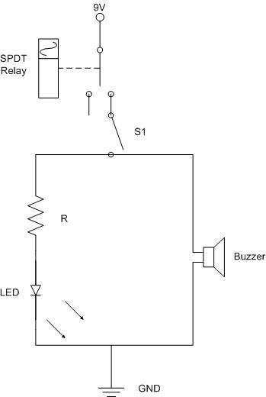
Figure 65: Schematic for Alarm Circuit
In order to include the audio component of the alarm circuit a 9VD buzzer will be used. This buzzer is placed in parallel with the LED and resister. The positive lead is connected to the 9 volt DC supply while the negative lead will be connected to ground.(30) The buzzer that will be used is the 100dB Piezo 2-Tone Buzzer. This buzzer is rated for use with voltages between 6 – 16VDC. The maximum current is 65mA at 12VDC and the tone of the buzzer is rated at 3,200 Hz.

5.2 Power Supply
The Mini-Substation Monitoring System consists of several components that will need to be powered in order for them to work. Since the substation is using 120 VAC source from the wall, this can also be used to power the station. The issue that comes into play is that the system components need a DC supply, therefore the 120 VAC needs to be converted into DC power then regulated at the appropriate voltages needed for each component.

5.2.1 Transformer
The transformer that will be used will have 120 VAC on the primary side and 12 VAC with a current of 300mA on the secondary side. This will reduce the complications and risks of going from AC to DC supplies. A fuse is going to be needed on the primary side of the transformer for protection along with a switch that is appropriate for turning off the monitoring system power when not in use.
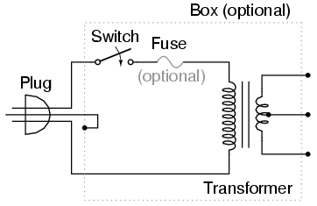
Figure 66: Transformer Schematic
Reprinted with permission from Allaboutcircuits.com
A regular plug will be use in order to get the 120 VAC source from the wall. This will then feed to some sort of line switch or terminal switch. The switch and fuse are then wired to the primary side of the transformer. A Terminal strip will be used to connect the secondary side of the transformer to where any components can be connected with the transformer output. A diagram of this layout can be seen in Figure 67 below along with a brief description of each part.
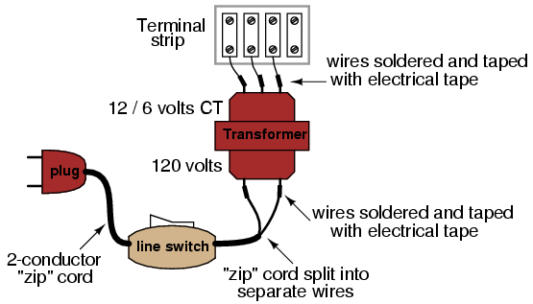
Figure 67: Transformer layout and detailed description
Reprinted with permission from Allaboutcircuits.com

5.2.2 Rectifier
Once the signal is stepped down through the transformer it then needs to be converted into a DC signal. This power supply will use a full wave rectifier that will invert the negative portion of the signal and make it positive as shown in Figure 68: Full Wave Rectified AC Signal.
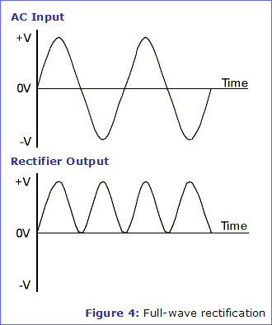
Figure 68: Full Wave Rectified AC Signal
Reprinted with permission from Eleinmec.com
The rectifier for the power supply can be built using four diodes placed in the arrangement shown below in Figure 69. The nodes and direction of the diodes are very important in order for this circuit to work properly. Notice the limited direction of the current flow allowed by the diodes. This allows the full AC signal to flow to the positive terminal not allowing any to flow to the negative terminal.
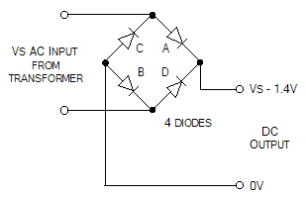
Figure 69: Full Wave Rectifier
Reprinted with permission from Eleinmec.com
There are bridge rectifier IC's that help simplify the rectification of the signal. The bridge rectifier that will be used is the KBPC1005. This will simplify the actual fabrication of the circuit reducing the amount of parts that will be needed. Below in Table 28 are the specifications for the KBPC1005.
Parameter Name | Value
Maximum Recurrent Peak Reverse Voltage | 50 V
Maximum RMS Voltage | 35 V
Maximum DC blocking Voltage | 50 V
Maximum Avg Forward Rectified current  at Ta=50°C | 3.0 A
Peak Forward Surge Current 8.3ms single  half sine-wave superimposed on rated load | 50 A
Maximum Instantaneous Forward Voltage  at forward current 1.5A DC | 1.1 V
Maximum DC Reverse Voltage Ta=25 °C  at rated DC blocking voltage Ta=100 °C | 10µA  1.0mA
Operating Temperature Range | -55 to +125 °C
Storage and operating junction Temperature | -55 to +150 °C
Table 28: KBPC1005 Specifications

5.2.3 Smoothing and Regulating
Once the signal has been full wave rectified it then needs to be smoothed out to create a DC signal. The use of capacitors here is essential due to its ability to hold charge. The size capacitor that will be used can be determined by the following equation which determines the ripple voltage.
$$V_{ripple}=\frac{I}{C*f}$$
This allows for the calculation of the capacitor size needed to give a ripple voltage of less than 10% of V_{s}. f is the frequency of the voltage peaks which will be two times the frequency of the 120V AC source coming from the wall. Since this is being produced in the United States the frequency is 120Hz. The last component is I, which is the For a 3.3 volt DC source the smoothing capacitor
The voltage regulator that will be used is the LM317 voltage regulator. This is a variable voltage regulator which allows the regulated voltage to change. It supports an input voltage of 3 volts to 40 volts while supplying an output voltage of between 1.25 volts and 37 volts. This range will enable the use of this one regulator to provide the station with multiple voltage lines to power the components. The output current is rated to be 1.2A however it is possible to obtain models with higher or lower current ratings. The full list of specifications can be seen on Table 29: LM317 Specifications.(32)
Parameter Name | Value
V_{out} Range | 1.25V - 37V
V_{in} - V_{out} difference | 3V - 40V
Operation ambient temperature | 0 - 125 °C
Output I_{man} | <1.5A
Minimum Load Current_{max} | 10mA
Table 29: LM317 Specifications
The circuit configuration that will be used can be seen below in Figure 70: 1.2V-25V Adjustable Regulator. This allows for different DC voltage lines being designed into the power supply while using the same voltage regulator chip. Using the same circuit and varying the value of R2 will allow the regulator output to be adjusted to the desire voltage.
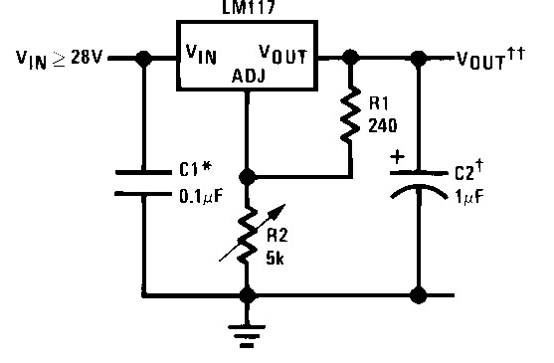
Figure 70: 1.2V-25V Adjustable Regulator
Reprinted with permission from National.com

5.3 Energy Metering Design
The Energy Metering IC is going to be what all the calculations are based on. The IC that has been chosen is the ADE7753 Energy Metering IC. This chip needs to be set up with the correct inputs for it to function properly. This IC will be placed on a printed circuit board designed by the group members. The PCB will have been designed to line up the correct inputs and outputs to the proper pins allocated for each signal. The Chip will have a 5V DC power source supplied by the designed power supply that powers the IC in order for it to function properly. This IC is developed as a surface mount part, which is a very important quality when designing the actual board. The physical dimensions of the IC can be seen in Figure 71.
Figure 71: 20-Lead Shrink Small Outline Package (SSOP)
Reprinted with permission from Analog.com
The ADE7753 is going to have a complex design for all the functionalities to work properly. It will have two sensor inputs, which are a current sensor and a voltage sensor. These will give the chip all of the available information to do the correct calculations. There will also be a 5V power source with a 5% tolerance that is needed to power the chip on. The ADE will also be directly connected to the microcontroller for serial data output. These are the main inputs and outputs that will be interfaced with the ADE7753. In Figure 72 below is the basic layout of the ADE7753 with the inputs and outputs that are going to be in communication with this device.(33)
Figure 72: Basic Layout of the ADE7753 configuration
Reprinted with permission from Analog.com

5.3.1 ADE7753 and PIC16F77 Pin Configuration
The ADE7753 is going to be directly integrated to the PIC16F77 in order for the monitoring system to have all of the proper functions. This portion of the project will involve a lot of programming to receive the data from the ADE7753. Once the data is received it then needs to be translated into a printable form for the LCD screen and the wireless transfer to the laptop computer. Another big portion is to take the pin configuration and design the pin layout for integration between the ADE7753 and the PIC16F77. Below in Figure 73 is the pin configuration for the ADE7753 SSOP package and will be used to design the schematic for the circuit.
Figure 73: Pin Configuration (SSOP Package)
Reprinted with permission from Analog.com

5.3.2 Current and Voltage Sensor Input
The current sensor that is going to be used is a current transformer, which will provide an accurate means of calculating the current. This current sensor then needs to be fed into the ADE7753 Energy Metering IC where it will begin the calculation process. The signal coming from the current transformer is a voltage that will be integrated by an internal integrator in the ADE7753. After being integrated the signal will be a current signal that is proportional to the current in the 120V AC line. The circuit below in Figure 74 is what will be built between the current transformer and the ADE7753 in order to get the signal ready for integration. Pin 4 will be designated for the positive terminal of the current sensor input and pin 5 will be designated for the negative terminal. These inputs are fully differential voltage inputs with maximum differential input signal levels of ±0.5V, ±0.25V, and ±0.125V, depending on the full scale selection. (33)
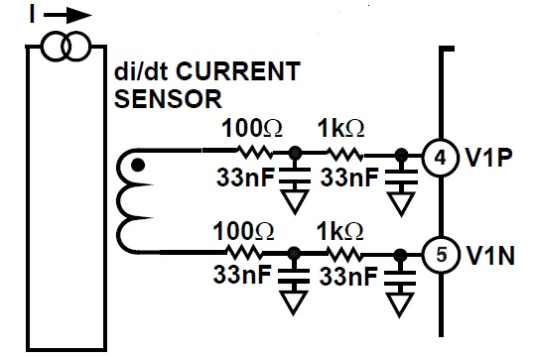
Figure 74: Current Sensor Input circuit to ADE7753
Reprinted with permission from Analog.com
The line voltage is too high to feed directly to the voltage sensor input on the ADE7753. Attenuating the voltage signal is appropriate here in order to protect the IC. The voltage sensor is just a basic circuit that brings down the voltage to a safe proportion in order for the ADE7753 to be able to read it. As seen below in Figure 75 is the two inputs for the ADE7753. The 600kΩ resister is what will dissipate the majority of the voltage coming from the source. Pin 6 will be designated for the negative terminal of the voltage sensor and pin 7 will be designated for the positive terminal. These inputs are fully differential voltage inputs with a maximum differential signal level of ±0.5V. (33)
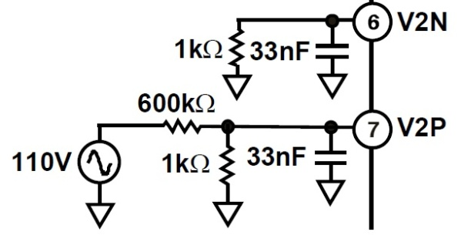
Figure 75: Voltage Sensor Input Circuit to ADE7753
Reprinted with permission from Analog.com
The ADE7753 IC also requires other inputs in order for it to function properly. A crystal oscillator is needed to supply a stable clock signal for the digital integrated circuit. This oscillator circuit is built using a 3.58MHz crystal oscillator along with two 22pF capacitors arranged as seen below in Figure 76. Along with the oscillator a RESET circuit needs to be built. This can simply be done by tying pin 1 to the 5V DC input in parallel with a 100nF capacitor and a 10µF capacitor. This circuit can also be found in Figure 76.
Figure 76: Test Circuit for Performance Curves with Integrator On
Reprinted with permission from Analog.com

5.3.3 Serial Interface
The ADE7753 serial interface is comprised of four signals including SCLK, CS, DIN, and DOUT. Pin 17 is for the CS signal, which is a active low logic input that allows the ADE7753 to share the serial bus with several other devices. The SCLK signal is on pin 18, which is the serial clock input for the synchronous serial interface. All serial data transfers are synchronized to this clock. Pin 19 is for the DOUT signal, which is the data output for the serial interface. On the rising edge of the Serial Clock data is shifted out at this pin. Unless it is driving data onto the serial data bus this logic output is normally in a high impedance state. The last signal, DIN, is on pin 20, which is the data input for the interface. On the falling edge of the Serial Clock the data is shifted in at this pin. (33)
The serial clock for a data transfer is applied at the SCLK logic input. This logic input has a Schmitt -trigger input structure that allows slow rising clock edges to be used. All data transfer operations are synchronized to the serial clock. Data is shifted into the ADE7753 at the DIN logic input on the falling edge of the serial clock while data is shifted out at the DOUT logic output on a rising edge of the serial clock. The chip select input is used when multiple devices share the serial bus. A falling edge on CS also resets the serial interface and places the ADE7753 into communications mode. By bringing the chip select signal high during a data transfer operation one can abort the transfer and place the serial bus in a high impedance state. Below in Figure 77 is the data transfer sequence for a read operation and in Figure 78 is the data transfer sequence for a write operation. (33)
Figure 77: Reading Data from the ADE7753 via the Serial Interface
Reprinted with permission from Analog.com
Figure 78: Writing Data to the ADE7753 via the Serial Interface
Reprinted with permission from Analog.com

5.4 PIC16F77 Microcontroller
The microcontroller will be the central unit that connects all the different components of the project together and will be in control of the communication between the devices. Certain pins on the PIC16F77 will be designated to receive the serial data from the ADE7533. Below in Figure 79 is the pin configuration for the PIC16F77 DIP package and will be used to design the schematic for the circuit. This is a 40-pin microcontroller that has certain characteristics that make it an ideal choice for this project.
Figure 79: Pin Configuration (DIP Package)
Reprinted with permission from Microchip

5.4.1 Oscillator
There are four different oscillator modes that the PIC16F77 can be operated in. Two configuration bits can be programmed to select one of these four modes. The modes are as follows:
- LP Low Power Crystal
- XT Crystal/Resonator
- HS High Speed Crystal/Resonator
- RC Resistor/Capacitor
For this design a crystal or ceramic resonator will be used to clock the microcontroller. To create oscillation the crystal or ceramic resonator needs to be connected to the OSC1/CLKIN and OSC2/CLKOUT pins. A parallel cut crystal is required for the PIC16F77, because the use of a series cut crystal may give a frequency out of the crystal manufacturers specifications. Below in ... is the circuit layout for the crystal oscillator.
Figure 80: Crystal/Ceramic Resonator Operation (HS, XT or LP OSC Configuration)
Reprinted with permission from Microchip.com

5.5 Connecting Relay to a Microcontroller
Relays allow low power circuits to switch a relatively high Current/Voltage ON/OFF. For a relay to operate, a suitable pull-in & holding current should be passed through its coil. Relay coils are designed to operate from a particular voltage often its 5V or 12V.The function of relay driver circuit is to provide the necessary current (typically 25 to 70ma) to energize the relay coil. Figure 81 shows the basic relay driver circuit. Above we can see an NPN transistor BC547 which is being used to control the relay. The transistor is driven into saturation (turned ON) when a LOGIC 1 is written on the PORT PIN thus turning ON the relay. The relay is turned OFF by writing LOGIC 0 on the port pin. A diode (1N4007/1N4148) is connected across the relay coil; this is done so as to protect the transistor from damage due to the BACK EMF generated in the relay's inductive coil when the transistor is turned OFF. When the transistor is switched OFF the energy stored in the inductor is dissipated through the diode & the internal resistance of the relay coil. As we can see we have used a pull up resistor at the base of the transistor. AT8951/52/55 has an internal pull up resistor of 10k so when the pin is pulled high the current flows through this resistor so the maximum output current is 5v/10K = 0.5ma, the DC current gain of BC547 is 100 so the maximum collector current we can get is 0.5ma x 100 = 50ma, but most of the relays require more than 70ma-130ma current depending on the relay that we have used, 0.5ma of base current is not suitable enough for turning ON the relay, so we have used an external pull up resistor. When the controller pin is high current flows through the controller pin i.e. 5v/10k=0.5ma as well as through the pull up resistor. We have used 4.7k pull up resistor so 5v/4.7k=1.1ma so maximum base current can be 0.5ma + 1.1ma=1.6ma i.e. collector current =1.6ma x 100 = 160ma which is enough to turn ON most of the relays. This relay driver circuit is to be used only with controllers for using this circuit with other digital IC's like LM 555 use a resistor should be used between that IC's output & the base of transistor. (34)
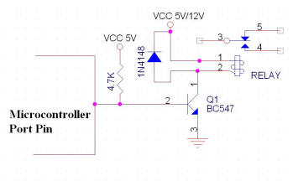
Figure 81: Relay Driver Circuit,
Emailed for Permission (34)

5.6 Wireless communications
For wireless connectivity, we decided on a pair of the XBee DigiMesh 2.4 RF transceiver modules based on its low price, small form factor, low power consumption, and adequate transmission range. The following is a specification table for the different varieties of the XBee RF module.(10)
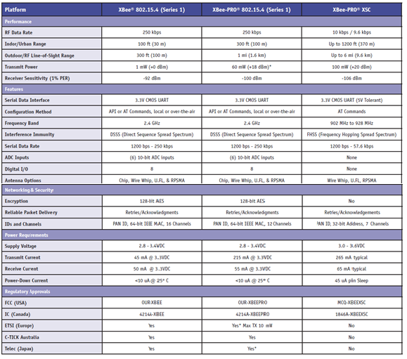
Figure 82: XBee specification table
Reprinted with permission from digi.com
The XBee DigiMesh uses spread spectrum type DSSS modulation technique, which means that the carrier signals occur over the full bandwidth of the modules transmitting frequency. This helps to resist jamming and background noise as well as allowing a single channel to be shared amongst several users. The XBee module utilizes the ZigBee standard, which operates using a mesh topology. This type of topology breaks long distances into shorter sections by forwarding the signal from one node to the next until it reaches its destination. Each node is wirelessly connected to at least two other nodes, which means if one node should fail, the entire network is not brought down. Thus the mesh topology serves to increase bandwidth and efficiency and offers redundancy. Some of the key features of the XBee are listed below.
- 16 Channels with 65,000 network addresses per channel
- Operating voltage of 2.8 – 3.4 VDC
- Transmit current of 35mA operating in normal mode
- Transmit current of 45mA operating in boost mode
- Receive current is 50mA
- Power-down sleep mode consumes < 50µA
The XBee also includes error handling with retries and acknowledgements. . The XBee frequency band is between 2.4000 and 2.4835 GHz. The physical size of the module is 0.960 in x 1.087 in (2.438 cm x 2.761 cm) and is weighs 0.10 oz (3g). The antenna option we chose is the wired whip antenna due to extended range that it offers as well as the fact that size is not much of a concern with our monitor. Shown below are a couple of dimension layout diagrams of the XBee RF module.
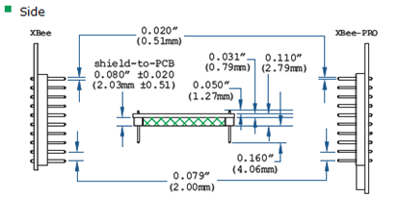
Figure 83: XBee dimensions diagram
Reprinted with permission from digi.com
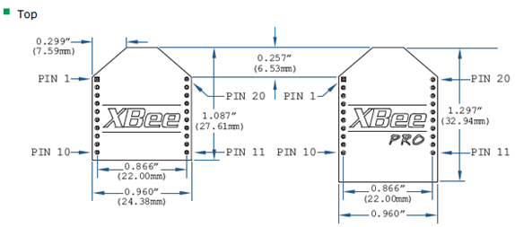
Figure 84: XBee specification table
Reprinted with permission from digi.com
The cost of the XBee module from the manufacturer is $19 for each module for a total of $38.
We have also chosen to use the XBee breakout board from sparkfun.com pictured below. This board is mounted to the printed circuit board and allows the XBee to be “plugged-in” to the breakout board using 2mm sockets without having to solder it in place. It “breaks-out” all 20 pins of the XBee to a standard header making the breadboard DIP friendly. The cost of this board is $2.95 and the cost of the 2mm 10 pin XBee Sockets are $1.00 a piece. A couple of photographs depicting the pin layouts and of the breakout board and the XBee module shown plugged into the breakout board are shown below.
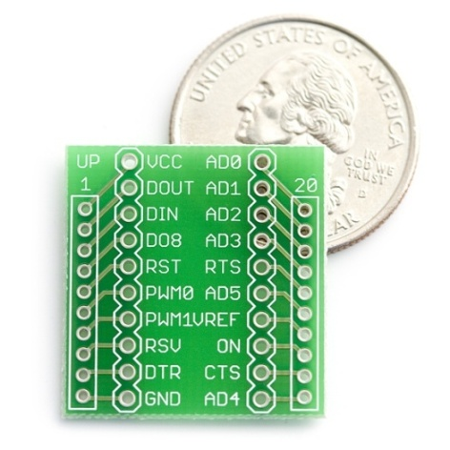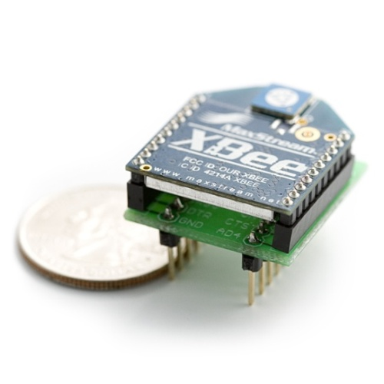
Figure 85: Breakout Board Pin layouts and XBee module
Reprinted with permission from sparkfun.com
For connectivity to the user interface on the receiving computer, we have chosen the XBee Explorer USB from Sparkfun.com. This device is a USB to Serial base unit that allows the XBee module to be “plugged-in” to the board and then connected to the base computer via a USB cable. The cost of this unit is $24.95. Photos of the Sparkfun USB breakout board with the dimensions and pin layouts are shown below.
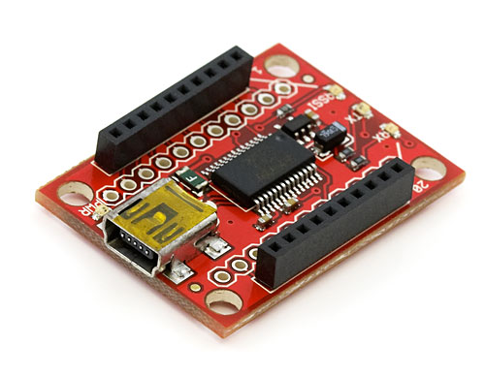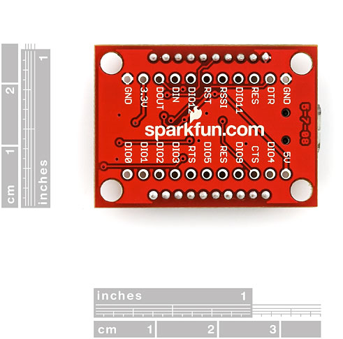
Figure 86
Reprinted with permission from sparkfun.com
Also required for the XBee Explorer USB is the USB miniB cable from sparkfun.com. This cable sells for $3.95 and converts the common A-type USB connect to the mini-B type connector on the XBee Explorer USB. A photo of the required USB cable is shown below.
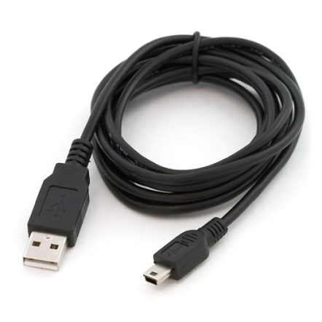
Figure 87: USB Cable
Below is a schematic of the XBee Explorer USB which shows pin assignments of the module.
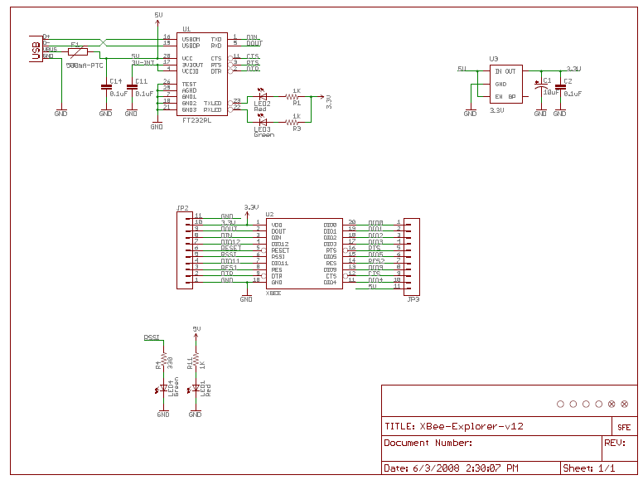
Figure 88: Schematic of XBee Explorer USB
Reprinted with permission from sparkfun.com
In addition we are using the XBee Explorer Serial from sparkfun.com. The unit allows the XBee RF module to be plugged directly into the board and includes an RS-232 serial connection. The unit supports Data Terminal Ready (DTR) communications so that the XBee can be connected to a computer for configuration and reprogramming. The XBee Explorer Serial will only be used for this purpose and will not be part of the final product as the XBee will be connected to the substation monitor via the breakout board as previously mentioned. Sparkfun.com sells this unit for $29.95. The XBee serial explorer schematic is shown below.
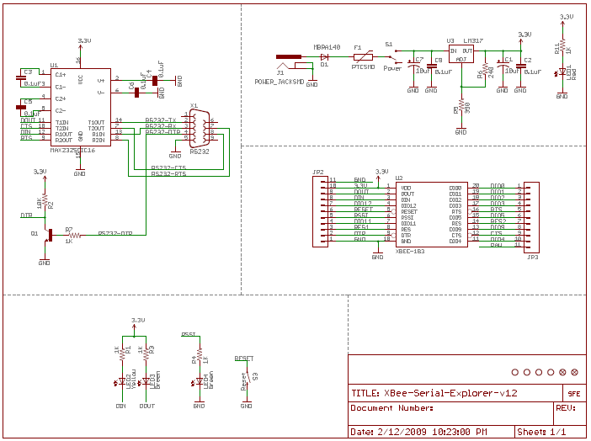
Figure 89: Schematic of XBee Serial Explorer
Reprinted with permission from sparkfun.com
The following photos are top and bottom views of the XBee Explorer Serial unit.
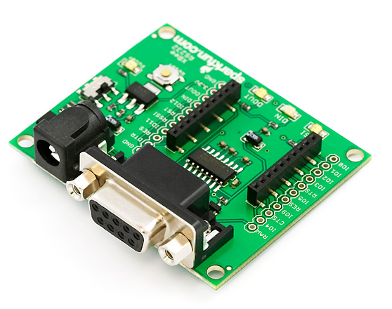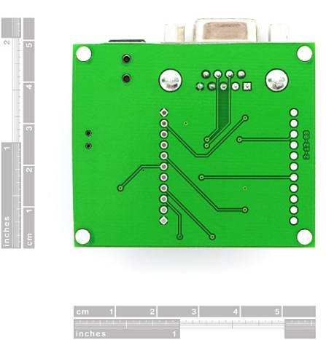
Figure 90: XBee Explorer Serial Unit (Top – Left) (Bottom - Right)
Reprinted with permission from digi.com
Configuring the X-Bee devices is done with the use of Digi’s X-CTU configuration utility. Digi offers the utility free of charge on their website Digi.com. X-CTU is a windows based utility that interacts with the firmware files on the XBee. Once the software is launched, four tabs appear across the top of the program. The following was taken from the Digi.com website.
“PC Settings: Allows a customer to select the desired COM port and configure that port to fit the radios settings.
Range Test: Allows a customer to perform a range test between two radios.
Terminal: Allows access to the computers COM port with a terminal emulation program. This tab also allows the ability to access the radios’ firmware using AT commands (for a complete listing of the radios’ AT commands, please see the product manuals available online).
Modem Configuration: Allows the ability to program the radios’ firmware settings via a graphical user interface. This tab also allows customers the ability to change firmware versions.” A screenshot of the referenced window is shown below.
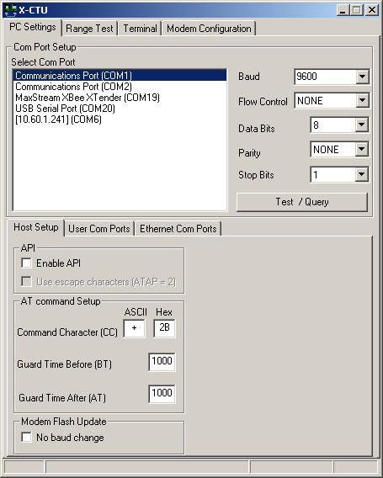
Figure 91: X-CTU screenshot
Reprinted with permission from digi.com
Initially the COM port must be configured by selecting the COM port settings window. Some of the settings include”
- Baud Rate – standard / non-standard
- Flow Control – hardware, software (Xon/Xoff), none
- Data bits - 4, 5, 6, 7, and 8 data bits
- Parity – none, odd, even, mark and space
- Stop bit – 1, 1.5, and 2
The settings can be changed by using the pull down menu to the left of the value and then selecting the proper setting, except with the baud rate you just type the baud rate in the box. Once all of the settings are selected you can test to see if they are correct by using the Test / Query button. If the settings are correct a response similar to the one below is received.
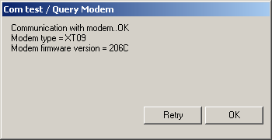
Figure 92: X-CTU screenshot
Reprinted with permission from digi.com
If the above response is received, then the Host Setup tab must be selected. This section allows the user to configure the interface between the X-CTU program and the module’s firmware. One of the options is to decide whether the API or AT command mode should be used to access the firmware. In addition the proper command mode character and sequence. The Default settings are given below.
- API mode – not checked
- Command mode Character – +(ASCII) 2B(Hex)
- Before Guard Time – 1000 (1 Sec)
- After Guard Time – 1000(1 Sec)
The next part that needs to be configured is the User COM ports. This portion of the software allows the user to add or delete a COM port that is user created. Once this is completed then next step is to proceed with the Range Test. This test is outlined in the Test Procedure section below.

5.7 User Interface Design

5.7.1 Software
The user interface and software we are using is Control Microsystems ClearScada. ViewX is the development environment that is used to configure, create, and design your own customized system for the application that is needed to be completed. It is an entire application that has a server built in and runs on a computer after installation and licensing. There are four areas of interest to follow when designing a SCADA system within the software. The four sections are as follows: the design stage, the build stage, the operate stage, and the maintain stage.
The Design phase of the SCADA system starts with the layout of the network plans and is where RTU communications are decided. All options for network protocols to use and the scaling of the project to be small or large are also decided here. The build stage is the biggest of the group of four. During this stage, you can use ClearScada’s Integrated Development Environment where more than one engineer can work on objects at the same time due to ClearScada’s non-compiled design of their system. This is where our design of the system comes into the picture.
ClearScada is an object oriented database of information. Each object has properties associated with it that include configuration fields and data fields. These configuration properties can be set and adjusted by the user of the individual instance of the object. The data fields can be changed in real time and are the representation of the current value and current state of the object you are building. One of the key features or concepts of ClearScada’s object oriented database programming is the fact of inheritance from a derived class. If two classes A and B are similar but class B has a few extra properties of class A, how do you create class B? In ClearScada you can just copy class A and use it as a base for class B then add the additional properties needed. All value parameters and functionality of the objects will be copied over not stepping on each other’s footprints.
The first thing to do when building the design of our project is to create a group which is similar to creating a folder in Windows Explorer tree architecture. Within that group is where you add your points of reference that you want to be monitored. Examples of this would be your actual analog and digital points or internal points that you can use in calculations or scripts. The points you choose to monitor can be configured in many ways. A digital point is just what you think as in 0 or 1 digital logic. The states of this point can be configured to change when an input is set to 1 logical value.
An analog point is an actual numerical value with configuration fields of; data type, alarm limits including full scale, high high scale, high scale, low scale, low low scale and zero scale, hysteresis, scaling if needed, percent of tolerance before the value changes, colors, and descriptions. Below in Figure 93 is a screenshot of the configurations properties of an analog point where the values of the alarms, scaled values, descriptions and other interests that would like displayed on the screen when manually picked or just dragged and dropped onto a previously designed mimic that you created.
Figure 93: Configuration Screenshot for an analog point
These points you create can be dropped onto mimic templates. Mimic are like templates you create of a specific design layout that can be used over and over to create an eye pleasing graphical user interface like a group of fields put together to make a single point (i.e. name, color, description, value, … etc.). Below in figure 6.2.1a is an example of a mimic in the form of NAME: VALUE, where you can drop the point onto it and the mimic becomes populated with the object point’s name, value, color, and other parameters.
After all the analog and digital points are created that you want to be monitored, pages and their parameters, scripts, and buttons have to made in order to do the tasks that are desired. A page consists of certain monitored points or mimics placed on a particular page separating your digital points from your analog points for example. The overall objective of each of the pages is to make navigation as easy as possible and to have a clear view of your points that are being monitored. Figure 94 is a screenshot of a full meter values page for a power project with currents, voltages, harmonics, and power value points displayed on the screen. Notice all the little boxes that are next to some of the points. These are trend buttons.
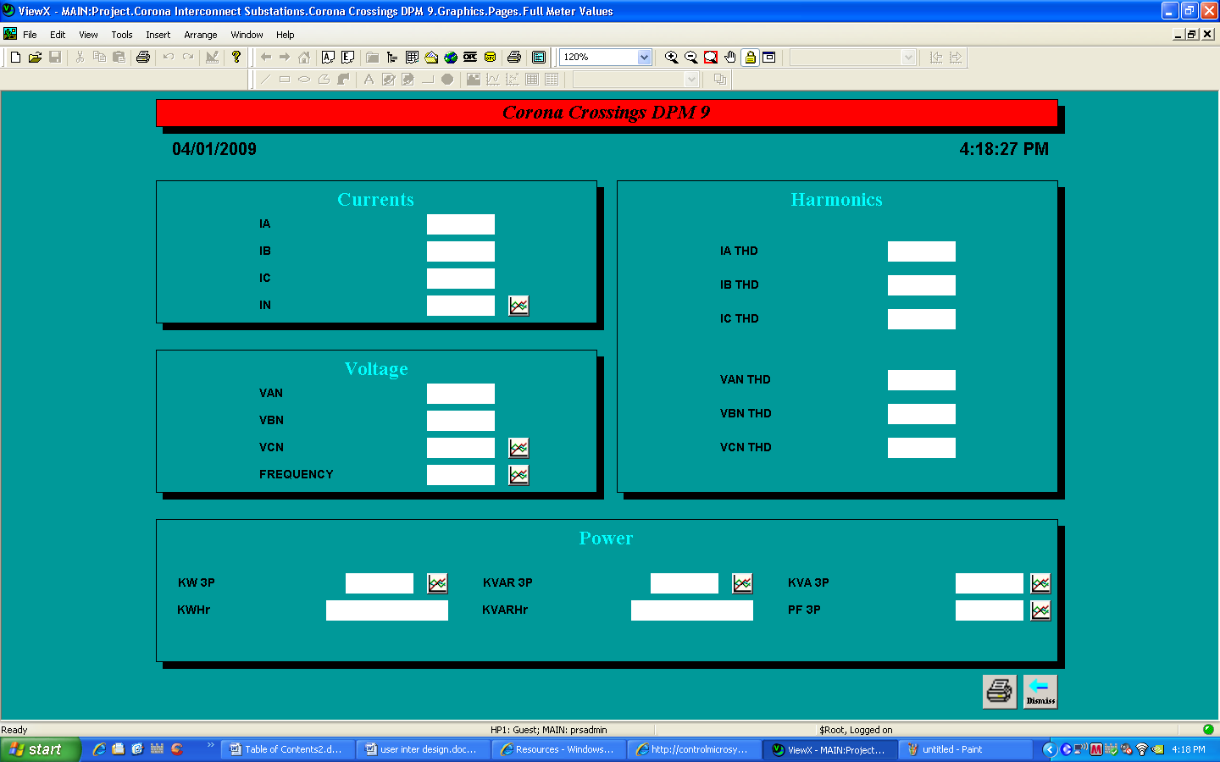
Figure 94: Screenshot of a full meter values page
courtesy of BBCI Technologies
Trending the data or showing a graph of the values over an amount of time can help with finding the average over that period of time which can also lead to helping better the efficiency of your system. If you want to have a trend of say all the voltages that you have created points for to show a graph over time than a trend page has to be made with buttons to get to it. Below in Figure 95 is an example of a trend printed with the permission of BCI Technologies. The over range and under range line on the trend are values that are set in the alarm section of configuration.
Figure 95: A Trend screenshot from ClearScada
printed with permission
In out project, in order to make the buttons work, scripts that run in the background or run when the button is pressed have to be written. This task can get quite complicated or can be as easy as calling another page to be displayed when a button is pressed. When we find the points that correspond with each trend page we create and make them open the right corresponding trend page. This also works with the navigation buttons that we will have on the bottom of the screen. For digital points such as open and close buttons, we have to write some scripts to run so that when the buttons is pressed a function will call the specific point and write a value to it. In the case of opening and closing our relay it will just be a 1 or a 0. In some cases, like if you are changing states and needed a specific value to be stored to a register or point then this would not be a 1 or 0 but a numerical value. A screenshot of the open and close scripts can be found in Figure 96.
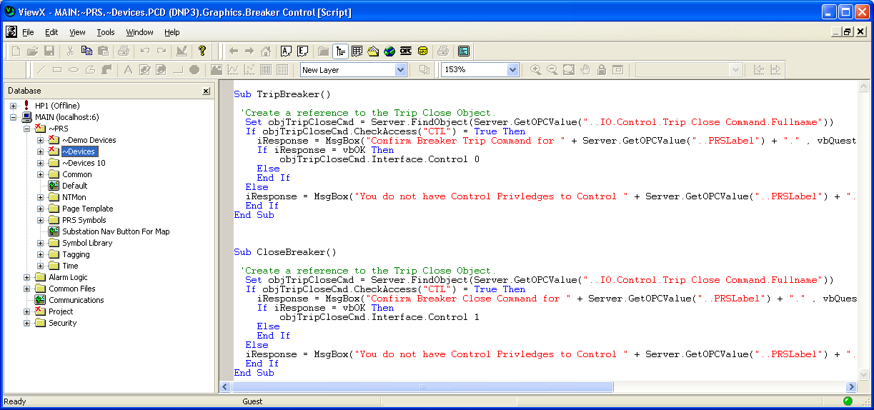
Figure 96: A screenshot of our scripts that are used for the open and close buttons
After all of the scripts are written, we will check to make sure our communications are correct. We are planning to communicate with the mini substation panel by serial wirelessly. The other way we could communicate is through a TCP/IP connection. We have to have a correct outstation for our project which is the outlet in which the software communicates with other devices. Since we are planning for a serial connection we have to set our outstation set to com1 and give it an address of 1 because we are only planning to have one device that the system will be connected to.
The code that precedes this Figure 97 below is the code that makes these buttons work on the breaker status screen. This is our first drawing of our controls for our relay breaker in our mini substation project. We are planning to have our communications up to date where we can control the voltage on the relay breaker and actually trip the relay ourselves in order to test the function of the relay. The relay will also trip in order to save the equipment if an alarm condition such as over voltage or an over current condition.
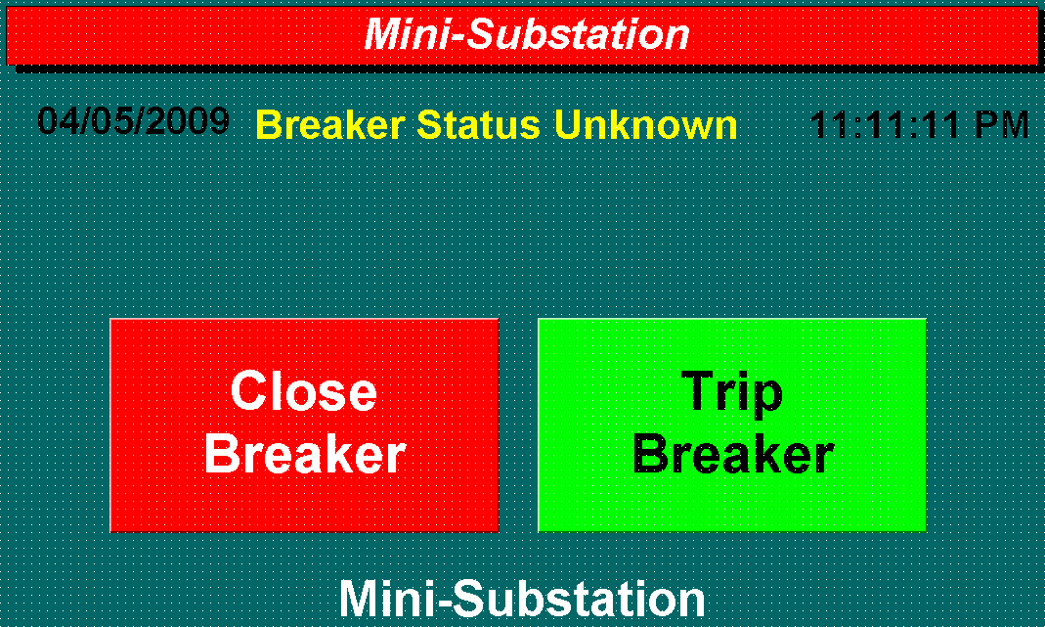
Figure 97: Preliminary design for our controls on opening, closing and the status of our relay breaker
This is our own screenshot of our software we are using preliminary design.
The overall objective of the user interface is to make an eye pleasing control environment that is easy to navigate for the user or operator. By creating many pages, you can allow lots of data to be displayed and only see this in an alarm condition or when you select on the current page you wish to see. In our project we will have 3 or 4 pages to demonstrate this. The main page will have and very graphical introduction page then with the navigation buttons like in Figure 98 and Figure 99. These navigation buttons are buttons that we create and have to animate them with the proper destination of where the button will take us.
Figure 98: Screenshot of some navigation button examples used on the different pages
Used with permission of BCI Technologies
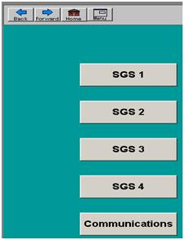
Figure 99: Screenshot of a few navigation buttons used on the main introduction page of a project
Used with the permission of BCI Technologies
The main pages of projects can get quite intricate and as eye catching as you would like them to be. On our project we will try to draw our mini substation panel so that we can click on the components drawn and they will take you to the pages with their information on them. Below is an example of an intricate main page in Figure 100. This is a map of the center of Oklahoma and each one of the blue name tags is a button to the corresponding page.(22)
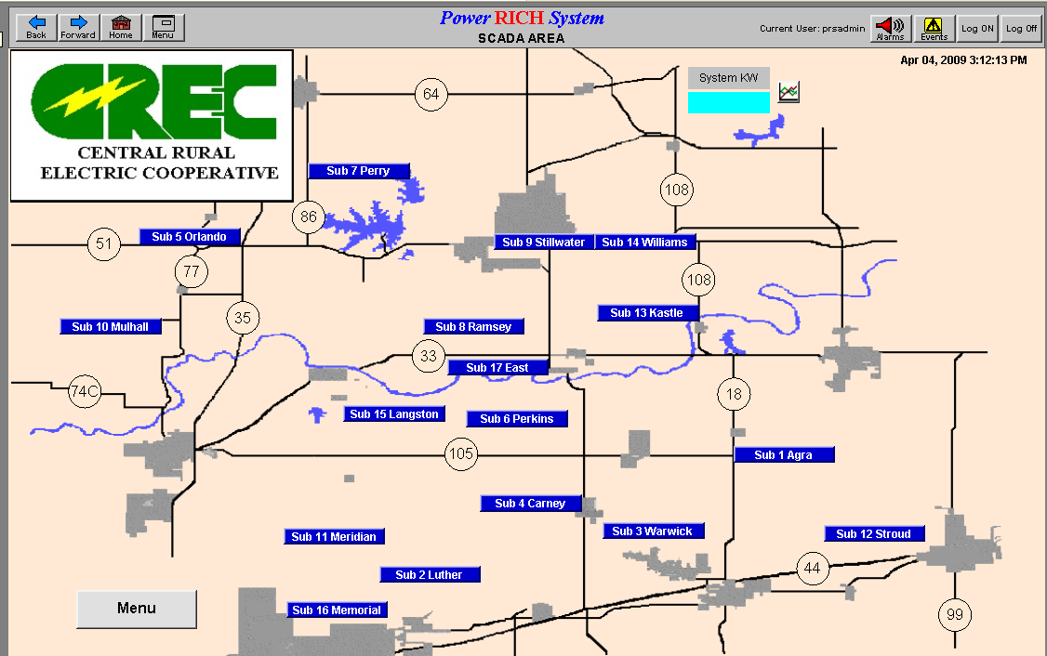
Figure 100: Example of an intricate main page
printed with the permission of BCI Technologies

5.7.2 Modbus Communication
In modbus communication protocol there are two types of structure for the messages that are sent. These two different types are Modbus/ASCII and Modbus/RTU. Depending on which type is chosen is how the messages will be encoded when sent from the device back to the computer and back again. In Table 30, you can see the comparison between the different types of modbus serial transmission modes. If the Modbus/ASCII is chosen the messages are sent in an ASCII format which can be read at any time during the monitoring. Each message that is sent through the modbus/ASCII is coded in a hexadecimal format using the zero to nine numbers and A to F in the letters. If the Modbus/RTU is chosen for the message structure the message is encoded and unreadable during the actual monitoring and had to be decoded on the other side. The benefits of this include a smaller size of each message which would increase the amount of information that can be sent in a given time period comparing to the Modbus/ASCII. All device points or nodes in the modbus network must be on the same type of transmission mode to communicate successfully.

 | Modbus/ASCII |  | Modbus/RTU
Characters | ASCII 0...9 and A..F |  | Binary 0...255
Error check | LRC Longitudinal Redundancy Check |  | CRC Cyclic Redundancy Check
Frame start | character ':' |  | 3.5 chars silence
Frame end | characters CR/LF |  | 3.5 chars silence
Gaps in message | 1 sec |  | 1.5 times char length
Start bit | 1 |  | 1
Data bits | 7 |  | 8
Parity | even/odd | none | even/odd | none
Stop bits | 1 | 2 | 1 | 2
Table 30: Properties comparing ASCII and RTU formats
Printed with the permission of Modbus-IDA
In out project we are going to use the Modbus/ASCII format of message coding. This encoding requires us to have two communication bytes for every byte of information data that is sent. These communication bytes are needed because in byte can only define four bits of data in a hexadecimal system. These messages we send over the wireless serial connection are not just sent in plain text they have to be framed with a start and a finish so the computer understands when the messages begins and when it ends. In the Modbus/ASCII format, a “:” is used the flag to symbolize the start of the message and each message will end with a carriage return line feed. The format of the Modbus/ASCII messaging can be found on Table 31 below.
Start | Address | Function | Data | LRC Check | End
1 char | 2 chars | 2 chars | n chars | 2 chars | 2 chars CRLF
Table 31: ASCII message format of the frame
printed with the permission of Modbus-IDA
The device address is the first part of the message that is received. This section is coded with two hexadecimal characters in length. The range of values that can be sent here are from 0 to 247. The 0 address is reserved for the broadcast address so we will start our device at 1. For example, when our master requests address 01, master is where the original message begins, our slave (the device) will repeat the requested address back to the master confirming that the slave understood and received the message then reply back with the answer to the request. This is like a call and echo response just to make sure the message was sent correctly and to reassure the correct response is given back to the master.
Also included in the addresses are the input registers, output registers, and the holding registers for the information that is to be sent. The output Modbus addresses range from 1 to 10000. The input addresses usually range from 10001 to 20000. The output addresses range from 40001 to 50000. A range of these values can be seen in Table 32 below. These values can vary depending on the device used in the application. These values also vary depending on whether they are digital inputs and outputs or analog inputs and outputs. In both the input addresses and the holding registers, an offset must be specified and subtracted from the device address in order to get the correct address to put in the Modbus/ASCII message structure.(27)
Device address | Modbus address | Description
1...10000* | address - 1 | Coils (outputs)
10001...20000* | address - 10001 | Inputs
40001...50000* | address - 40001 | Holding registers
Table 32: Range of address values given in Devices and modbus adrdresses
Printed with the permission of Modbus-IDA
The function code section of the message is also important because that is where the instructions on what the message is to accomplish. The function code defines the type of the message and what action is required by the slave device. It has one byte of information in two hexadecimal characters. The valid function codes that are allowed can range from 0 to 255. A table of the common function codes is listed in figure 6.2.2d below. We will be using the 03 function for most of our communication which is reading the holding registers
Code | Description
01 | Read coil status
02 | Read input status
03 | Read holding registers
04 | Read input registers
05 | Force single coil
06 | Preset single register
07 | Read exception status
15 | Force multiple coils
16 | Preset multiple registers
17 | Report slave ID
Table 33: Range of address values given in Devies and Modbus Addresses
printed with the permission of Modbus-IDA
The function 03, reading the holding registers, is to read what is stored in the internal values of the modbus device. These holding registers can have configuration parameters and details or have measured values such as voltages and temperatures stored in them. The registers in a modbus device start at the address 40001 with an offset of 0. One or more holding registers values can be accessed from a single device in a single query. However, only one modbus device can be addressed at a time. This is perfect for our project being that we will only have our one device to communicate with. In the format of the function call is the starting address of data, ending address of data, high byte register of data, the low byte register of data, and the error check that is tagged on the end. The format of the modbus message can be found in Table 34.
Byte | Value | Description
1 | 1...247 | Slave device address
2 | 3 | Function code
3 | 0...255 | Starting address, high byte
4 | 0...255 | Starting address, low byte
5 | 0...255 | Number of registers, high byte
6 | 0...255 | Number of registers, low byte
7(...8) | LRC/CRC | Error check value
Table 34: Function code 03 message structure
Information provided by BCI Technologies
We will use the reading the holding register function in order to keep track of the data that is in the holding registers. A flow chart of how we will write our code to read the holding registers is show in Figure 101 on the next page. All field in the master request of the reading the holding registers function must match in order for the slave to answer the master back. This is also true when the master is receiving the response back from the slave. There has to be a complete cycle in order for the request to be carried out successfully. After a request has been made and processed by the master, the modbus response of adequate size for the transaction is built and carried out. There are two types of responses that can be built:
- The positive Modbus response:
  - The function code sent = the function code requested.
- The Modbus exception response:
  - The purpose is to provide detail on the error detected during the processing.
  - The function code = the requested function code + 0x80
  - An exception code is provided with the response to indicate the reason for the error.
Another flow chart of how we will write our code to check and make sure the requested message equals the message sent can be found on the next page in Figure 102.(28)
Figure 101: flowchart of how we are going to build our code to
read the holding registers for the modbus message
The microcontroller will be used as the slave device and the software on the computer will be our master device. In order for the microcontroller to communicate with the software it must be configured to understand Modbus protocol. The code that is built to understand Modbus and the error checking is to be implemented on the microcontroller itself and utilized when polling the panel for data values. The microcontroller must be programmed with the Modbus data structure in order to communicate with our wireless serial software. We will have to write the exception coding, the input registers, output register, and holding registers in a Modbus format on the microcontroller.
Figure 102: Flowchart of how we are going to build our
code to check the modbus message for accuracy

6. Test Procedure

6.1 Wireless Communication
In order to test that wireless communications are working between the host and substation monitor we plugged one of the XBee modules into the Explorer USB board and then into the host computer. The second XBee module was then plugged in the Explorer Serial board and then looped back to the host computer using an RS232 serial cable. We then downloaded and installed the X-CTU software from the Digi.com website onto the host computer, which is software developed by the manufacturer to setup the wireless communications on the XBee. The following is information has been summarized from the Digi.com website. (10)
Figure 103 – X-CTU Range Test screenshot
Reprinted with permission Digi.com
Initially, when the software is launched, the Host Setup tab appears (see above screenshot) which allows the user to specify how the X-CTU program talks with the XBee module. It allows the user to define whether the API or AT command mode can access the XBee’s firmware. The default settings are:
  - API mode: not enabled (Not checked)
  - Command mode Character: + (ACSII) 2B (Hex).
  - Before Guard Time: 1000 (1 Sec)
  - After Guard Time: 1000 (1 Sec)
In order to test the range of the XBee module, the X-CTU software has a “Range Test Tab”. The range test sends a specified data packed and then verifies that the receiving unit receives the same packet within a specified time. The default size of the data packet sent is 32 bytes. The packet size can be modified by changing the value next to the “Create Data” box.
Users have the option to see the received signal strength under the RSSI window as well as test the API function of a module while conducting the range test. To conduct this test:
“1: Configure the Base with API enabled and a unique 16 bit or 64 bit source address.
2: Configure the remote radio with a unique source address and set the Destination address to equal the Base radio’s source address.
3: Enable the API option of the X-CTU on the PC Settings tab and connect the base radio to the PC (See Figure 3).
4: Connect the red loopback adapter to the remote radio and place them a distance apart.
5: Enter either the 16 bit or 64 bit destination address of the remote radio into the Destination Address box on the Range Test tab (See figure 6).
6: Create a data packet of your choosing by typing in the data in the Transmit box
7: To start a Range test, click on Start.
You will notice the TX failures, Purge, CCA, and ACK messages will increment accordingly while the range test is performed. To stop a range test, click on the Stop button.” The preceding was taken directly from the Digi.com website with permission.” Below is a screenshot of the X-CTU range test window.
Figure 104 - X-CTU Range Test screenshot
Reprinted with permission from Digi.com
Within the software’s Terminal tab is a terminal emulator with the option to send and receive data packets. In the Terminal window the user can see the communications made while using the emulator. The blue text is the data sent out and the red text indicates the incoming data as shown in the below screenshot of the Terminal window.
Figure 105 - X-CTU Terminal window screenshot
Reprinted with permission from Digi.com
The assemble packet option is located on the Terminal tab which allows the option of having the data packet assembled in ASCII or Hex characters. To select this option, click on the Assemble packet window. ASCII is the default method, but this can be changed selecting the Hex option. After the assembly selection is chosen, the packet is assembled by typing in the desired characters. The Send Packet confirmation window is shown below.
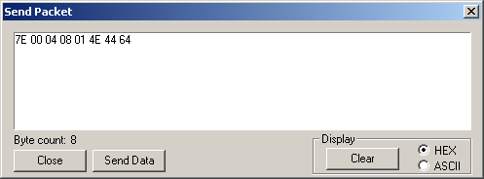
Figure 106 – Packet confirmation screenshot
Reprinted with permission from Digi.com
There is also a Line Status indicator which displays the status of the RS232 handshake line. A green indication means that the asserted and a black indication means that the line is de-asserted. A Break option in the software allows the user to select the serial line break. This can be accomplished by asserting the Break option from the window. This placed the Dl line high and prevents data from being sent to the RF module.
“Modem Configuration tab
The Modem configuration tab has four basic functions:
1: Provide a Graphical User Interface with a radio’s firmware
2: Read and Write firmware to the radio’s microcontroller
3: Download updated firmware files from either the web or from a compressed file
4: Saving or loading a modem profile

Reading a radio’s firmware
To read a radio’s firmware, follow the steps outlined below:
1: Connect the radio module to the interface board and connect this assembly or a packaged radio (PKG) to the PC’s corresponding port (IE: USB, RS232, Ethernet etc.).
2: Set the PC Settings tab to the radio’s default settings.
3: On the Modem Configuration tab, select “Read” from the Modem Parameters and Firmware section.

Making changes to a radio’s firmware
Once the radio’s firmware has been read, the configuration settings are displayed in three colors (see Figure 10):
Black – not settable or read-only
Green – Default value
Blue – User-specified “
The preceding was reprinted with permission directly from the X-TCU user manual. The Modem Configuration tab is shown in the screenshot below.
Figure 107 - X-CTU modem configuration screenshot
Reprinted with permission from Digi.com
The user-settable parameters can be modified by simply typing a new value in the window associated with command. Once a command is selected a quick description is displayed on the screen. After all of the user defined values have been entered into the software they can be saved to the radio’s non-volatile memory. To make changes to the RF module’s memory you can click on the Write button in the Firmware section entitle, Modem Parameters.
Writing to the XBee’s firmware can be accomplished by clicking on the Modem Parameters and Firmware section. Once the window is opened, click on the Write button and input the data in the blank area of the screen. The Modem Configuration window with the Read option is shown below.
Figure 108 - X-CTU Modem Configuration screenshot
Reprinted with permission from Digi.com
The Modem Configuration tab allows users to download updated firmware files or install them from a disk. To accomplish this task, follow the procedure below.
- Select Download New Versions under the Version section
- Click on Web or File depending on where the software will be imported from
- Click OK and then Done when complete
Screenshots of the aforementioned windows are shown below.
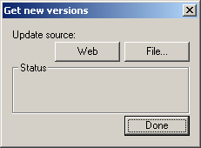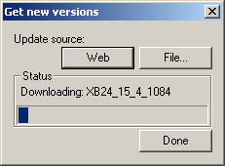
Figure 109: Software Update Screenshot
Reprinted with permission from Digi.com
The X-CTU software allows users to save user-defined modem profiles the RF module. This allows multiple modules to be programmed easily as long as the parameters are going to be identical. To save a profile follow the procedure below.
- Create the desired profile by following the aforementioned instructions
- Under the Profile section, select Save
- Type the name of the profile in the File Name Box
- Selection the location to save the profile and click Save
To load a saved profile, follow the instructions below.
- From the profile section, click Load
- Browse the file location
- Click on Open
It is also possible to configure the RF Modules by using over the air commands. This allows the user to configure remote radio parameters with the X-CTU or API packets. To accomplish this task the radio connected via cable to the PC needs to be set in API mode. The radio that is not hard connected must be within range.
Remote radios can also be accessed through the X-CTU. To accomplish this, click on the Modem Configuration Tab and then the PC Setting tab. Next click on Enable API and the COM port setting will be displayed. Next select the Remote Configuration option on the Modem Configuration tab and click on Open Com Port and then Discover. Then select the desired modem form the list and then click on Read. The Modem Configuration window is shown in the screenshot below.
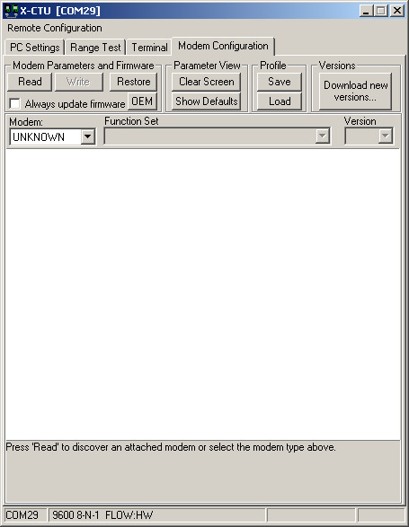
Figure 110: X-CTU Modem Configuration screenshot
Reprinted with permission from Digi.com
The remote radio’s configuration is now displayed in tab entitled Modem Configuration tab. If you wish to clear the displayed nodes from the list, click on the Clear button under the Node List area. The node list option also includes the ability to:
- Print the discovered list
- Remove a single node from the list
- Add nodes that were not discovered
- Save the list
- Load a saved list

7. Project Milestones

7.1 Senior Design 1
Senior Design 1 consists of several milestones that needed to be completed in order to fulfill the requirements of the course. The timeline schedule of events has been carefully planned out creating a guide for the group to use. Making deadlines is an important task in order for a project to be completed on time. This helps everyone’s time management skills, which are very important in an engineering work force. Seen in Figure 111 are the milestones that were set out for the first semester of Senior Design. Each milestone is carefully given an appropriate time schedule.
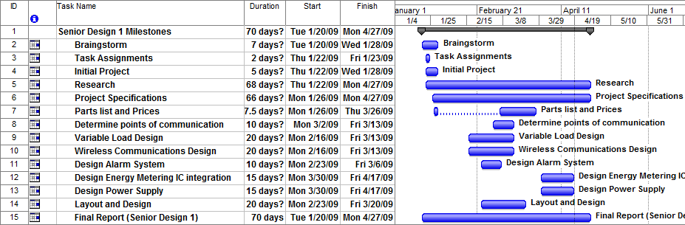
Figure 111: Senior Design 1 Gantt chart

7.2 Senior Design 2
In Senior Design 2 there are several things that will need to be done in order to build test in prototype the Mini-Substation Power Monitoring System. This semester will consist mostly of building and testing the product. There will need to be adjustments and improvements made along the way, which is normal in an engineering design project. Seen below in Figure 112 are the milestones for the second semester of senior design. Similar to the milestones in Figure 111 each one is carefully placed in a time frame that appropriately measure importance and difficulty to the project.
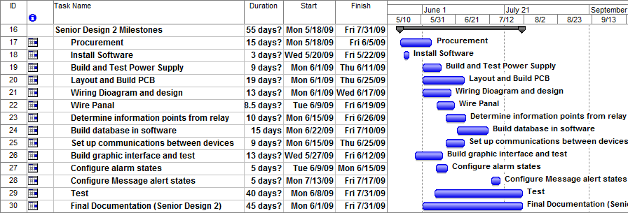
Figure 112: Senior Design 2 Gantt chart

7.3 Project Cost of Material
As detailed in the many pages and sections previous to this one there will be a number of devices, parts and equipment that will need to be purchased to complete the design of the proposed prototype device. The costs associated with each component of the monitoring system are shown on Table 35 below. The development cost is what is would cost to reproduce the mini-substation monitoring system and the actual cost is what is going to cost us with donations and free domo software.
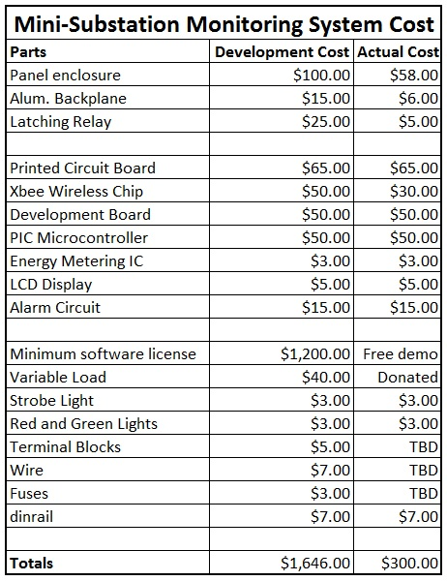
Table 35: Mini-Substation Monitoring System Costs

8. Final Product
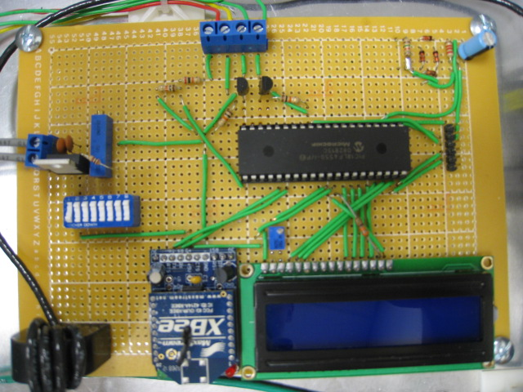
Figure 113: Final Circuit Board Design
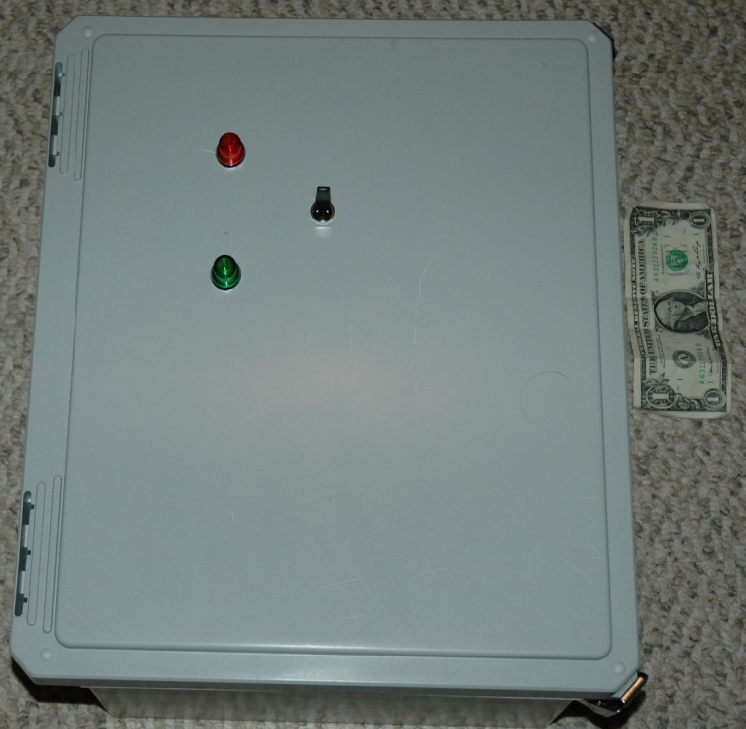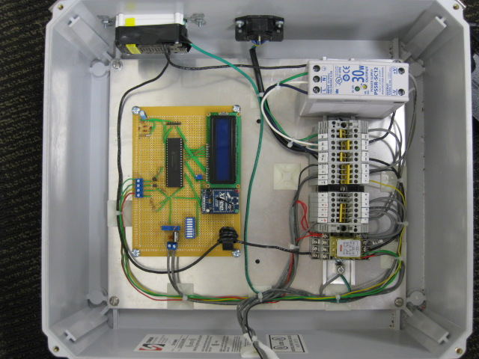
Figure 114: Final Product
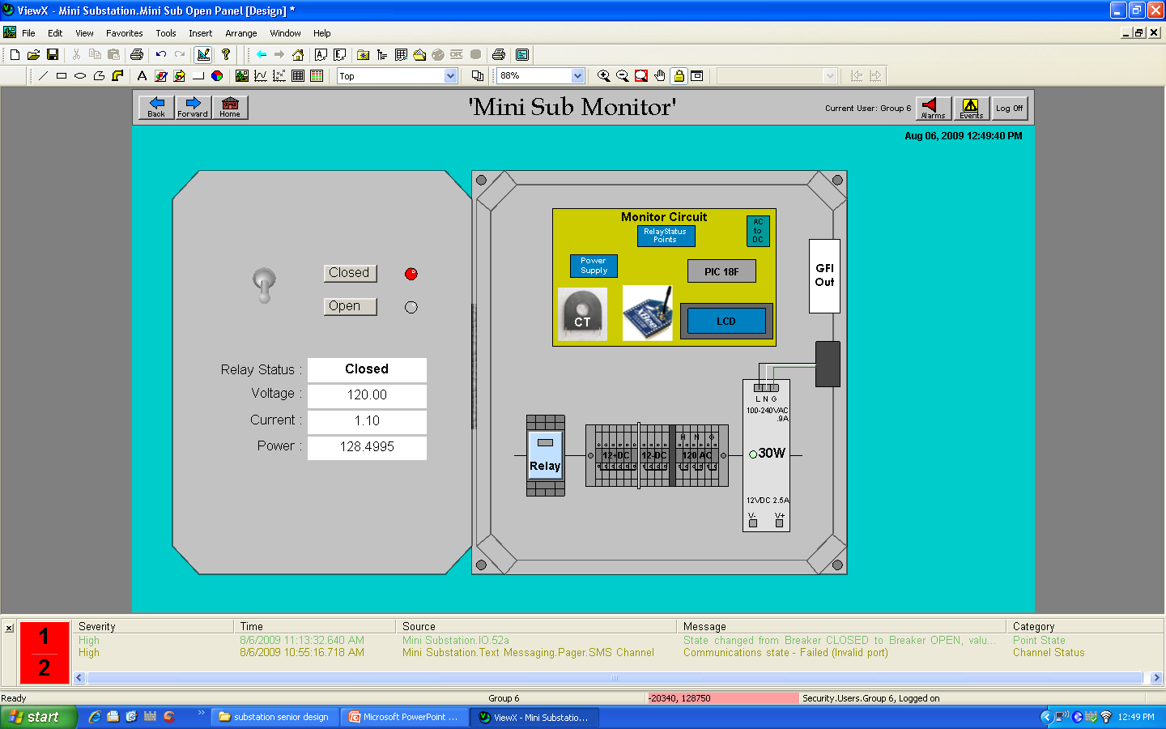
Figure 115: SCADA Panel Environment

Appendix

Permissions Granted
Microchip.com Permission of use
From: | Jacqueline.Eichman@microchip.com
Subject: | Re: Permission to use your website figures in College Paper
Date: | Mon, March 30, 2009 3:10 pm
To: | johnb@bcitech.com
Microchip grants you permission to reprint the requested Microchip
copyrighted materials in your student paper. Microchip's Third Party
Copyright Permission Guidelines are available at:
http://www.microchip.com/stellent/idcplg?IdcService=SS_GET_PAGE&nodeId=4
87&param=en023282

We do request that Microchip's copyrighted materials are properly
acknowledged and Microchip's trademarks are properly used.

Should you need anything further regarding this matter, please contact
me.

Jacqueline Eichman
Legal Coordinator
Microchip Technology Incorporated
2355 W. Chandler Blvd.
Chandler, AZ 85224-6199 - USA
Direct Phone: 480-792-7894
Direct Fax: 480-792-4112
jacqueline.eichman@microchip.com

THIS E-MAIL TRANSMISSION, AND ANY DOCUMENTS, FILES OR PREVIOUS E-MAILS
ATTACHED TO IT, IS CONFIDENTIAL INFORMATION INTENDED ONLY FOR THE USE OF
THE NAMED RECIPIENT(S). ANY DISSEMINATION, DISTRIBUTION OR DUPLICATION
OF THIS TRANSMISSION IS STRICTLY PROHIBITED. If you believe you have
received this e-mail in error, please notify the Sender and delete the
e-mail from your system.

-----Original Message-----
From: Eric Sells - C07786
Sent: Monday, March 30, 2009 1:57 PM
To: Jacqueline Eichman - C08745
Subject: FW: Permission to use your website figures in College Paper

-----Original Message------------------------------------------------------
From: johnb@bcitech.com [mailto:johnb@bcitech.com]
Sent: Monday, March 30, 2009 1:15 PM
To: Eric Sells - C07786
Subject: Permission to use your website figures in College Paper

To whom it may concern,

My name is John Blackburn. I am currently a senior electrical
engineering
student at the University of Central Florida. My group and I are
working
on our senior design project which has to do with substation power
monitoring using software and a microcontroller. I am contacting you to
request the use of some of your pictures and figures on your Microchip
website to use in our Final Paper for reference. Would this be
feasible?

thank you for your time

John Blackburn
UCF EE Group 6

Multi-Tech Permission of use
Steve -
I am writing in response to your e-mail dated April 17, 2009 requesting permission to use images and content from Multi-Tech Systems' website for use in your research project.
Multi-Tech Systems, Inc. hereby grants you permission to use excerpts, copy and/or images from the above-mentioned documentation that pertains to wireless communications devices for use in your research project being conducted at the University of Central Florida. All of your research documentation containing Multi-Tech Systems excerpts, copy and/or images should be used in accordance with Multi-Tech's copyright and should be given acknowledgement as follows: "Portions of this document are reprinted by permission of Multi-Tech Systems, Inc.".
Any Multi-Tech Systems logo's or registered trademarks/tradenames would need to included the proper ® or TM symbol, indicating the mark is a registered mark of Multi-Tech Systems, Inc.
If you should require further assistance, please feel free to contact me.
Regards,
Carol Montour
Carol Montour
Marketing Communications Manager
Multi-Tech Systems, Inc.
Direct: 763.717.5530 | Fax: 763.792.8484
cmontour@multitech.com

Siemens Energy Permission of use
From: | "Wagener, Lydia" <lydia.wagener@siemens.com>
Subject: | web information - Siemens Energy
Date: | Wed, April 1, 2009 6:01 am
To: | johnb@bcitech.com
dear John,
thank you for your interest in the Siemens ENERGY web and in the topic of High Voltage substations and power monitoring.
All facts and figures available on the official Siemens Energy websites may be used in your papers by quoting the source.
If you have any further questions do not hesitate to contact us again.
With best regards,
Lydia Wagener
Siemens AG
Energy Sector
Power Transmission Division
High Voltage Substations
E T HS SC 2
Freyeslebenstr. 1
91058 Erlangen, Germany
Tel.: +49 (9131) 7-33517
Fax: +49 (9131) 7-34876
mailto:lydia.wagener@siemens.com
Siemens Aktiengesellschaft: Chairman of the Supervisory Board: Gerhard Cromme; Managing Board: Peter Loescher, Chairman, President and Chief Executive Officer; Wolfgang Dehen, Heinrich Hiesinger, Joe Kaeser, Barbara Kux, Hermann Requardt, Siegfried Russwurm, Peter Y. Solmssen; Registered offices: Berlin and Munich, Germany; Commercial registries: Berlin Charlottenburg, HRB 12300, Munich, HRB 6684; WEEE-Reg.-No. DE 23691322
Important notice: This e-mail and any attachment thereof contain corporate proprietary information. If you have received it by mistake, please notify us immediately by reply e-mail and delete this e-mail and its attachments from your system. Thank you.

Citect Permission of use requested
From: | "Global Support" <Support@Citect.com>
Subject: | RE: CSR245859 EE student information request
Date: | Fri, March 27, 2009 7:52 am
To: | johnb@bcitech.com
Hello,

The best thing to do is to contact our Atlanta office

Citect Corporation
30000 Mill Creek Ave
Suite 300f
Alpharettada, GA 30022
United States of America
+1 (770) 5217511

Regards,

Michel Latumaelissa
Global Support Engineer
Citect by Schneider Electric

Tel Aus: 1300 131 631
Tel NZ: 0800 880 026
Tel USA : 1 866 589 6855
Tel South Africa: 0800 998 887
Tel Other: +61 2 9496 7400 or visit Contact Support
Fax +61 2 9496 7399
Email support@citect.com

-----Original Message-----
From: johnb@bcitech.com [mailto:johnb@bcitech.com]
Sent: Saturday, 28 March 2009 1:02 AM
To: Global Support
Subject: CSR245859 EE student information request

To whom it may concern,

My name is John Blackburn. I am currently a senior electrical engineering
student at the University of Central Florida. My group and I are working
on our senior design project which has to do with substation power
monitoring using software. I am contacting you to request the use of some
of your facts and figures on your CitectScada software website to use in
our Final Paper for reference. Would this be feasible?

thank you for your time

John Blackburn
UCF EE Group 6

Modbus-IDA permission of use
From: | "Lenore Tracey" <lenore@control.com>
Subject: | RE: Permission to use your website information and figures in College Paper
Date: | Sun, April 19, 2009 4:19 pm
To: | johnb@bcitech.com
Hello John,
It would be fine for you to use material from the protocol specification and
implementation guides if you cite the source appropriately. Information that
relates to a member company's products should reference that company and it
would make sense to contact them as well. I can provide contact information
if you plan to do that.

Would you like to share your paper and project with the Modbus community
when you have completed it?

Regards,
Lenore

Lenore Tracey
Executive Director
Modbus-IDA
+1 508-435-7170 ph
+1 508-435-7172 fax
lenore@modbus-ida.org

-----Original Message-----
From: johnb@bcitech.com [mailto:johnb@bcitech.com]
Sent: Sunday, April 19, 2009 7:09 PM
To: info@modbus-ida.org
Subject: Permission to use your website information and figures in College
Paper]

To whom it may concern,

My name is John Blackburn. I am currently a senior electrical engineering
student at the University of Central Florida, USA. My group and I are
working on our senior design project which has to do with substation power
monitoring using software and a microcontroller. I am contacting you to
request the use of some of your information, pictures and figures on your
Modbus protocol website to use in our Final Paper for reference. We
would properly document and cite all information that we would use. Would
this be feasible?

thank you for your time

John Blackburn
UCF EE Group 6

Digi.com permission of use

Radiocrafts permission of use
RE: Permission to use photos?
Friday, April 17, 2009 3:59 PM
From:
"Hallvard Moholdt" <h.moholdt@radiocrafts.com>
To:
"Steve Johnson" <sjj196@yahoo.com>
Hello, Steve;
This is ok, no problem, but please make the “Radiocrafts” logo on the shielding visible ☺
Thank you and good luck with your report.
Med vennlig hilsen/Best regards
*****************************************
Hallvard Moholdt, M.Sc.E.E.
Development Manager
Radiocrafts AS
Sandakerveien 64
NO-0484 OSLO
NORWAY
Switchboard: (+47) 4000 5195
Tel (GSM): (+47) 930 24 999
Fax: (+47) 22 71 29 15
email: mailto:h.moholdt@radiocrafts.com
web: http://www.radiocrafts.com
*****************************************

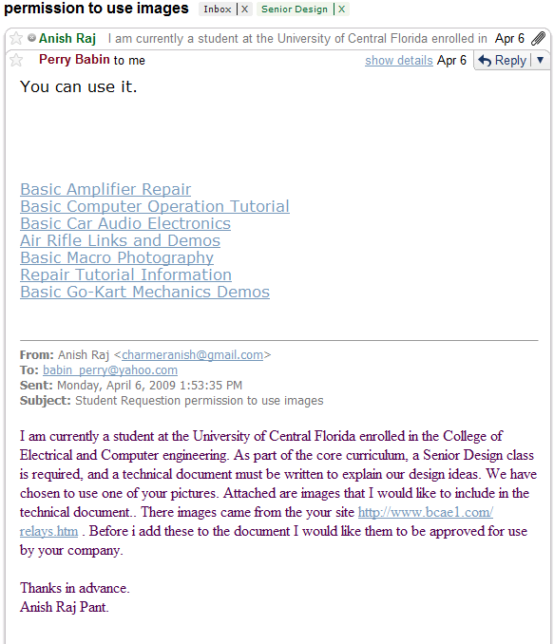

Use of Microchip Copyrighted Material
Educational and Non-Profit Use of Copyrighted Material: If you use Microchip copyrighted material solely for educational (non-profit) purposes falling under the “fair use” exception of the U.S. Copyright Act of 1976 then you do not need Microchip’s written permission. For example, Microchip’s permission is not required when using copyrighted material in: (1) an academic report, thesis, or dissertation; (2) classroom handouts or textbook; or (3) a presentation or article that is solely educational in nature (e.g., technical article published in a magazine). Please note that offering Microchip copyrighted material at a trade show or industry conference for the purpose of promoting product sales does require Microchip’s permission.
http://www.eleinmec.com/about.asp#legal
Disclaimer
The author(s) and the publisher make no representation or warranties of any kind with regard to the completeness or accuracy of the contents of this website and accept no liability of any kind including but not limited to performance, merchantability, fitness for any particular purpose, or any losses or damages of any kind caused or alleged to be caused directly from the content of this website.
While comments posted to the Electronics in Meccano message boards are monitored and unsuitable comments will be removed as soon as possible, the publisher takes no responsibility for the content that may be found on the message boards.
Copyright
All articles and website content © 1998 - 2009 Tim Surtell.
Article text, figures, circuit schematics and design aids on this website may be printed and copied for individual and educational use. No part of this website may be reproduced in any way commercially without the prior permission of the publisher.
If you wish to link to this website, please click here.
http://www.national.com/analog/site_terms
Access and Use of the Site. You are granted permission to access and use the Site, including permission to download, copy, and display materials contained on the Site, on a limited basis for internal, noncommercial, informational purposes only and strictly subject to these Terms. The permissions granted by these Terms shall extend to officers, directors, employees, and agents authorized by You in accordance with these Terms ("Authorized Users"), subject to such Authorized Users being bound by this to the same extent as You. You shall be liable, jointly and severally, for all acts and breaches of these Terms by any Authorized User.
http://www.allaboutcircuits.com/l_dsl.html
Copying and distribution
Permission is granted to distribute, publish or otherwise present verbatim copies of the entire Source Data of the Work, in any medium, provided that full copyright notice and disclaimer of warranty, where applicable, is conspicuously published on all copies, and a copy of this License is distributed along with the Work.
Permission is granted to distribute, publish or otherwise present copies of the Object Form of the Work, in any medium, under the terms for distribution of Source Data above and also provided that one of the following additional conditions are met:
(a) The Source Data is included in the same distribution, distributed under the terms of this License; or
(b) A written offer is included with the distribution, valid for at least three years or for as long as the distribution is in print (whichever is longer), with a publicly-accessible address (such as a URL on the Internet) where, for a charge not greater than transportation and media costs, anyone may receive a copy of the Source Data of the Work distributed according to the section above; or
(c) A third party's written offer for obtaining the Source Data at no cost, as described in paragraph (b) above, is included with the distribution. This option is valid only if you are a non-commercial party, and only if you received the Object Form of the Work along with such an offer.
You may copy and distribute the Work either gratis or for a fee, and if desired, you may offer warranty protection for the Work.
The aggregation of the Work with other works which are not based on the Work -- such as but not limited to inclusion in a publication, broadcast, compilation, or other media -- does not bring the other works in the scope of the License; nor does such aggregation void the terms of the License for the Work.

Works Cited
1. SCADA, Industrial & Facilities Management Software. [Online] [Cited: March 12, 2009.] http://www.citect.com.
2. Transformers. Wikipedia. [Online] The Wikimedia Foundation. [Cited: 4 5, 2009.] http://en.wikipedia.org/wiki/Transformer.
3. Rectifier. Wikipedia. [Online] The Wikimedia Foundation. [Cited: April 4, 2009.] http://en.wikipedia.org/wiki/Rectifier.
4. Voltage regulator. Wikipedia. [Online] The Wikimedia Foundation. [Cited: April 5, 2009.] http://en.wikipedia.org/wiki/Voltage_regulator.
5. Brain, Marshall. How Microcontrollers Work. HowStuffWorks.com. [Online] April 01, 2000. [Cited: March 30, 2009.] http://www.howstuffworks.com/microcontroller.htm.
6. PIC microcontroller. Wikipedia. [Online] The Wikimedia Foundation. [Cited: March 31, 2009.] http://en.wikipedia.org/wiki/PIC_microcontroller.
7. Atmel AVR. Wikipedia. [Online] The Wikimedia Foundation. [Cited: March 31, 2009.] http://en.wikipedia.org/wiki/Atmel_AVR.
8. Shunt (electrical). Wikipedia. [Online] The Wikimedia Foundation. [Cited: April 2, 2009.]
9. Rogowski coil. Wikipedia. [Online] The Wikimedia Foundation. [Cited: March 25, 2009.] http://en.wikipedia.org/wiki/Rogowski_coil.
10. X-CTU software. Digi.com. [Online] [Cited: March 30, 2009.] http://ftp1.digi.com/support/documentation/90001003_A.pdf.
11. Aurel Wireless Modules. Aurelwireless.com. [Online] [Cited: March 24, 2009.] http://www.aurelwireless.com/rf-wireless-modules/data-transceivers.asp.
12. RadioCrafts. Radiocrafts.com. [Online] [Cited: March 30, 2009.] http://www.radiocrafts.com/index.php?sideID=241&ledd1=32.
13. MultiTech Wireless Modem. multitech.com. [Online] [Cited: April 12, 2009.] http://www.multitech.com/PRODUCTS/Families/MultiModemGPRS/.
14. Relay. [Online] [Cited: 04 03, 2009.] http://en.wikipedia.org/wiki/Relay.
15. Oceancontrols. [Online] [Cited: 04 05, 2009.] http://www.oceancontrols.com.au/relays/Goodsky_RET.pdf.
16. Goodsky. [Online] [Cited: 04 05, 2009.] http://www.oceancontrols.com.au/relays/Goodsky%20RW-RWH.pdf.
17. Solid State Relay. [Online] [Cited: 04 03, 2009.] http://en.wikipedia.org/wiki/Solid_state_relay.
18. Liquid Crystal Display. Wikipedia. [Online] Wikipedia Organization. [Cited: 04 03, 2009.] http://en.wikipedia.org/wiki/Liquid_crystal_display.
19. CFA632-YFB-KS. Crystalfontz. [Online] [Cited: 04 10, 2009.] http://www.crystalfontz.com/product/CFA632-YFB-KS.html.
20. CFA634-NFA-KS. Crystalfontz. [Online] [Cited: 04 10, 2009.] http://www.crystalfontz.com/product/CFA634-NFA-KS.html.
21. DNA technology. [Online] [Cited: 04 09, 2009.] http://www.dnatechindia.com/index.php/Tutorials/8051-Tutorial/Interfacing-LCD.html.
22. Product Features. ClearScada product Features. [Online] [Cited: March 24, 2009.] http://www.clearscada.com/product-features/.
23. HMI Available for OEM - Hunam Machine Interface software. SCADA, Industrial & Facilities management Software - Citect Home. [Online] [Cited: March 19, 2009.] http://www3.citect.com/products/citecthmi.
24. Prodigy SCADA HMI Industrial Automation Software. [Online] [Cited: March 18, 2009.] http://www.tascomp.com/~tascomp/index.php/section-home/.
25. Power transmission & Distribution by USA Siemens. Siemens Energy. [Online] [Cited: March 18, 2009.] http://www.energy.siemens.com/cms/us/home/Pages/home.aspx.
26. Spectrum PowerCC Energy Control / SCADA. Siemens Energy. [Online] [Cited: March 16, 2009.] http://www.energy.siemens.com/cms/us/US_Products/Portfolio/ControlCenterEnergyManagementSolutions/Pages/SpectrumPowerCCEnergyControlSCADA.aspx.
27. Modbus protocol, specifications and in depth tutorial. Lammert Bies - Computer Interfacing. [Online] April 2008. [Cited: April 10, 2009.] http://www.energy.siemens.com/cms/us/home/Pages/home.aspx.
28. Modbus Application protocol V1 1b. Modbus-IDA. [Online] [Cited: April 4, 2009.] http://www.modbus-ida.org/docs/Modbus_Application_Protocol_V1_1b.pdf.
29. SPDT and SPST Automotive Relays. the12volt.com. [Online] [Cited: March 25, 2009.] http://www.the12volt.com/relays/relays.asp.
30. Power Failure Alarm Project. Electronics Project Design. [Online] [Cited: March 25, 2009.] http://www.electronics-project-design.com/PowerFailureAlarm.html.
31. LED circuit. Wikipedia. [Online] The Wikimedia Foundation. [Cited: March 30, 2009.] http://en.wikipedia.org/wiki/LED_circuit.
32. LM317. Wikipedia. [Online] The Wikimedia Foundation. [Cited: April 10, 2009.] http://en.wikipedia.org/wiki/LM317.
33. ADE7753: Single Phase Multifunction Energy Metering IC with de/dt Input (Serial-Port Interface). analog.com. [Online] [Cited: April 10, 2009.] http://www.analog.com/en/analog-to-digital-converters/energy-measurement/ADE7753/products/product.html.
34. Shah, Amol. DNA Technology. [Online] 11 2007. [Cited: 04 06, 2009.] http://www.dnatechindia.com/index.php/Tutorials/8051-Tutorial/Relay-Interfacing.html.

